PIERNIKI

1 cup honey
4 cups flour
4 eggs
1 cup sugar
pinch of ground black pepper
1/2 tablespoon ground cinnamon
1/2 tablespoon ground nutmeg
1/2 tablespoon ground cloves
1/2 tablespoon ground allspice
1 tablespoon baking soda

Heat the honey in a small saucepan until it just begins to boil. Take off heat and allow to cool slightly. Combine eggs and sugar in a bowl and beat together until slightly thickened. In another bowl, mix the flour, spices, and baking soda together and add slowly to the egg and sugar mixture while beating rapidly. The dough should not have any lumps. Pour in the lukewarm honey and mix everything until smooth. You can cover the dough with plastic and refrigerate until ready to make the cookies.

KOMPOT Z SUSZU

1 1/2 pounds mixed dried fruit
6 cups of water
1 lemon
6 whole cloves, 1 cinnamon stick
1 cup of sugar

Rinse and soak fruit in 4 cups of water overnight in a ceramic or glass bowl. Transfer fruit and the water into to a stainless steel or enameled pot, add 2 more cups water, sugar, cloves, and cinnamon. Peel the lemon, leaving the peel in one piece, if possible, and add the peel to the pot. Then cut the peeled lemon in half and squeeze the juice into the pot. Cook for 30 minutes, adding more water, lemon juice, or water to taste. Refrigerate for a few hours. Serve cold in glass bowls, along with Christmas cookies, for dessert.

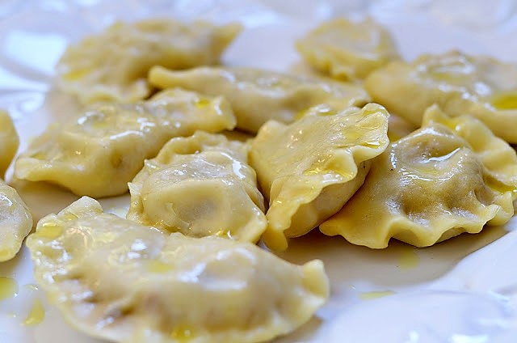
PIEROGI

PIEROGI DOUGH
2 cups all purpose flour
2 eggs
2 tablespoons sour cream
1/2 teaspoon salt
1/2 cup lukewarm water

Mound flour on a large cutting board and make a well in the center. Drop eggs, sour cream, and salt into well. Add water a few drops at a time and work it into the flour with a knife, moving slowly from the center to the outside of the flour mound. While mixing the liquid into the flour with one hand, keep the flour mounded with other hand. Try not to let any liquid break through the walls of the mound.
When all the water and egg is mixed into the flour, knead until the dough is firm and well mixed and no longer sticks to yours hands (about 10-15 minutes). Add flour if it seems too sticky; a few drops of water if it seems too dry. Then cover the dough with a bowl or clean dishtowel and let rest for 30 minutes.
Divide the dough into halves. On a well-floured surface, using half of the dough at a time, roll it out as thinly as possible. Cut out 3-inch rounds with a biscuit cutter or a drinking glass. Then place a tablespoon of filling in the middle of each round of dough, fold over carefully and press edges together. Be sure to press firmly as filling will spill out during cooking if the dough rounds are not well sealed.
Pierogi can be frozen at this point. Layer carefully in freezer container, be sure to separate layers with wax paper. If you are going to eat right away, drop 12-20 pierogi into a large pot of boiling, lightly salted water. Cook gently 3 to 5 minutes, or until pierogi float. Lift out of water with perforated spoon.
Toss in butter and place in heatproof serving dish. Pierogi can be reheated in the microwave or in the oven, just before serving. They can also be reheated by frying in butter. Serve pierogi with sour cream and chopped chives.

SAUERKRAUT AND MUSHROOM FILLING
2 cups sauerkraut
2 tablespoons butter
1/2 cup chopped onion
4 ounces mushrooms
1/4 teaspoon pepper
1 hardboiled egg, finely chopped
1 tablespoon breadcrumbs
2 tablespoons sour cream

Rinse sauerkraut in cold water and drain well. Sauté for 10 minutes in medium saucepan until dry. Set aside. In frying pan, sauté onion and mushrooms in the remaining butter. Add sauerkraut and pepper. Fry until sauerkraut is golden. Add chopped egg, breadcrumbs, and sour cream. Mix. Cool thoroughly before stuffing pierogi.

POTATO AND CHEESE FILLING
4 Russet potatoes
8 ounces farmer's cheese or dry cottage cheese
1 onion, finely chopped
2 tablespoons butter
Salt and pepper to taste

Peel and boil the potatoes until tender. Mash until smooth and let cool. Sauté chopped onion in the butter. Let cool. When mashed potatoes are cool, add onions and cheese. Mix well. Add salt and pepper to taste before filling pierogi. Serve with sour cream.

BARSZCZ

3 or 4 cans of whole beets
2 cans of vegetable, mushroom, or beef broth
2 cups of water
4 cups of tomato or vegetable juice
juice of 1/2 lemon
1/2 teaspoon sugar
1/2 teaspoon pepper
1 teaspoon salt

Strain the beets and set aside. Combine beet juice, broth, water and tomato or vegetable juice in an enameled or stainless steel soup pot. Bring to a gentle boi -- do not let the soup boil for more than a minute or it will lose its clear red color. Grate the beets from one or two cans into the soup. (Reserve the remaining beets for a salad). Add lemon juice and seasonings to taste. Reheat before serving, making sure not to bring to a boil. Place 5 or 6 uszka dumplings in each bowl before serving and pour barszcz over them (uszka recipe follows).

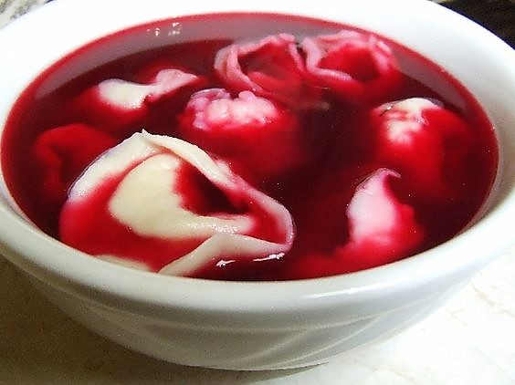

USZKA

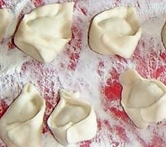
For the stuffing:
16 ounces fresh mushrooms, finely chopped
1 stick butter
1 medium-sized onion, finely chopped
white of one hard-boiled egg, finely chopped
2 tablespoons breadcrumbs
1 tablespoon parsley, chopped
Salt and pepper to taste

Sauté the mushrooms and onions in the butter for 10-15 minutes. Add bread crumbs, finely chopped egg white, and parsley. Mix well and add salt and pepper to taste.

For the dough:
1 egg yolk
2 cups of white flour, sifted
1/2 cup lukewarm water

Mix the flour with the egg yolk, adding water slowly and working it into the dough until a soft mass is formed. Keep kneading until the dough no longer sticks to your fingers. Roll dough into a ball and cover with flour. Place in a bowl covered with plastic and refrigerate for an hour.
Roll out a third of the dough into a thin layer on a floured surface and cut into 1 1/2 inch squares. Place a spoonful of the mushroom filling in the center of the square of dough, fold in half to form a triangle, and press the edges tightly to close. Then bring two corners of the triangle together and press tightly. Place dumplings on a floured dishcloth and cover with another cloth until ready to cook. Repeat with rest of dough. Cook dumplings in batches in boiling, salted water for 5 minutes, until they float to the top. Take out with slotted spoon and toss in meted butter. Serve immediately with barszcz or refrigerate and reheat gently before serving.

