Erasmus
My name is Petr Stefek.
I am from Czech Republic and I live in small village Dolni Lomna.
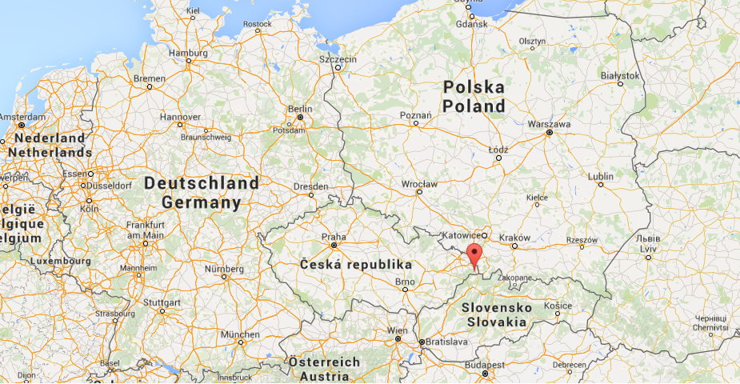
My favourite hobby is cykling and grow vegetables in our greenhouse.
I like good film and beautiful nature

