We are preparing for the new topic of our project - FOLK COSTUMES - and as you can see in the photos our pupils are colouring the pictures of the female folk costumes from different regions of Slovakia.
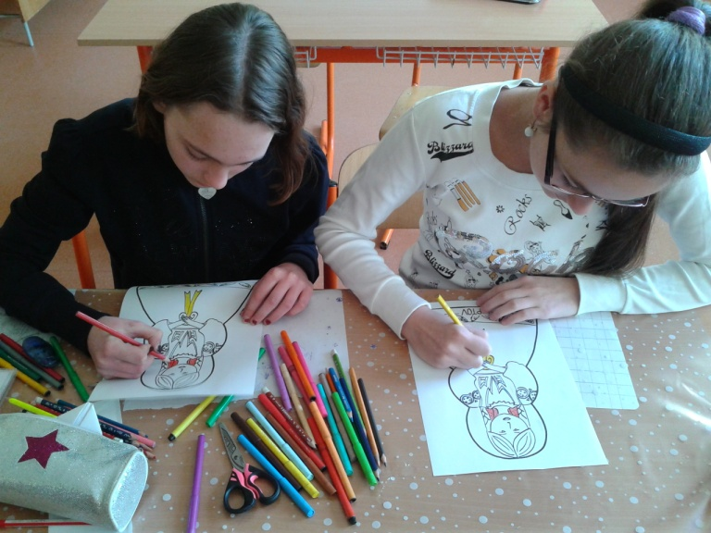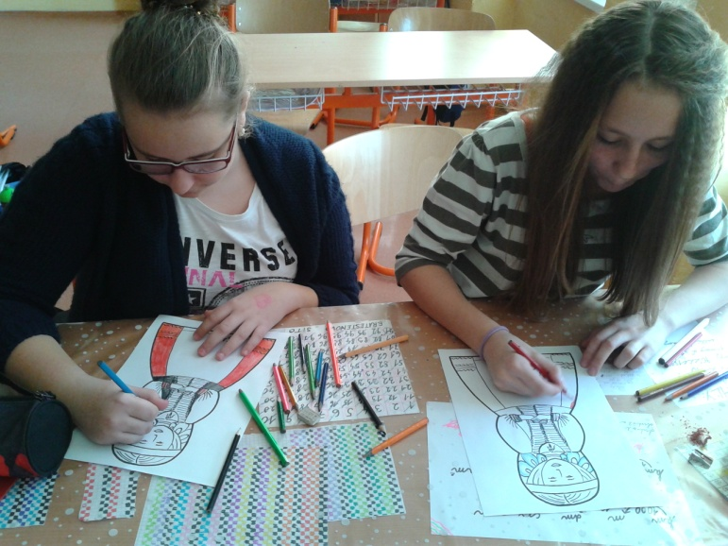
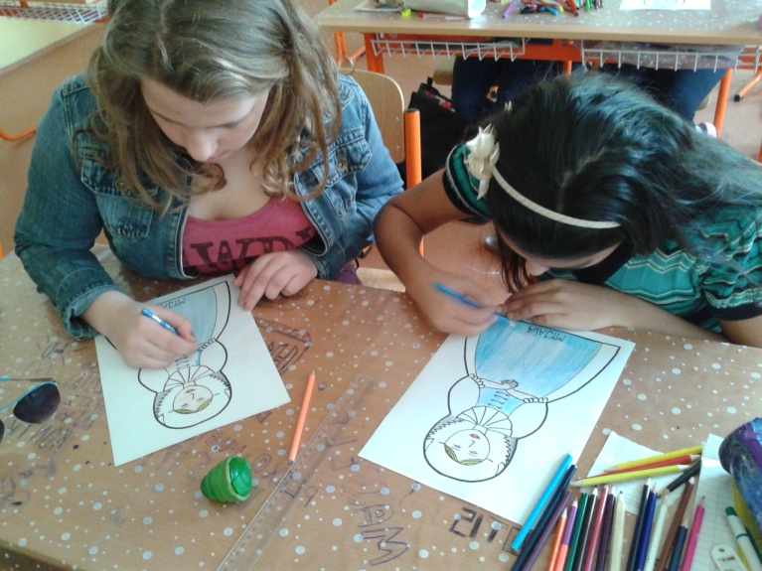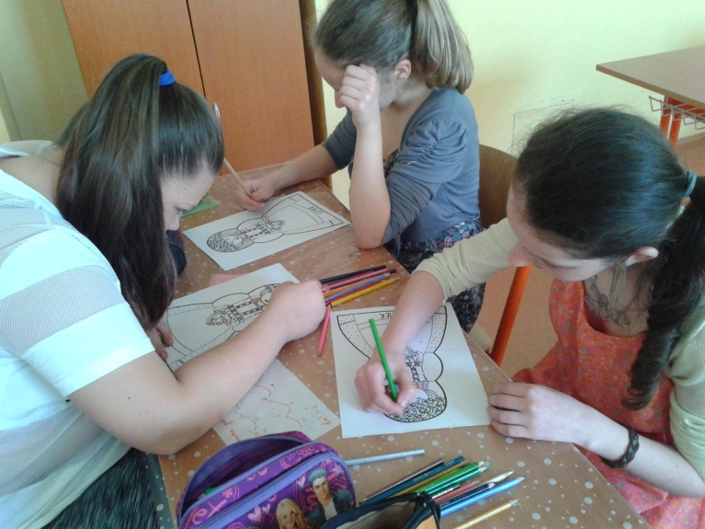
Our pupils are preparing a map of the female traditional folk costumes from different regions of Slovakia.
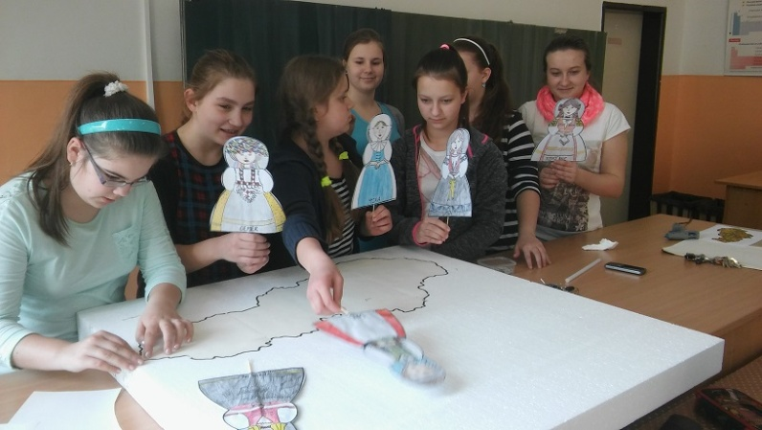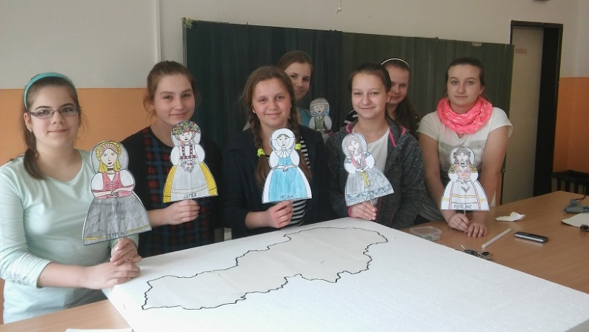

In this picture you can see our wall panel about The Kinds of Traditional Clothing.
