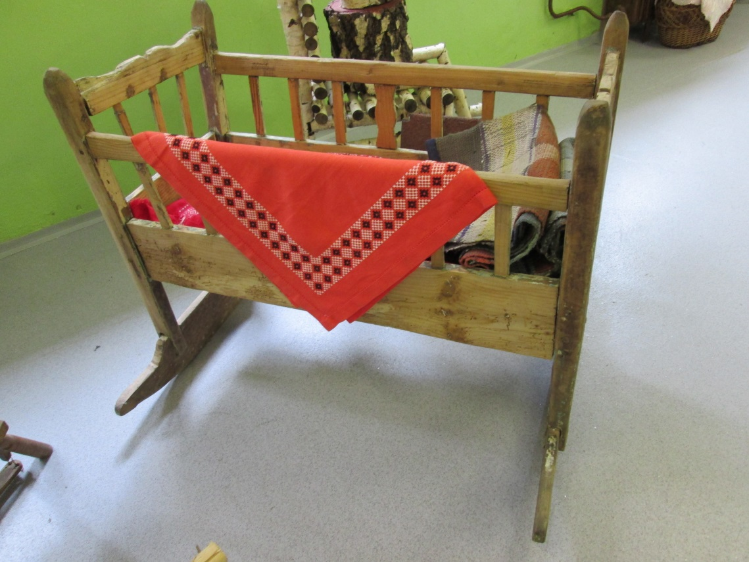

INVENTORY CARD – wooden object
Name of the  item | Slovak | Kolíska
 | English translation | Cradle
Inventory no. |  | 1.
Usage |  | For children
How it is made? |  | It’s carved from wood
Tools that were used in making the item? |  | Saw, wood, some type of knife
Who made it? / Where do you have it from? |  | Carver
When was the item made? / Acquisition date |  | 2016
Name of the person who described / registered the item & Village & Date |  | Valér Jakubčo

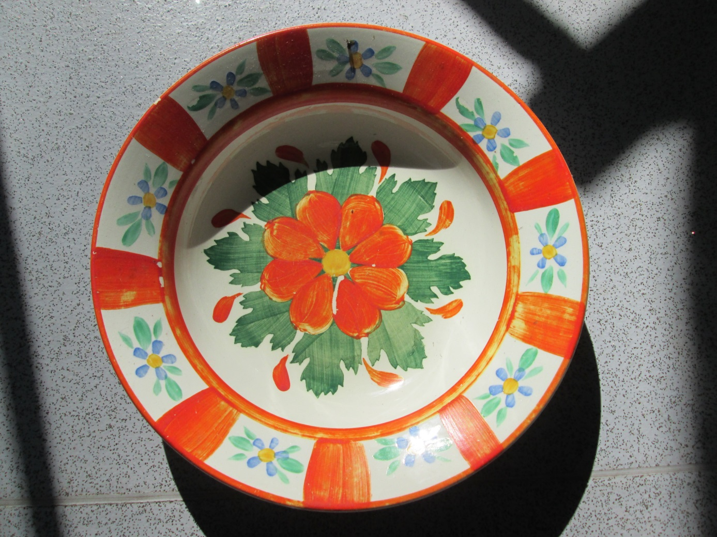

INVENTORY CARD – wooden object
Name of the  item | Slovak | Dekoračný tanier
 | English translation | Decorative plate
Inventory no. |  | 2.
Usage |  | For decoration or food
How it is made? |  | On the pottery wheel from the ground and subsequent baking
Tools that were used in making the item? |  | Pottery wheel and, ground, water, furnace
Who made it? / Where do you have it from? |  | Potter
When was the item made? / Acquisition date |  | 16th century/2016
Name of the person who described / registered the item & Village & Date |  | Natália Gavulová

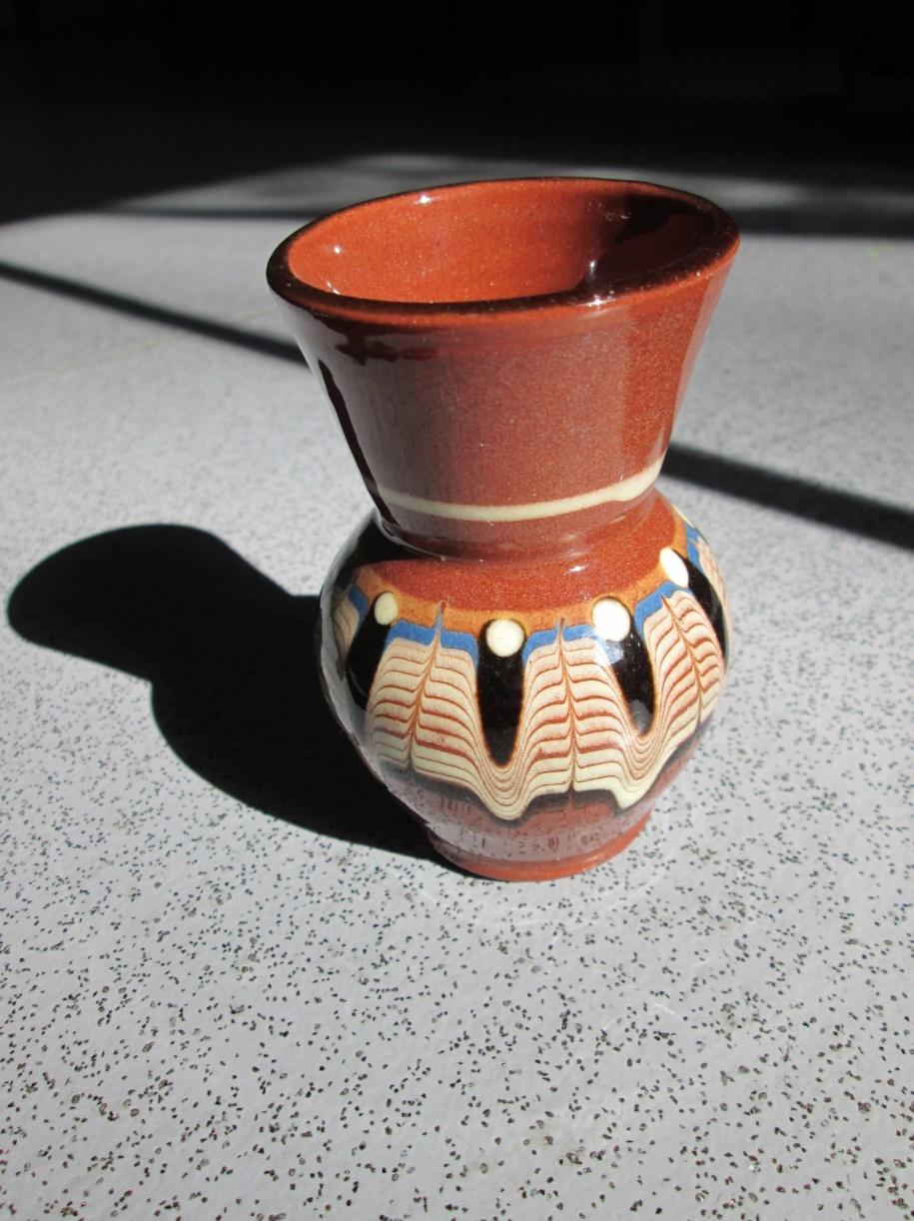

INVENTORY CARD – pottery
Name of the  item | Slovak | Dekoračná váza
 | English translation | Decorative vase
Inventory no. |  | 3.
Usage |  | decoration
How it is made? |  | Modeling from modeling clay
Tools that were used in making the item? |  | Modeling clay
Who made it? / Where do you have it from? |  | ceramist
When was the item made? / Acquisition date |  | 18th century/2016
Name of the person who described / registered the item & Village & Date |  | Laura Balicová

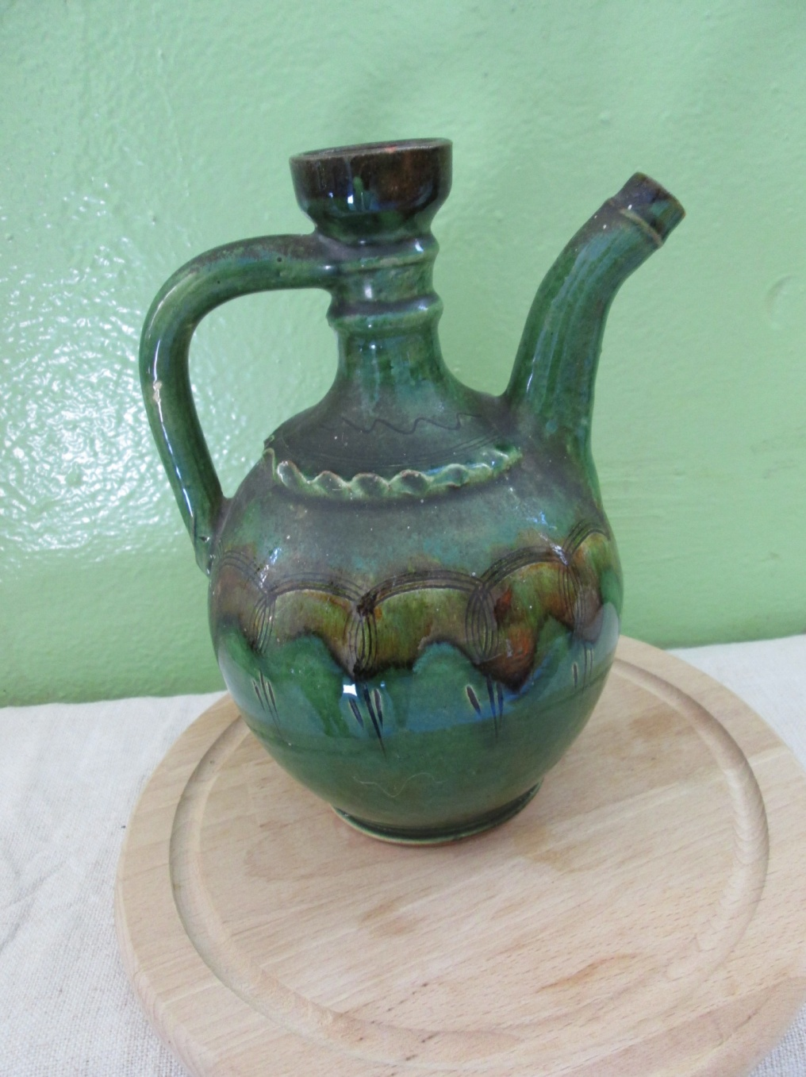

INVENTORY CARD – pottery
Name of the  item | Slovak | Dekoračný čajník
 | English translation | Decorative tea-pot
Inventory no. |  | 4.
Usage |  | Decoration
How it is made? |  | Modelling from modelling clay
Tools that were used in making the item? |  | Modelling clay
Who made it? / Where do you have it from? |  | ceramist
When was the item made? / Acquisition date |  | 18th century/2016
Name of the person who described / registered the item & Village & Date |  | Laura Balicová

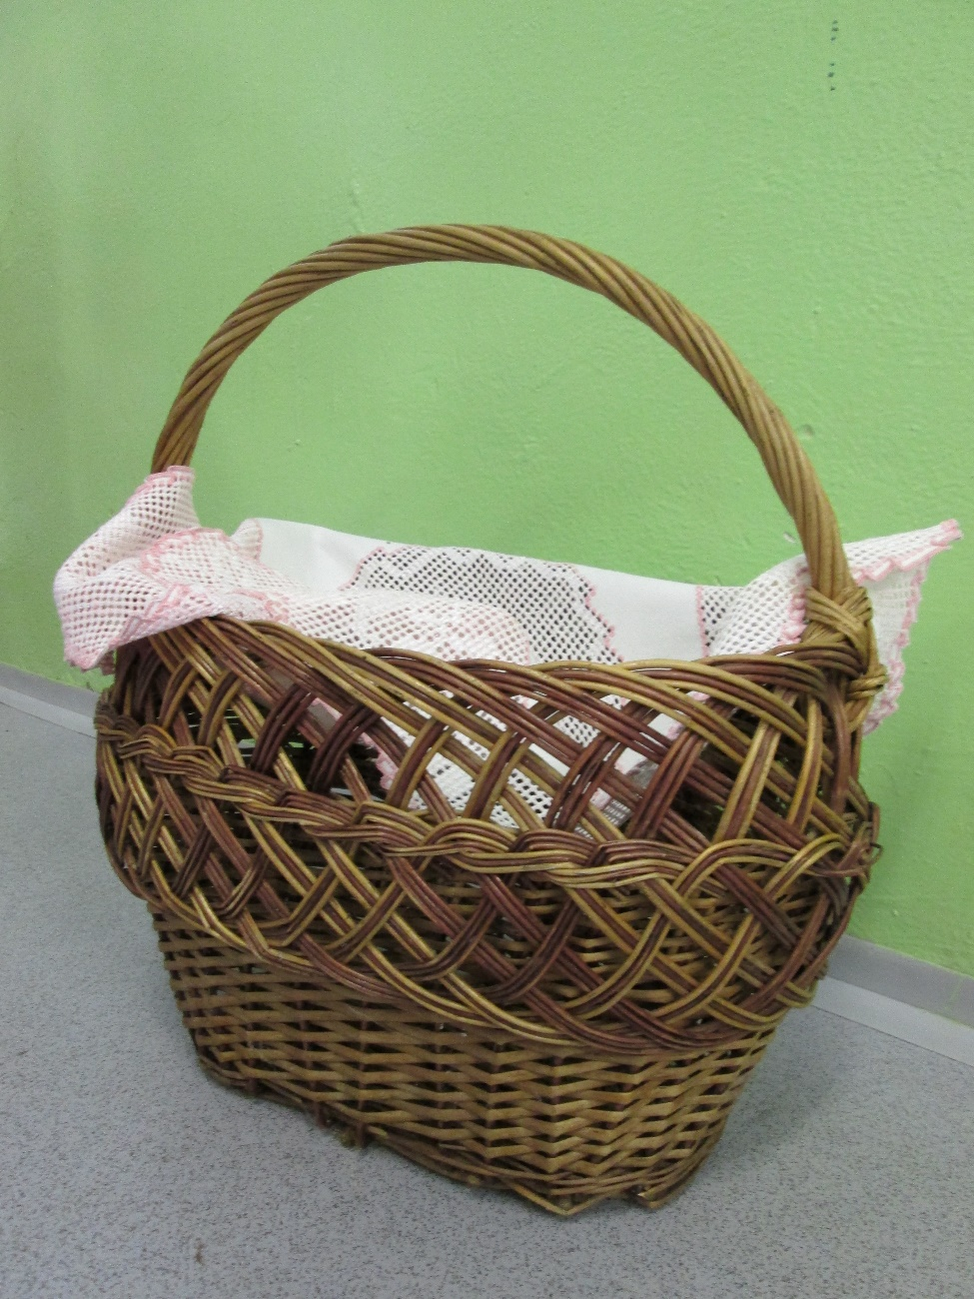

INVENTORY CARD – wooden object
Name of the  item | Slovak | Košík
 | English translation | Basket
Inventory no. |  | 5.
Usage |  | For transport things
How it is made? |  | Knitting
Tools that were used in making the item? |  | Rods, knife
Who made it? / Where do you have it from? |  | people
When was the item made? / Acquisition date |  | 2016
Name of the person who described / registered the item & Village & Date |  | Jakub Tkáč

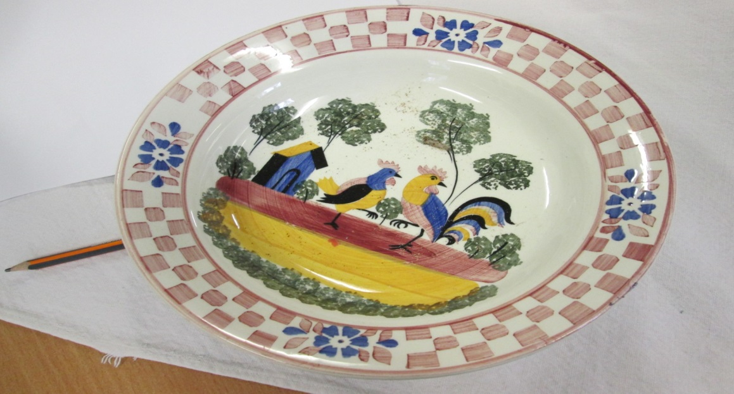

INVENTORY CARD – pottery
Name of the  item | Slovak | Tanier
 | English translation | Plate
Inventory no. |  | 6.
Usage |  | For eating
How it is made? |  | On potter‘s wheel
Tools that were used in making the item? |  | ground, water, potter’s wheel
Who made it? / Where do you have it from? |  | Ceramist
When was the item made? / Acquisition date |  | 18th century/2016
Name of the person who described / registered the item & Village & Date |  | Dávid Čvirk

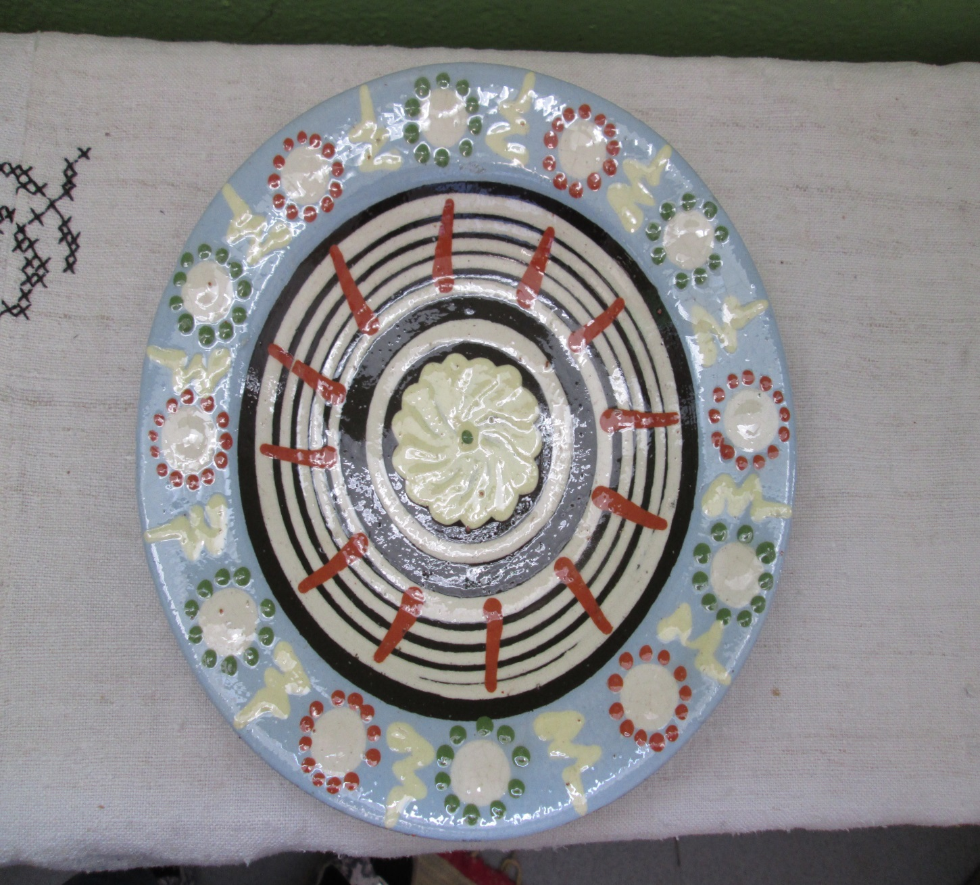

INVENTORY CARD – pottery
Name of the  item | Slovak | Tanier
 | English translation | Plate
Inventory no. |  | 7.
Usage |  | For eating
How it is made? |  | On potter‘s wheel
Tools that were used in making the item? |  | ground, water, potter’s wheel
Who made it? / Where do you have it from? |  | Ceramist
When was the item made? / Acquisition date |  | 18th century/2016
Name of the person who described / registered the item & Village & Date |  | Dávid Čvirk

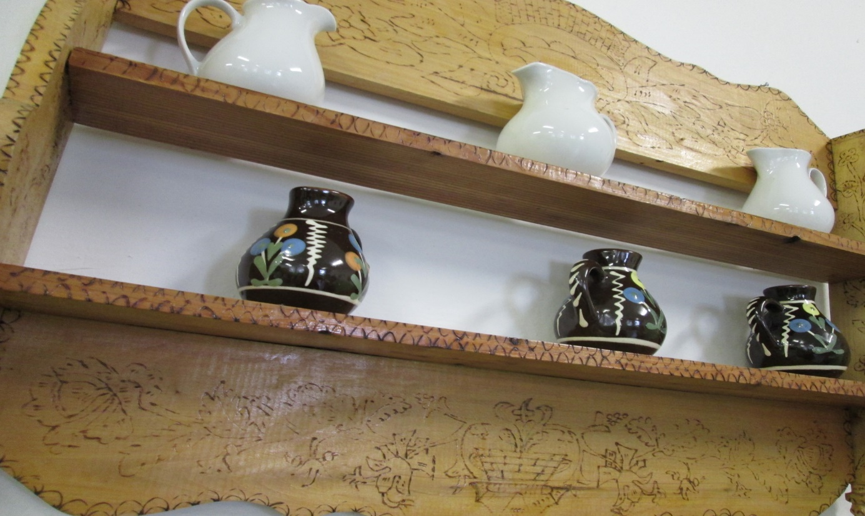

INVENTORY CARD – wooden object
Name of the  item | Slovak | Nástenná polica
 | English translation | Wall shelf
Inventory no. |  | 8.
Usage |  | Storage
How it is made? |  | Cutting wood
Tools that were used in making the item? |  | Chisel, saw
Who made it? / Where do you have it from? |  | Carpenter
When was the item made? / Acquisition date |  | 2016
Name of the person who described / registered the item & Village & Date |  | Ján Melich

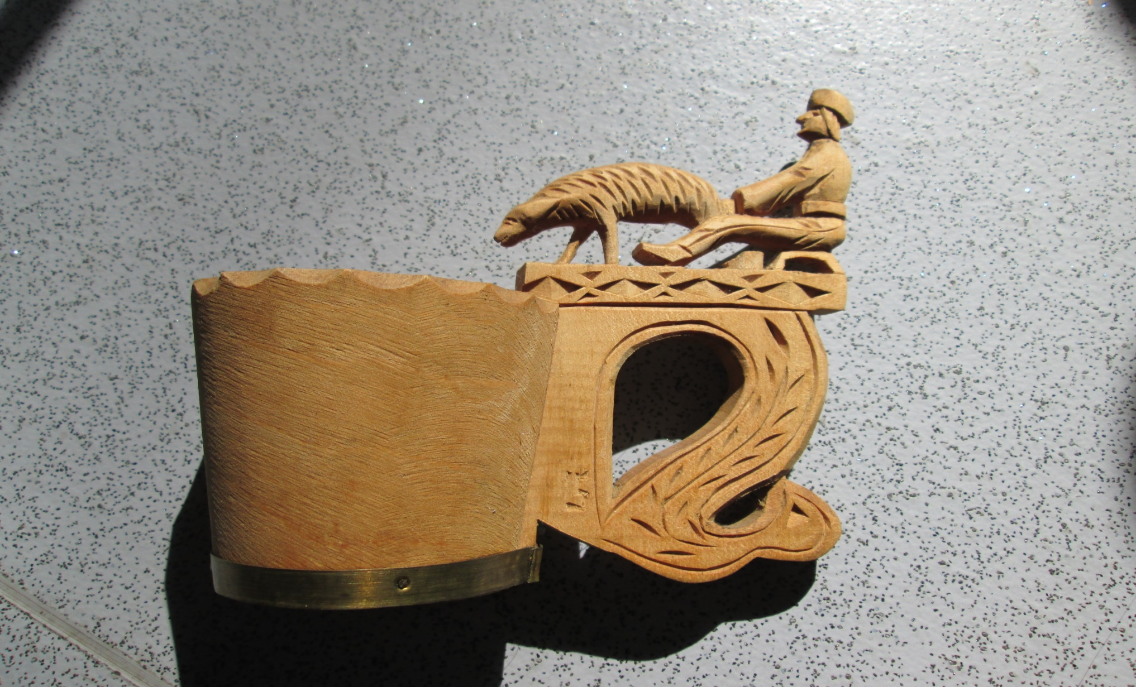

INVENTORY CARD – wooden object
Name of the  item | Slovak | Hrnček
 | English translation | Cup
Inventory no. |  | 9.
Usage |  | drinking
How it is made? |  | Cutting wood
Tools that were used in making the item? |  | chisel
Who made it? / Where do you have it from? |  | Carpenter
When was the item made? / Acquisition date |  | 2016
Name of the person who described / registered the item & Village & Date |  | Ján Melich

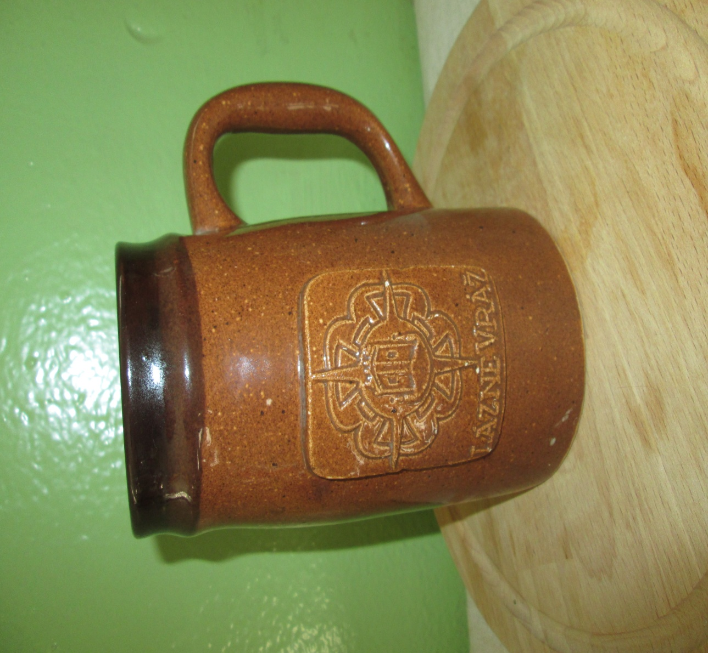

INVENTORY CARD – pottery
Name of the  item | Slovak | Keramický hrnček
 | English translation | Ceramic mug
Inventory no. |  | 10.
Usage |  | drinking
How it is made? |  | On potter’s wheel
Tools that were used in making the item? |  | Earth, potter’s wheel
Who made it? / Where do you have it from? |  | potter
When was the item made? / Acquisition date |  | 2016
Name of the person who described / registered the item & Village & Date |  | Ján Melich

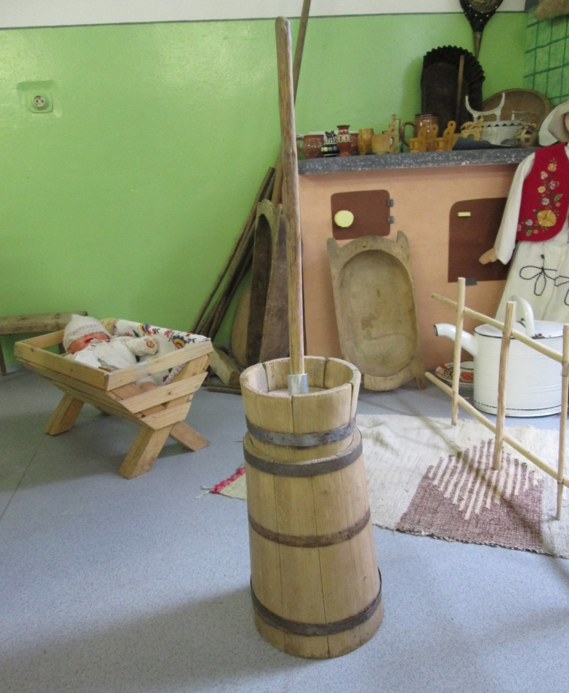

INVENTORY CARD – wooden object
Name of the  item | Slovak | Buťačka
 | English translation
Inventory no. |  | 11.
Usage |  | Making butter
How it is made? |  | It’s made from the wood
Tools that were used in making the item? |  | Knife, hammer
Who made it? / Where do you have it from? |  | Carpenter
When was the item made? / Acquisition date |  | 16th century/2016
Name of the person who described / registered the item & Village & Date |  | Daniela Macejová

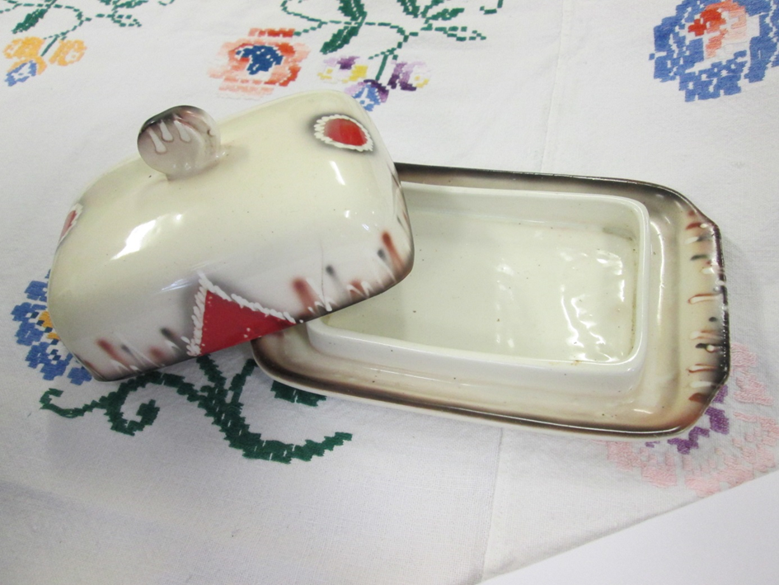

INVENTORY CARD – POTTERY
Name of the  item | Slovak | maselnička
 | English translation
Inventory no. |  | 12.
Usage |  | Storing butter
How it is made? |  | On the potter’s wheel
Tools that were used in making the item? |  | Potter’s wheel, ground, baking
Who made it? / Where do you have it from? |  | Potter
When was the item made? / Acquisition date |  | 18th century/2016
Name of the person who described / registered the item & Village & Date |  | Daniela Macejová

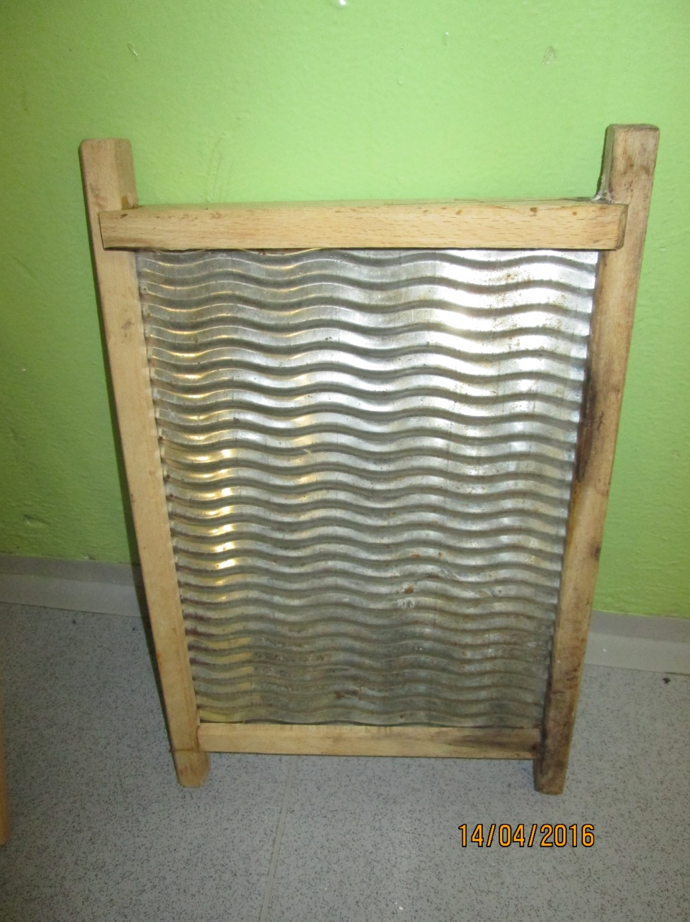

INVENTORY CARD – wooden object
Name of the  item | Slovak | Rajbačka
 | English translation
Inventory no. |  | 13.
Usage |  | For washing clothes
How it is made? |  | Carving from wood + steel
Tools that were used in making the item? |  | Chisel
Who made it? / Where do you have it from? |  | Carpenter
When was the item made? / Acquisition date |  | 18th century/2016
Name of the person who described / registered the item & Village & Date |  | Valér Jakubčo
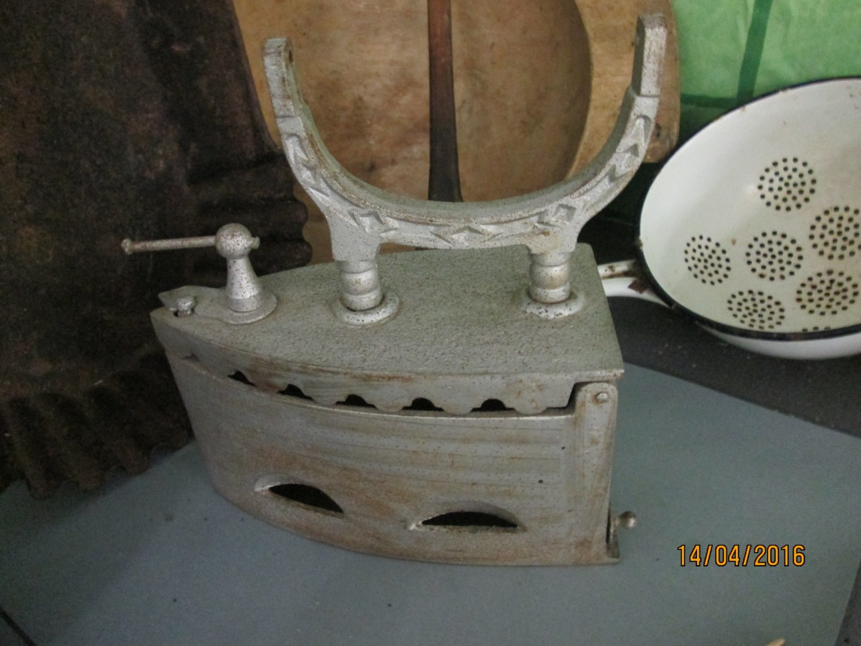

INVENTORY CARD – iron object
Name of the  item | Slovak | Žehlička
 | English translation | Iron
Inventory no. |  | 14.
Usage |  | For ironing clothes
How it is made? |  | Ironwork
Tools that were used in making the item? |  | Hammer, furnace
Who made it? / Where do you have it from? |  | Blacksmith
When was the item made? / Acquisition date |  | 16th century/2016
Name of the person who described / registered the item & Village & Date |  | Valér Jakubčo

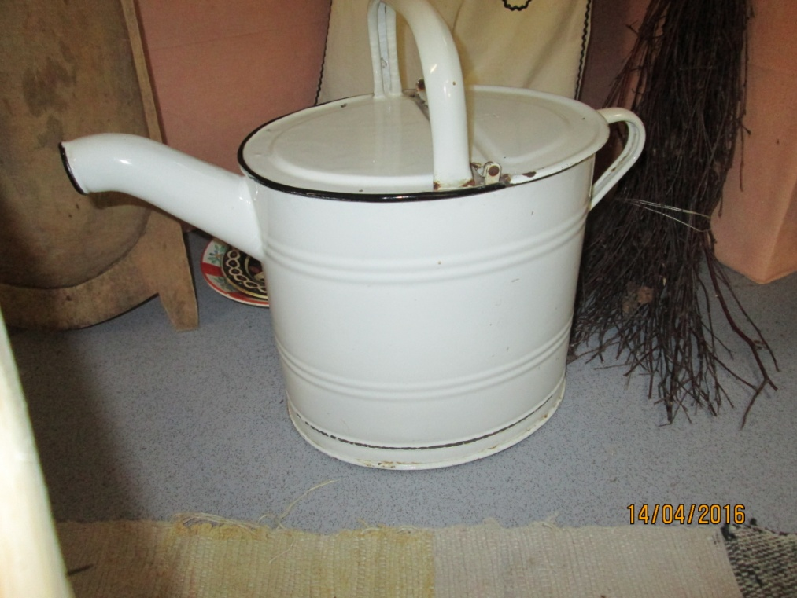

INVENTORY CARD – iron object
Name of the  item | Slovak | Polievačka
 | English translation | Watering-can
Inventory no. |  | 15.
Usage |  | Watering plants
How it is made? |  | Ironwork
Tools that were used in making the item? |  | Hammer, furnace
Who made it? / Where do you have it from? |  | Tinker
When was the item made? / Acquisition date |  | 18th century/2016
Name of the person who described / registered the item & Village & Date |  | Valér Jakubčo

