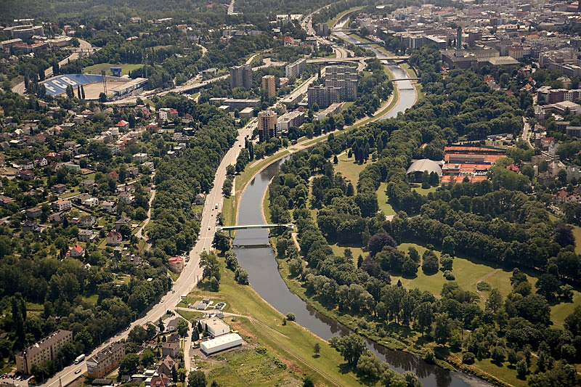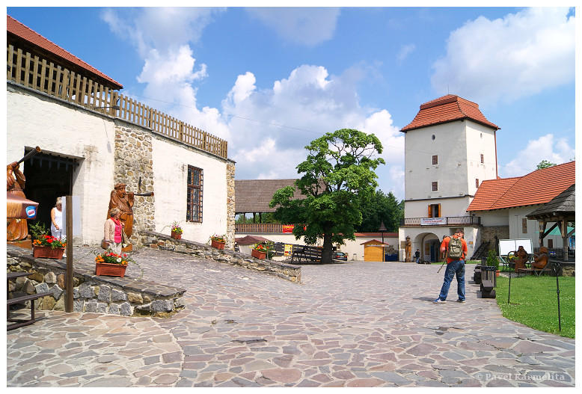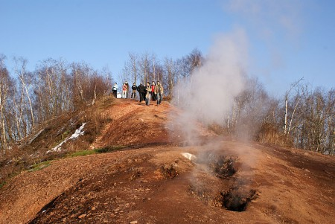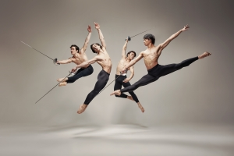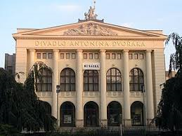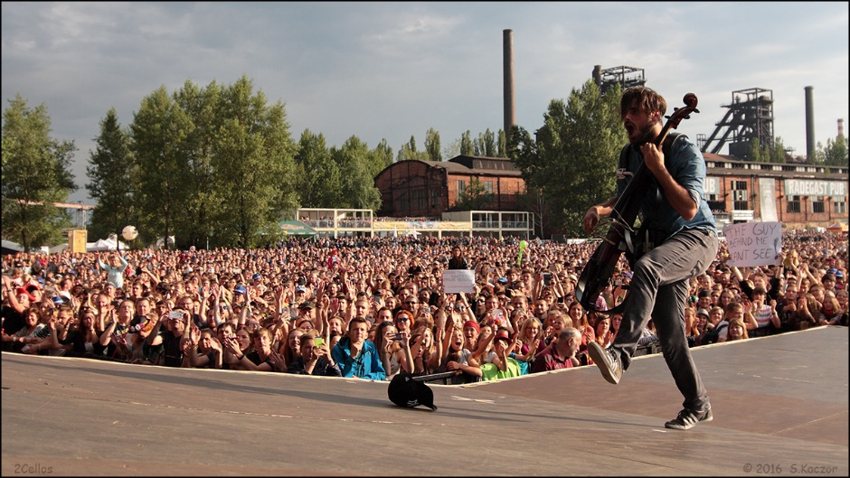**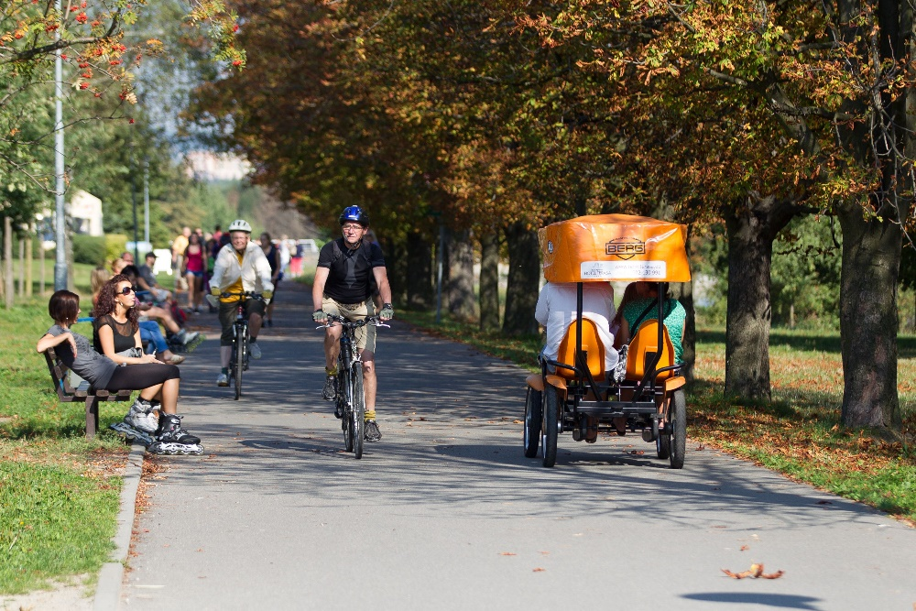 Explore the city of**

**COLOURS OF OSTRAVA**   
a festival of multiple genres like rock, jazz, metal, pop, folk, electronic, blues and many more.

It’s the biggest festival   
in Czech Republic.   
Come during July 17th and 22nd to **enjoy the unique atmosphere and music from all over the word**.

**„HILL“ EMA – 315 m.a.s.**

**Take a walk** to the hill built by people, consisting of tonnes of rock from coal mines about 1920.   
It still works. Thanks to inner temperature you can see   
(and also smell) white clouds.

Lovers of history can visit   
**SILESIAN OSTRAVA CASTLE,** that was built in 13th century.

**THEATRES**

are **worth to visit**. Our theatres, plays and actors are award winning. If you like classics, see The Bartered Bride by czech composer B.Smetana and ballet lovers shouldn´t miss the world premiere of The Three musketeers.

Explore the city  
 its **parks and banks of Ostravice river**   
**by bike or in-lne skates**. You can rest and   
have a barbecue, or in a hot day you can jump into the water.   
You will be surprised, how green is Ostrava!