Our region traditional songs
1st…“Čechomor-Gorale“
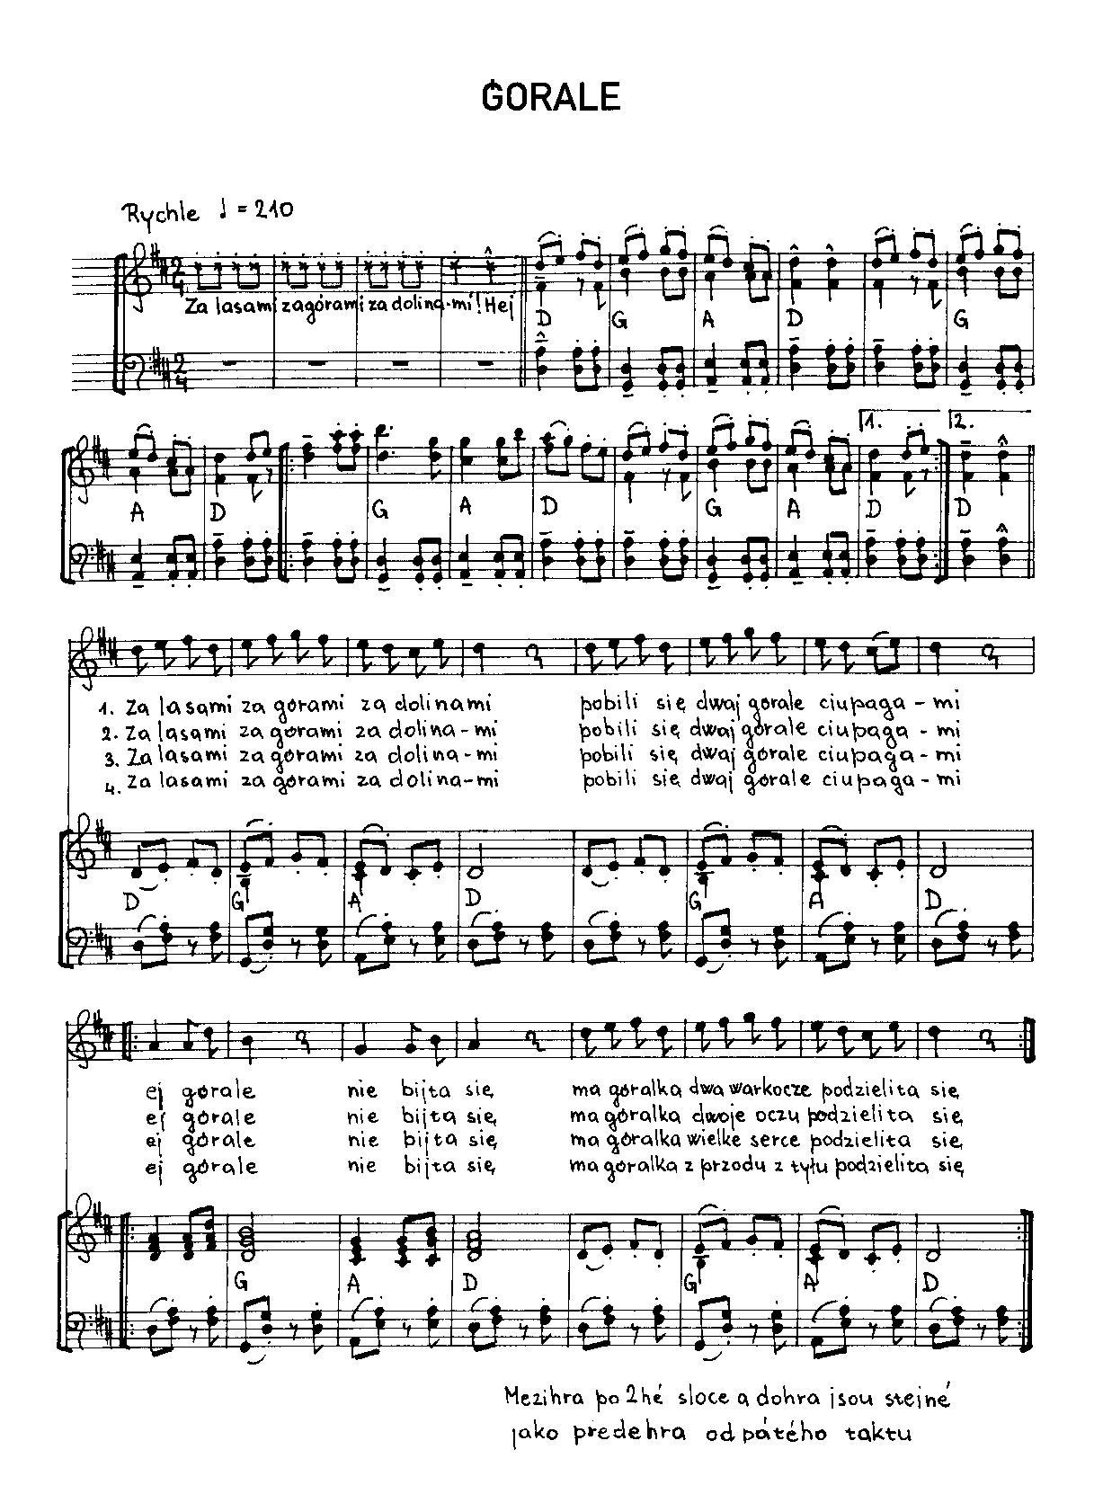
2nd….Za gorami,za lasami
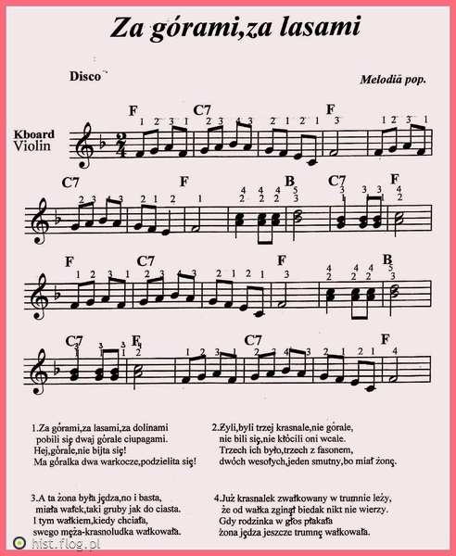
3rd….GÓRALU, CZY CI NIE ZAL

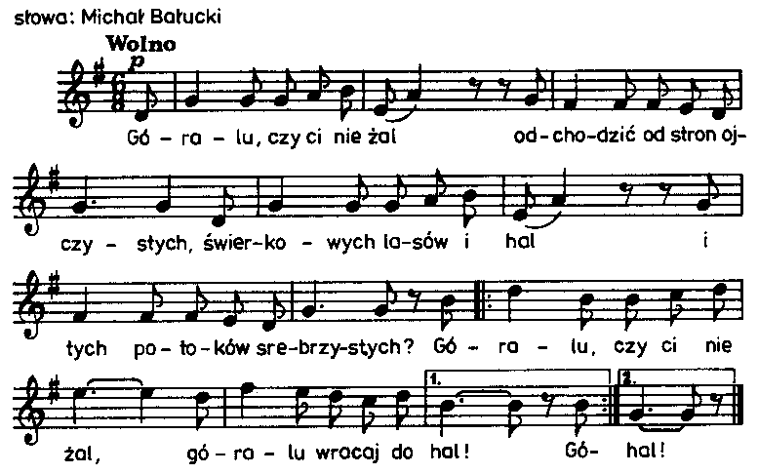

4th….Sto lat
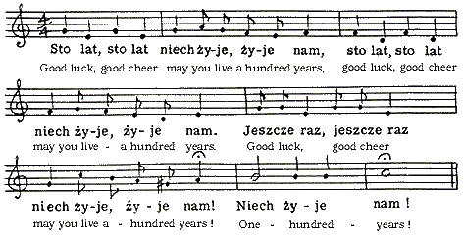

5th….Hej bystra woda
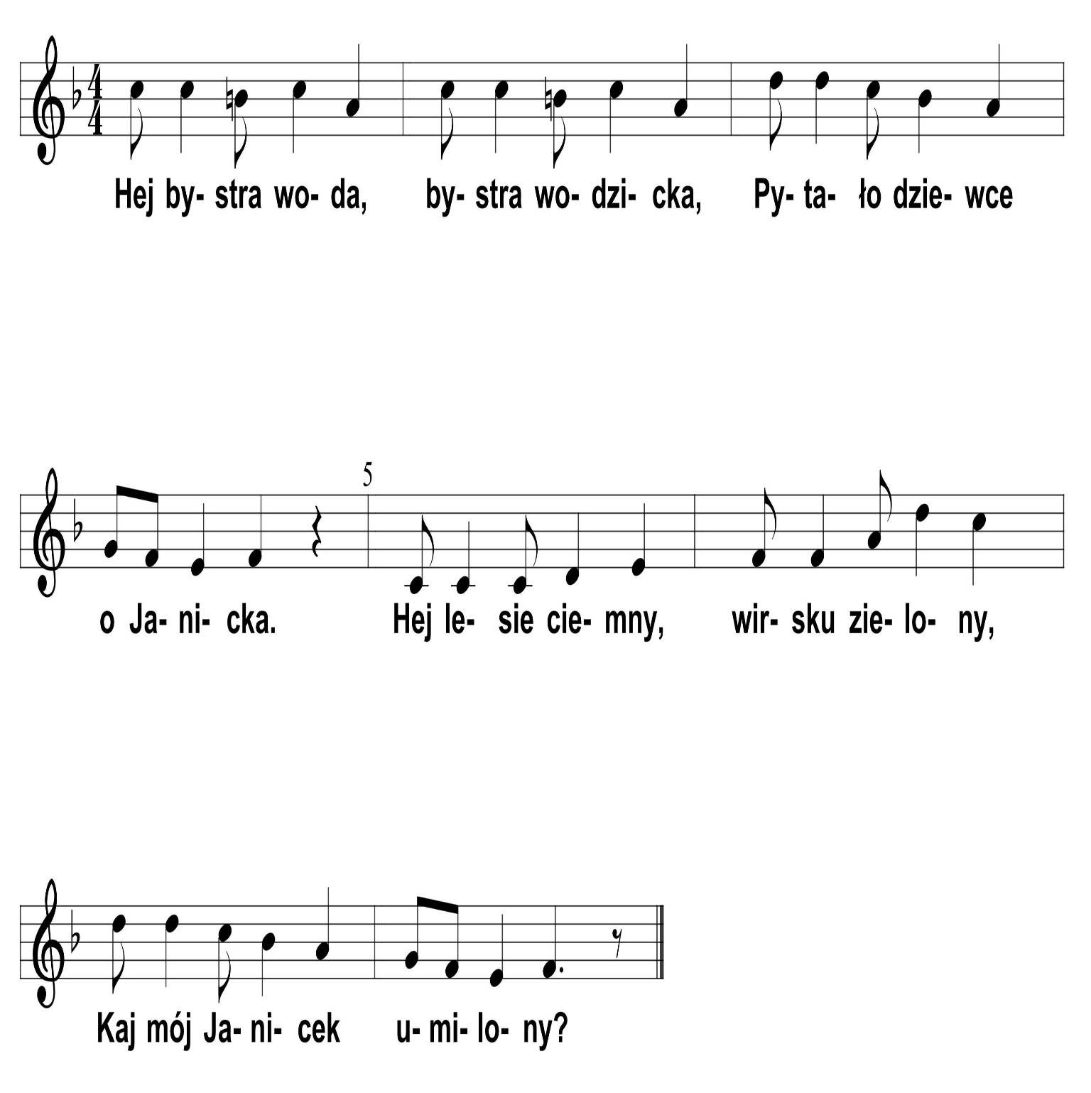

6th…hej sokoly
