POTTERY
A Lesson Activity – Pottery puzzle
1. Put together pieces of the given puzzle with your partner, then try to come up with the name of the pottery decoration pattern, glue the puzzle into your exercise book and colour it with its typical colour!

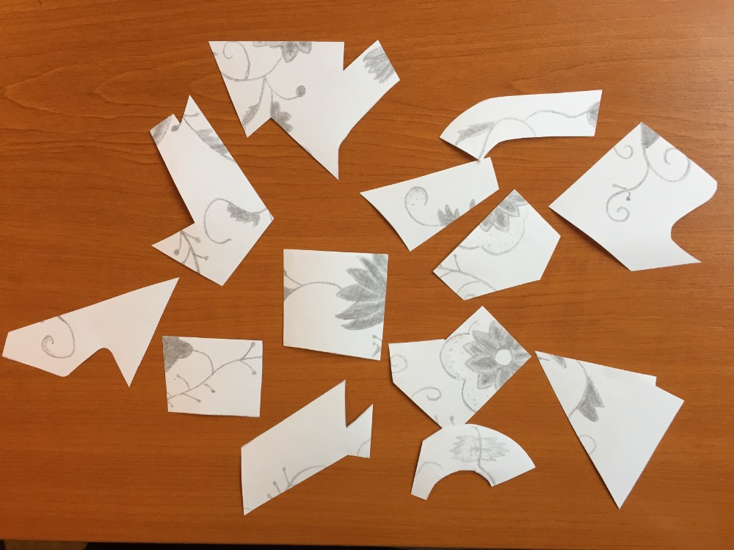

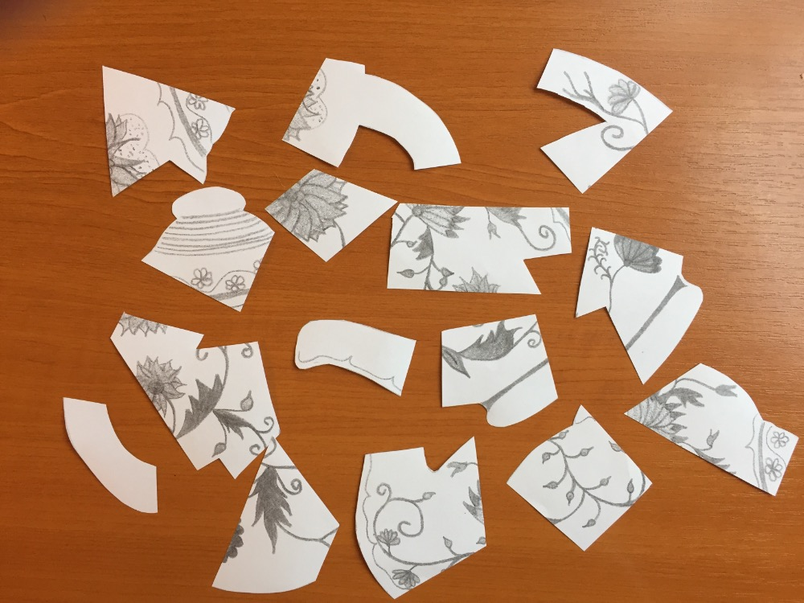

B Lesson Activity – Pottery decorating
1. Choose a shape of a pottery object and decorate it with the typical Czech pottery pattern, the so called “Cibulák“ – “The Blue Onion pattern“

