WOODEN OBJECTS
A Lesson Activity – Getting to know the wooden objects
Match the names of the wooden objects to the definitions and the pictures and then discuss with a partner if those objects are still used nowadays.

1. Spinning wheel
2. Nutcracker
3. Sieve for flour
4. Hand plane
5. Butter churn
A) - used to sifting flour
B) - used for opening the nuts
C) - used shaping wood
D) - used for spinning the wool
E) – used for converting butter into cream

a) 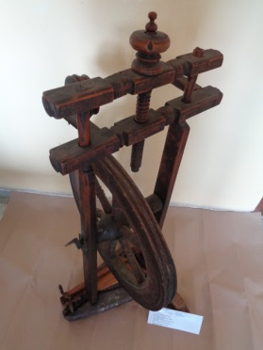 b) 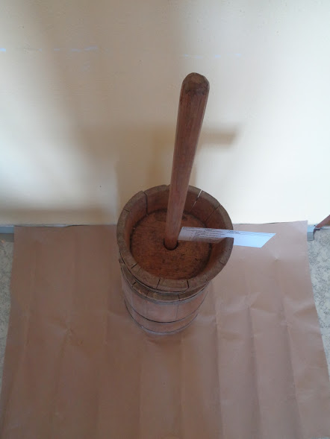 c) 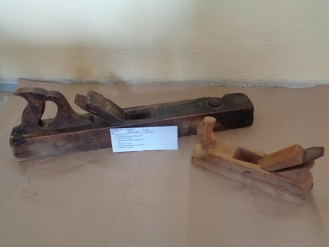

d) 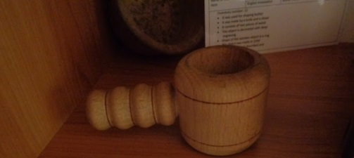 e) 