Kamenitý
Detailed characteristics of the place:

The object of the cottage Kamenitý was completely renovated and newly equipped. People lived in this once "idyllic place" with pastures and in very difficult living conditions. During the German occupation, the school at Kamenitý was left to its fate. The school was reopened in 1954. The former director, Jan Korzenný (the father of the regional historian), managed to make the necessary reconstruction thanks to the help of a number of local people. In the course of time, more and more people moved from Kamenitý and the school had to be closed in 1973 because of a small number of pupils. Nowadays it serves as a place for rest and some refreshments for people who love to hike in the Beskydy mountains.

Source: http://www.chatakamenity.cz/?page_id=2
http://www.javorovy.cz/cs/chata-kamenity

Used sources:
Author + the name of the book
Link of the website

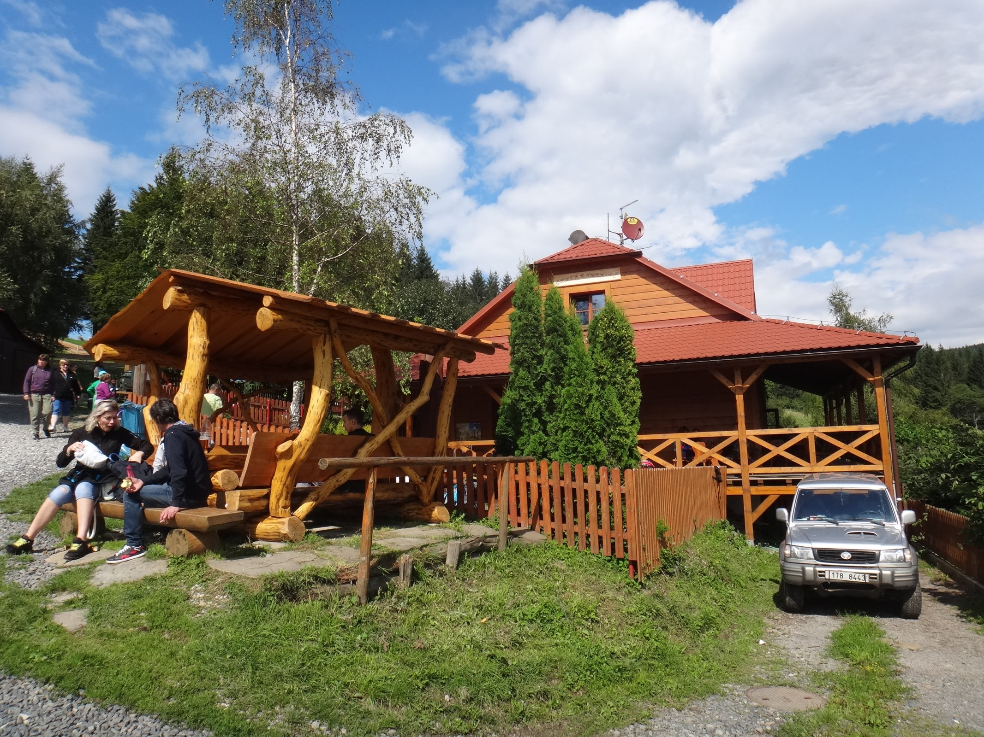

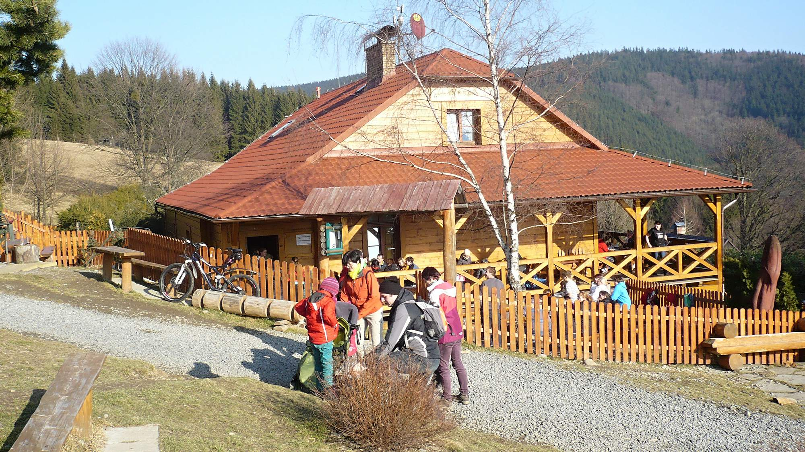

Basic characteristic:
A) Today it´s a restaurant.
B) Earlier it was a school.
C) It´s the most popular chalet in the Beskydy mountains.
D)It is located in a quiet part of Dolni Lomna.
E) Made of wood

Viac info nájdete na www.nazovwebstranky.doména
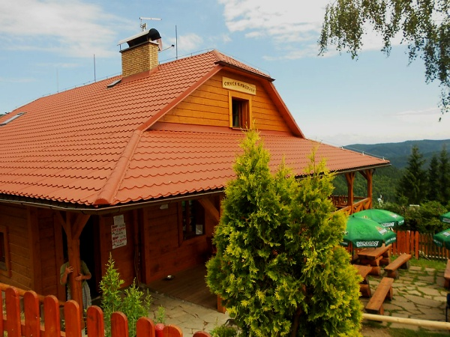

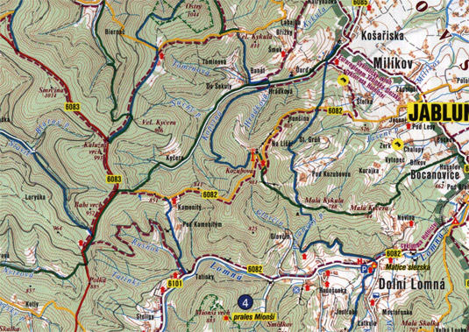
Availability:
Tuesday, Wednesday, Thursday, Sunday 09.00 - 18.00
Friday - Saturday 09.00 - 20.00

