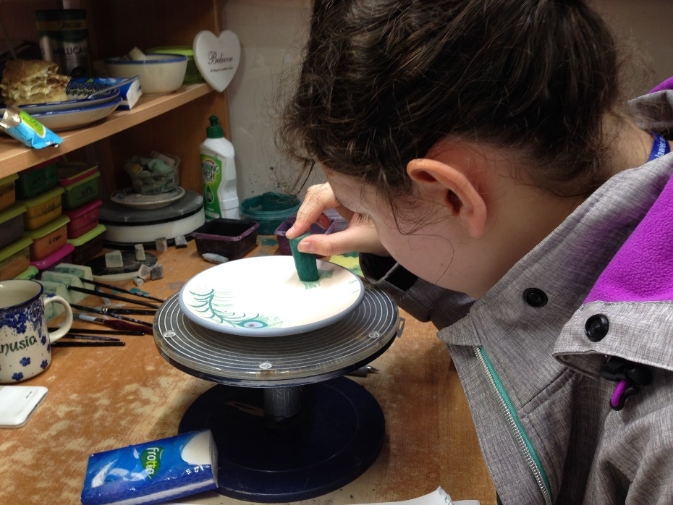
Mobility in Poland

See and read more on our school pages:
https://plus.google.com/114312677912814419096

