Blue cheese spread
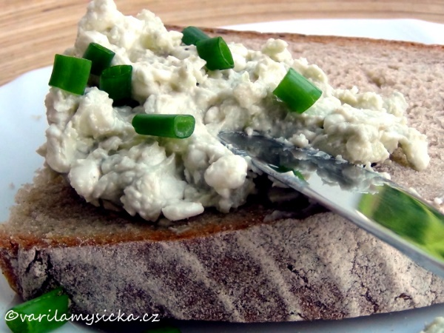
Ingredients:
1 spread butter
1 blue cheese
a piece of butter
chives or other culinary herbs

Procedure:
- Put the spread butter into a bowl.
- Grate the blue cheese coarsely or make it crumble with your fingers.
- Mix the ingredients.
- Pour in the melted butter and mix.
- Put the spread on sliced bread or roll.
- Decorate with chives or other herbs.

