**Have a fun and learn**

In this interactive exposition aimed on physics, math and chemistry you can **try a** **gyroscope**, which can raise the pressure up to 5G!

You can also take part in a **science show**.

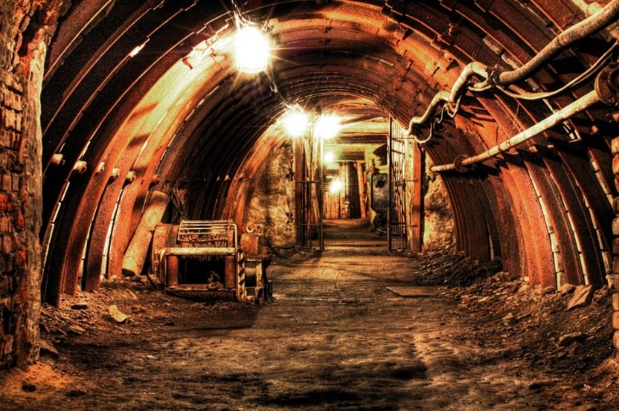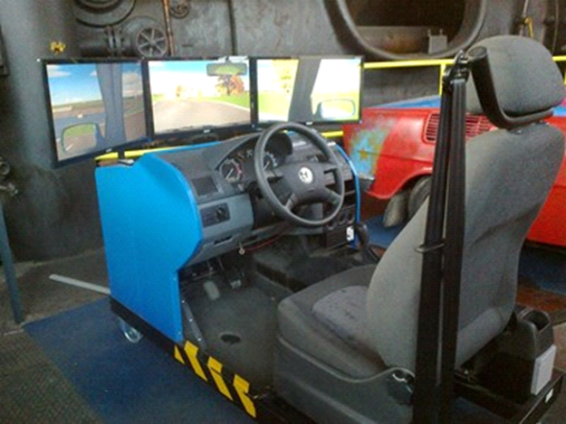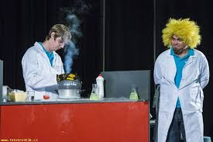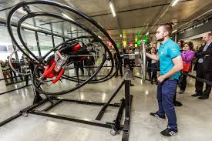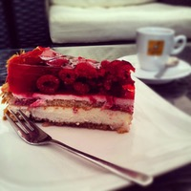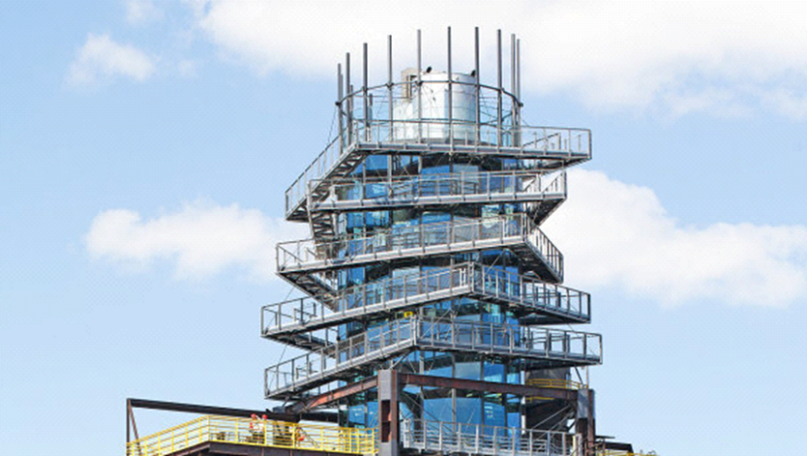[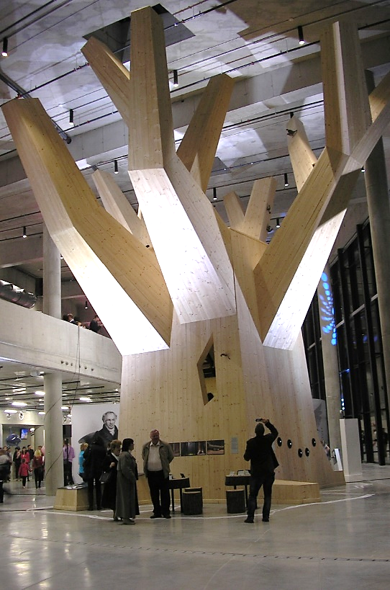](http://www.google.cz/url?sa=i&rct=j&q=&esrc=s&source=images&cd=&cad=rja&uact=8&ved=0ahUKEwiQ4N7EptjTAhWhAJoKHQFgBGwQjRwIBw&url=http://studiumartium.cz/jiri-pelcl-nejvetsi-brzdou-je-obvykle-clovek-sam/&psig=AFQjCNHKJQbcMdaSNf3-qlehvzn1XYXpIA&ust=1494058148352670)**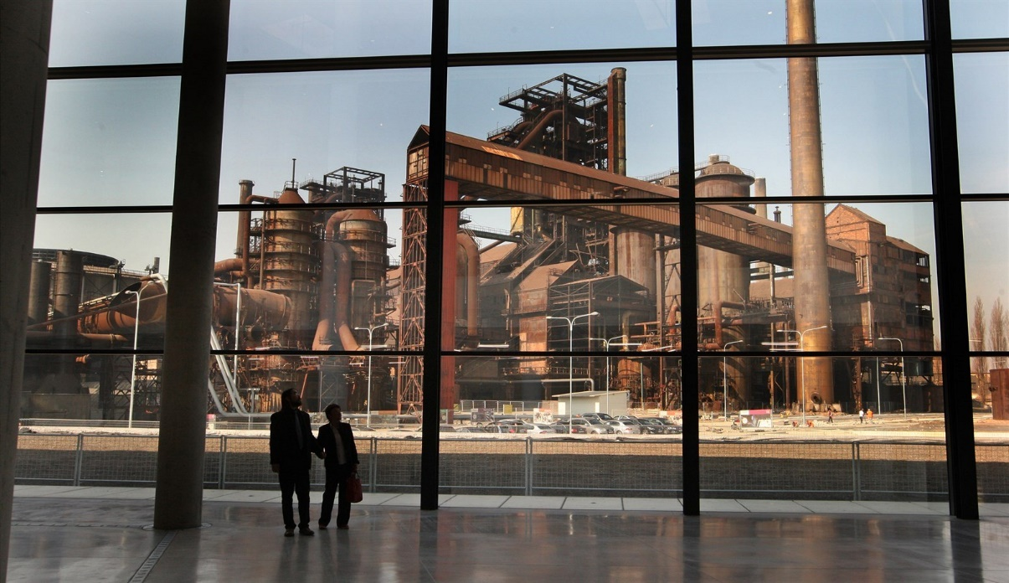in Science and technology centre Dolní Vítkovice**

**Experience miner´s feelings** down the pit in a real coal mine

**Try a car trainer** like in a driving school!

Climb a Bolt Tower (built on the blast furnace of Vitkovice).

**Enjoy lookout** with   
a cup of cofee or „recharge“   
in nearby refreshment.

In the past, coal was processed and melted in this area.   
Now, it is a European cultural heritage site (UNESCO) and becomes modern centre of culture, music and science.

In the **World of Nature**, you can climb a tree and **learn about birds** in Czech Republic.  
 Also, you can **try hunting a fish using a sonar** like a dolphin.