The Czech Republic
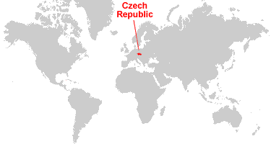
Geography: The Czech Republic is divided into 14 self-administrating regions. 5 regions are in Moravia or Silesia and 9 are in Bohemia. They have much to offer - beautiful nature, countless historic and cultural monuments. They also offer a wide range of cultural and sports activities. You can find there several universities and important industrial factories in the Czech Republic.

Prague
Prague is the capital city of the Czech Republic. It has more than 1,200,000 inhabitants.
One of the oldest European universities is located in Prague – Charles University, which was established in 1348. The Czech Polytechnic, which dates from the 18th century, is also an important university. The metropolis attracts visitors to it´s numerous historical monuments.
Language: The Czech language belongs to the group of West Slavic languages. From another perspective, Czech is an inflectional language, which means that the words “inflect” (their endings change). Because of that, it is a very difficult to learn.
Gastronomy: It is said that Czech cuisine is not the healthiest. However, from this aspect it does not differ so much from other Central European cuisine. It is related to German and Austrian cuisine. Meat is one of the most important ingredients in Czech cuisine. Pork, beef, poultry, rabbit and deer are used. Fish are mainly freshwater, chiefly carp, less frequently trout or pike.
Gravies and dumplings are Czech specialities. Gravies usually incorporate cream, butter and flour. There are many types of dumpling, for instance bread dumplings, potato dumplings or dumplings stuffed with smoked meat and even fruit. Soups are also popular in Czech cuisine as well as sweet pastries.
Beer is an excellent accompaniment to Czech cuisine. Czech beer is world famous and has a long tradition. Czechs consider it a national drink. The best-known beers are Pilsner Urquell and Budějovický Budvar. Grapes are also grown in the Czech Republic, mainly in South Moravia. White wines in particular frequently receive awards at international competitions.
The bittersweet Becherovka liqueur, which is made in the spa town of Carlsbad, is also a popular souvenir with visitors to the Czech Republic.

Famous historical figures:
Karel IV. - A Czech King and Roman Emperor.
Saint Wenceslas - The Czech Premyslid Prince, patron of the Czech lands, a martyr, a figure whose tradition played a very important role during emancipation of the Czech state and the Premyslid Dynasty within the terms of Christian Europe.
Bedřich Smetana - One of the greatest Czech music composers. Today he is mainly known for his symphonic cycle Má vlast (My Fatherland) and operas Libuše and Prodaná nevěsta (The Bartered Bride).
Jan Amos Komenský - A Czech theologist, philosopher, pedagogue, school and education system reformer, writer, the last bishop of the Unity of the Brethern.
Antonín Dvořák - A famous Czech composer, one of the founders of Czech modern music, together with Bedřich Smetana.
Johann Gregor Mendel - Darwin’s contemporary, discoverer of the basic laws of heredity, monk and also the abbot of the St Thomas Augustinian Monastery in Brno.

Used sourses:
http://www.czech.cz/

¨

Worksheet:
- The Czech republic is situated in:

- The Central Europe
- The Eastern Europe
- The Southern Europe

- Fill in the right information:

The capital city of the Czech Republic is ……………………….The most famous Czech university got its´ name after king………………………….. One of the most important ingredients in the czech cuisine is …………….……………The names of two czech famous composers are……………………………….. and ………………………………..
- Connect pictures with names of the famous Czechs:
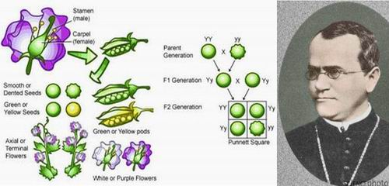
- 1 - Jan Amos Komenský
2 – Gregor J. Mendel
3 – Saint Wenceslas
B)
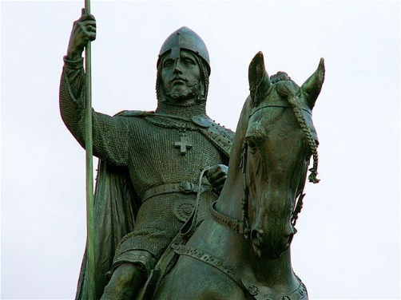

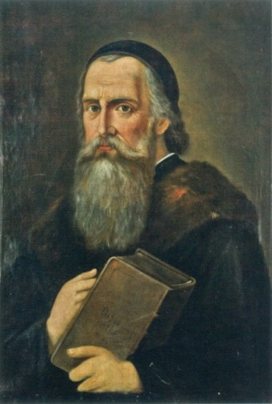
C)

