Non- baked summer cake
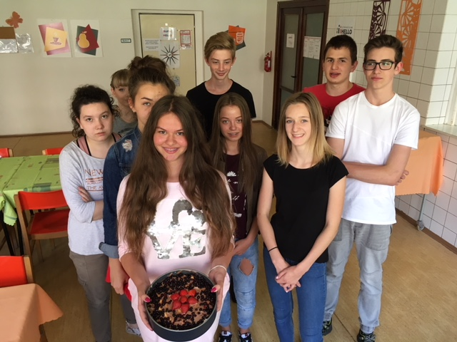
Ingredients:
- 1 piece of butter (250 g)
- ½ litr of milk
- 2 packs of biscuits
- Cocoa
- Puding powder
- 2 spoons of sugar
- 1 piece of cottage cheese (250 g)

Procedure:

- Prepare a puding from milk and puding powder. Let it cool down.
- Prepare a cream. Start with butter, add sugar, then cottage cheese and finaly gently mix in puding.
- Put the bottom of cake form biscuits. Cover them with seasonal fruit.
- Apply 1 ply of cream (half of ).
- Cover again with biscuits and fruits.
- On the top apply second half of the cream (you can add cocoa before).
- Put to the fridge overnight.
- Serve and enjoy!

