TRADITIONAL

ZEMPLIN

COOKBOOK

collected by Mrs. Jana Vajsová
recepes translated by Diana Dančíková (8b), Filip Barabaš (9c) and Natália Zelenaková (9a)

Bryndzové halušky

Ingredients
2 medium potatoes
1 cup of flour
1 tea spoon of salt
150 g smoked bacon
125 g bryndza

Instruction
Grate the potatoes and place in a bowl. Mix flour and salt with potatoes until you get a thick, sticky dough. Add salt to taste.

Boil enough water in a large saucepan with 2 tbsp of salt.
Then form the dumplings with a knife or teaspoon on wooden platter and thrown them into the bubbling salted water– boil the dumplings a little.
When the dumplings are done they will float on the surface of the water. Pick them out with a strainer, rinse with cold water and mix with bryndza.
Cut up little pieces of smoked bacon and fry them. Then put the fried bacon pieces on top of the meal.

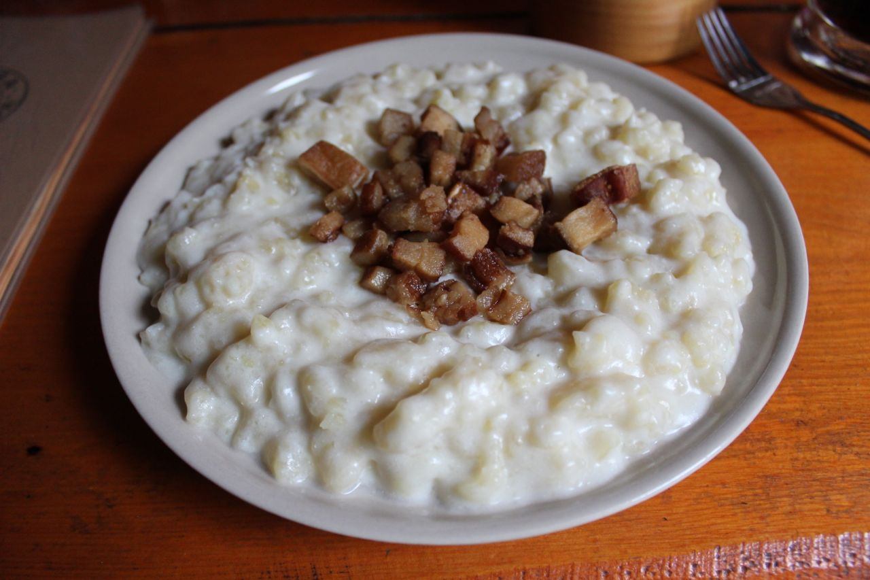

Bobalky with poppy seeds

Ingredients
500 g flour, plus more for dusting, 1 sachet (7 g) of dried yeast 1/2 teaspoon salt
1 1/2 tablespoons granulated sugar about 250 ml milk, 1 egg
For poppy seeds:
200 g greated poppy seeds, 100 g sugar, water, oil for greasing baking trays

Instructions
Put all the ingredients for the dough (with a half of milk) into a large bowl and knead the dough (about 10 minutes).
Cover the bowl with a clean table cloth and let it rise for 1 hour in a warm place. Divide the dough into small parts and let them rise sitting on the worktop for about 1/2 an hour.
Pre-grease 2 baking trays.
Preheat oven to 220˚C. Cut off a piece of a doug, roll out or pull it out to about thick log, then cut it into 1 - 2 cm long pieces. Throw the pieces directly onto the baking sheets. Don't let them to touch one another. Let bobalky rise for another 15 minutes.
Bake in the oven for 10 minutes or until golden brown.
Put bobalky into a bowl. Sprinkle with poppy seeds and sugar, then pour over some water. Bobalky are done when all the water is absorbed, sugar is dissolved and bobalky are completely soft and evenly coated in poppy seeds.
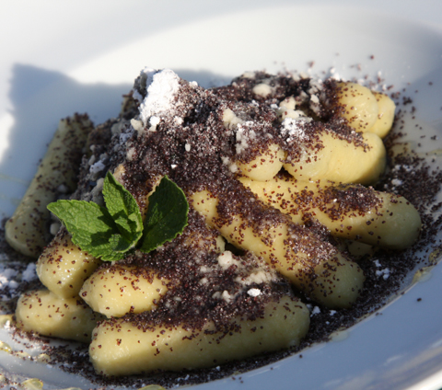

Kapustnica

Ingredients

sauerkraut, garlic, black pepper, caraway seeds, bay leaves, dried mushrooms, onion, pork, sausage, red pepper,

Instructions
Put water and sauerkrat to a large pot. Add a garlic, an onion, black pepper and caraway seeds, two bay leaves and dried mushrooms. Also add smoked pork cut into small pieces. Cook for about 40 minutes. Just before cooking add some spicy smoked sausage. Also add some crushed red pepper and boil 2 minutes.

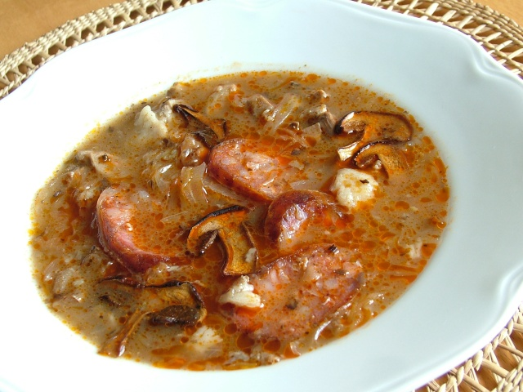

Lokše

Ingredients

6 potatoes, cup of flour, butter, salt

Instructions

Cook the potatoes with their skin, grate them and put into a bowl.

Then add about a cup of flour and salt and prepare a smooth non-sticky dough. Put it onto a floured board, and form into a roller. Cut into the same pieces slices. Then roll each one into the pancakes 2 mm thick. Roast on a dry pan on each side. Grease one side with some butter.It is great with roasted duck or goose.

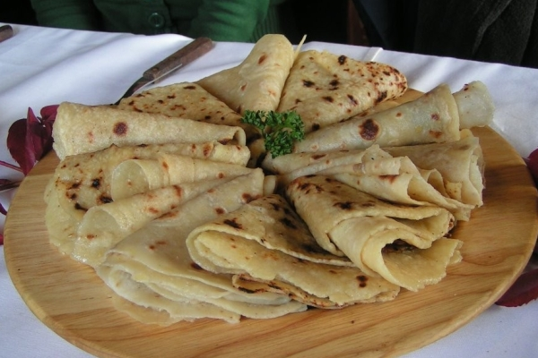

Bryndzové pirohy

Ingredients

about 2 potatoes, some 2 cups flour, one egg, salt, bacon, bryndza

Instructions

Start by cooking few potatoes. Add about a cup of flour, one egg and about a tablespoon of salt. Mix everything together by hand. Form the dough into a loaf and place it onto a dusted board. Dust top with flour to prevent the pin from sticking. Roll out to an about 3 millimeters thick pancake. Then take a drinking glass and cut out circles. Top each circle with a teaspoon of stuffing (bryndza, cottage cheese, jam, boiled potatoes, sour cabbage...) Fold the circle over and pinch the seal closed with the tip of your fingers. Place pirohy into the pot of boiling water. Pirohy are ready when they float to the top. Scoop them out using a large strainer. Put fried bacon bits on the top of pirohy. Finally top pirohy with sour cream.

