Legends

Teaching activity – “Krkonošské pohádky” or The Rűbezahl stories are very famous legends about a folklore mountain spirit, Rűbezahl. The stories are popular mostly among little children in the Czech Republic. Each story comes with a moral. Look at the comic strips from one of the stories and:

- Put the pictures in the correct order!
I. _____ II._____ III. _____ IV. _____ V._____ VI._____
- Think of the name for the story!
- Discuss the moral of the story with your partner!

A.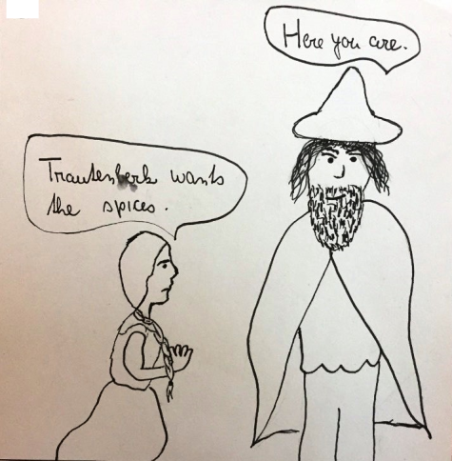 B. 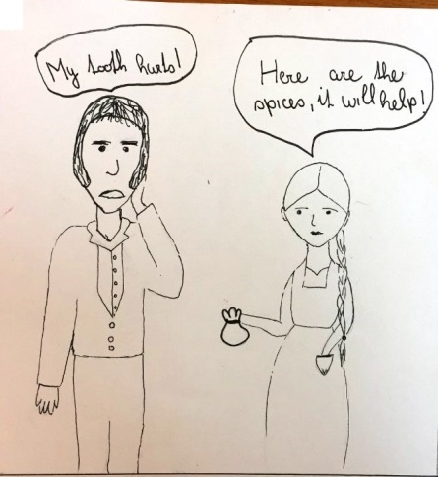 C.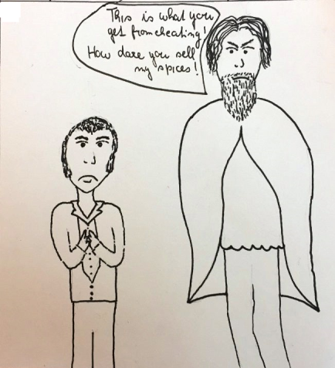

D. 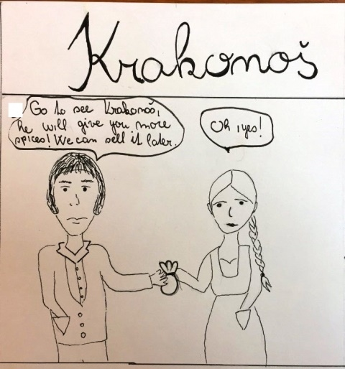 E.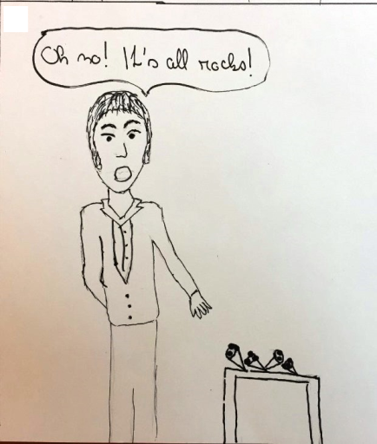 G. 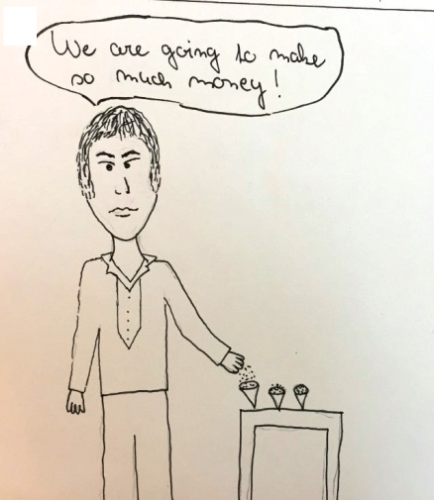

- Read the story and check your answers!

The Rűbezahl from Návsí – How Trautenberk wanted Rűbezahl’s spices

The legend tells the story of Rűbezahl, a folklore mountain spirit, Trautenberk, a greedy master, and Annie, Jakub and Hajný, all of them Trautenberk´s servants. This short part is called „How Trautenberk wanted Rűbezahl´s spices“.

When Trautenberk has a toothache, Annie offers her grandma´s magic spices to him. Suddenly, it relieves his pain and he orders his servants, Jakub and Hajný, to pretend that they are ill. When Annie sees it, she must go and find Rűbezahl and ask him for magic spices. However, Rűbezahl knows that Trautenberk wants the magic spices to make money out of its sale and keep it for himself. So he gives Annie what she wants and sends her home.

At the end, Trautenberk has a toothache again and Rűbezahl comes to his house to give him a warning not to thrive on people´s misery. When Trautenberk stops his bad behaviour towards people, Rűbezahl will finally relieve his pain.

