**DISCOVER SURROUNDINGS OF OSTRAVA  
FOR HISTORY, NATURE AND MUSIC LOVERS**

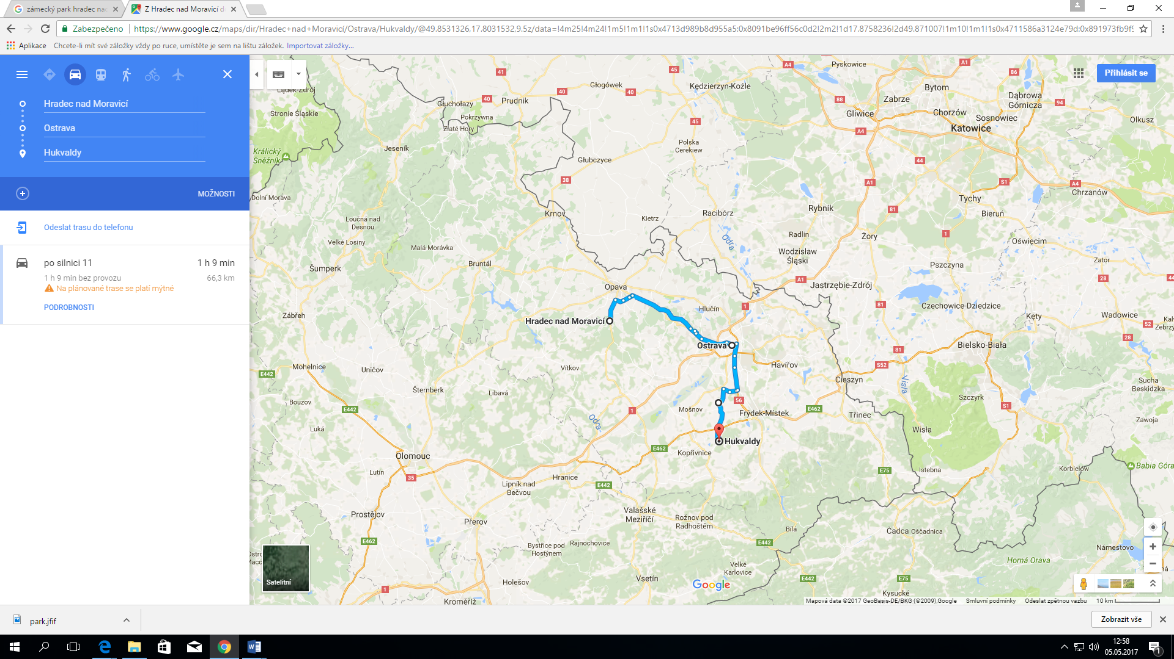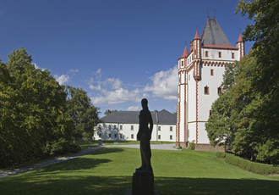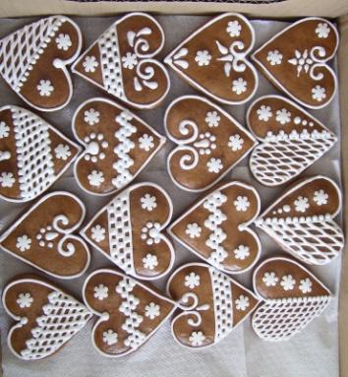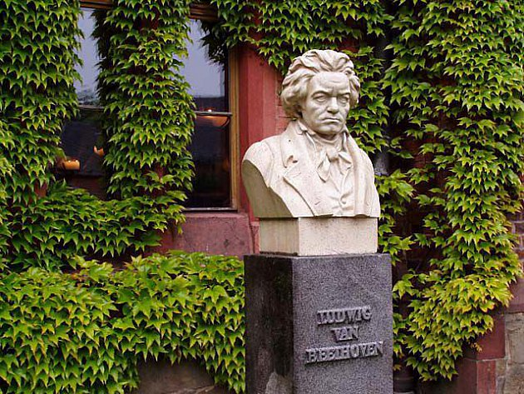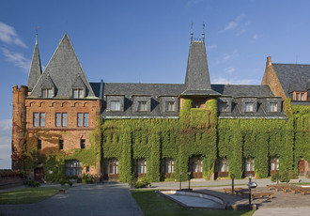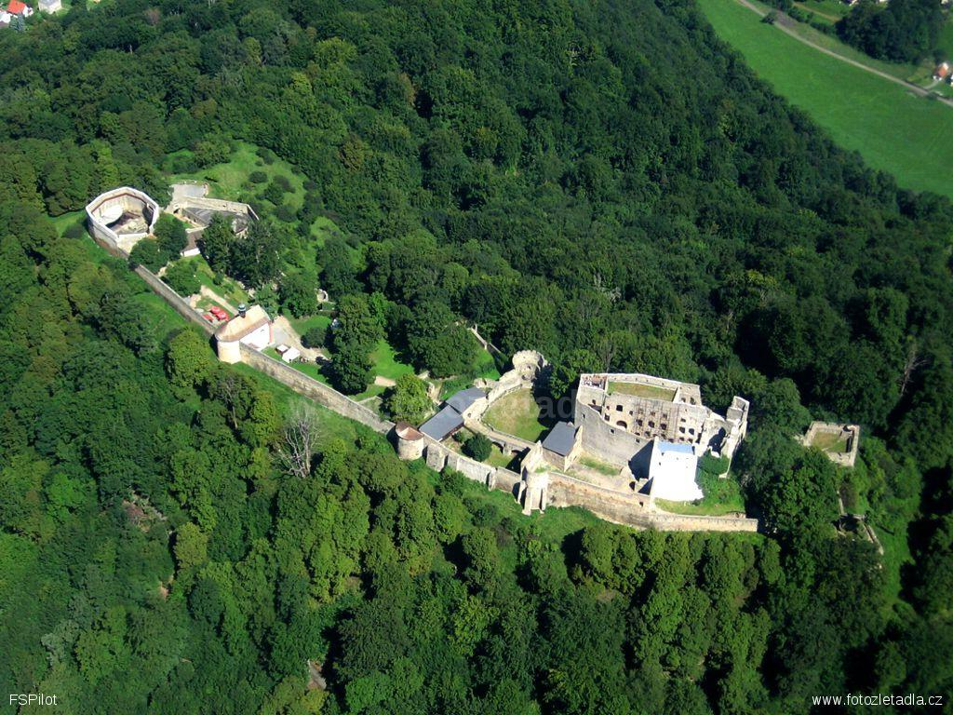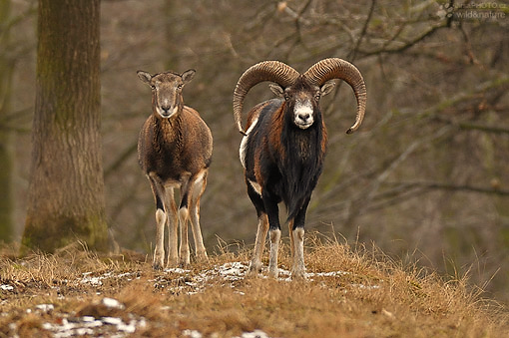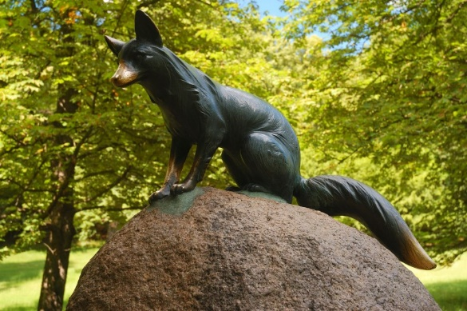**Hukvaldy** – a small village (25 km from Ostrava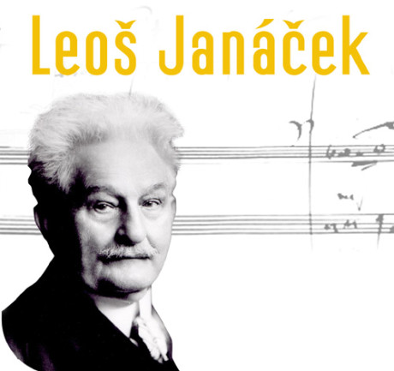) **Hradec nad Moravicí** – historical town (35km from Ostrava)

**Taste   
a gingerbread** made and sold here.

Take a guided **tour around one   
of the top attractions** in our region.

**Relax in its beautiful gardens and forest park** that were often visited by famous composers like Beethoven, Mozart or Liszt.

**Visit Beethoven’s Hradec** - a festival of classical music held every year in the beginning of June.

Statue of fox -   
to remember one of Janacek´s operas called „Fox Bystrouška“.   
**Touch** **the fox´s tail** and your wish will come true!

**Enjoy** **the largest ruins** of castle   
in Moravia.

Leoš Janáček – famous composer, was born here.  
**Visit** **his birthplace** and places where he found an inspiration for his music.

**Observe** **moufflons and fallow deers** in one of the oldest deerparks in the Czech Republic.