Results of the questionnaire to the Erasmus + project:
United through cultural and natural diversity - learning through research

In the diagrams below you can find the graphical results of the questionnaire taken by the local community and the pupils from the Czech Republic, ZŠ Návsí which has been carried out during January, February and March of 2016.

- What is you gender?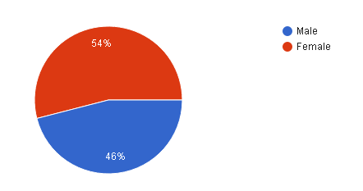
- How old are you?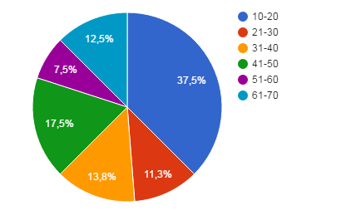
- Where do you live?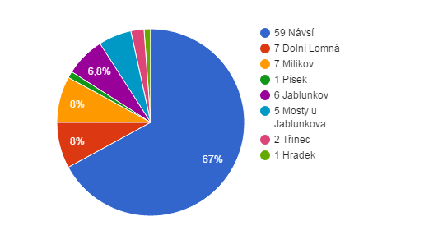
- What was the most commonly used material in the construction of houses in the second half of the 19th century?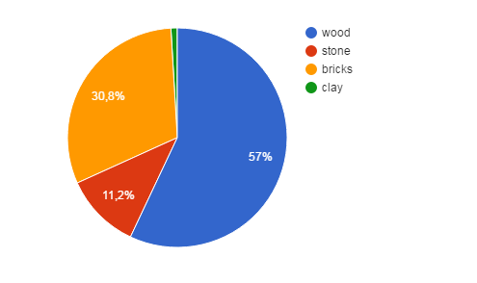
- What does “hoblík” serve for?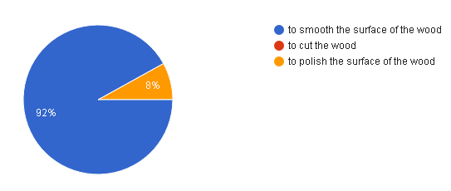
- Which material was in the past mainly used to make spoons, forks, plates, etc.?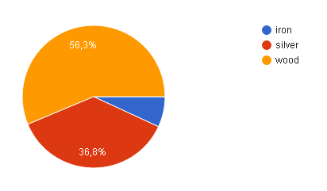
- What is an essential part of the final phase in pottery making?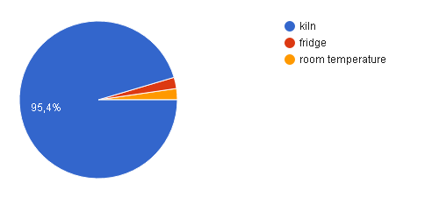
- What can be healed in “Lurdská” cave in Hrčava according to one old legend?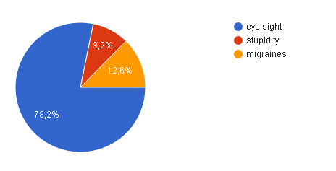
- Which combination of the three folk costumes is typical of “Těšínské Slezsko”?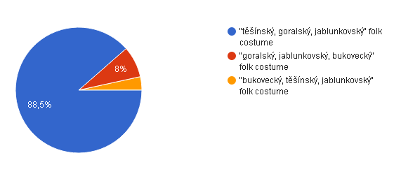
- What is the original meaning of the word “Jackové“?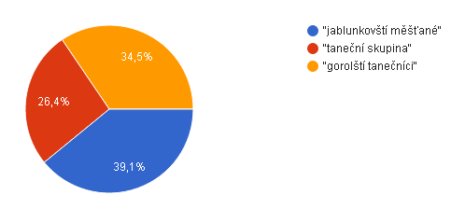
- Until the beginning of the 20th century there was only a Polish school in Návsí. The Czech school was opened in: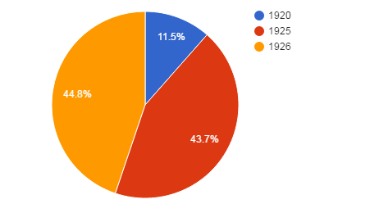
- Which traditional musical instruments were used in our region in the past?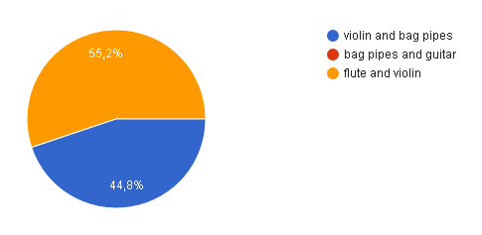
- Which time of the year is “šmiergust” connected with?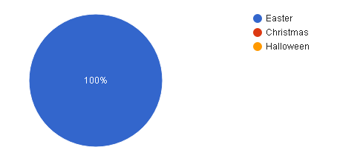
- Which season of the year is the “Dožínky” fest connected to?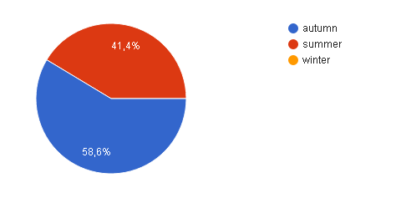
- What was “Morana” believed to keep away?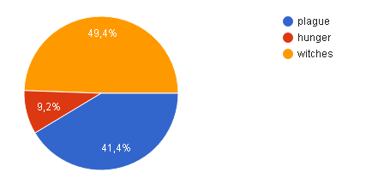
- In which century was Návsí founded?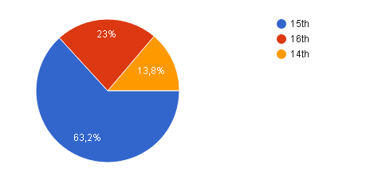
- What was the surname of Návsí´s first mayor?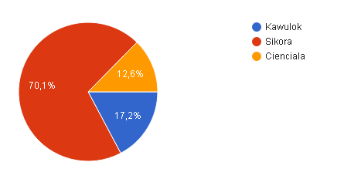
- What is the official meaning of the word “Návsí”?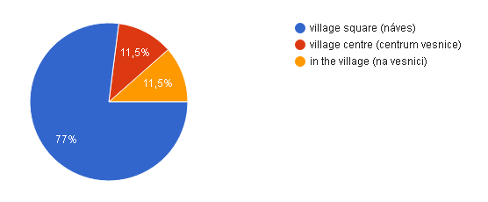
- What is “Zamčiska”?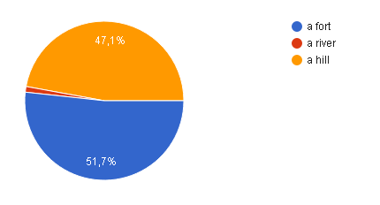
- The Evangelical Church in Návsí, built at the end of the 18th century, was originally made from: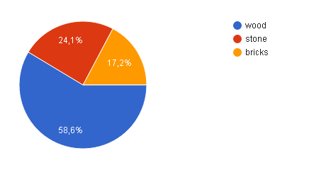
- Until the beginning of the 20th century there was only a Polish school in Návsí. The Czech school was opened in: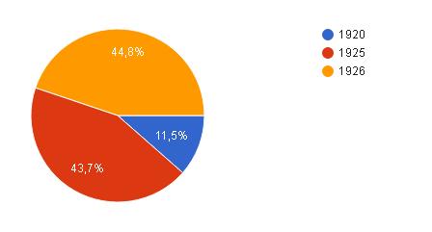
The symbols of Návsí are: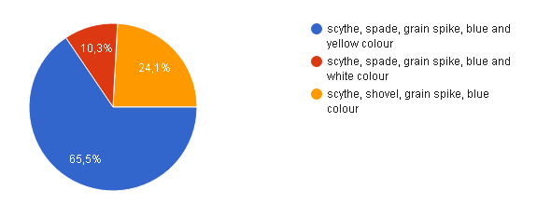

- Which dishes are an essential part of the traditional Christmas dinner?
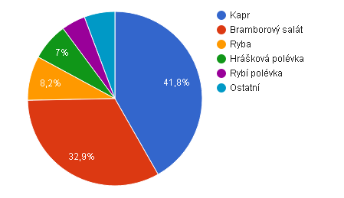
- Which food is a typical part of the traditional Easter holidays?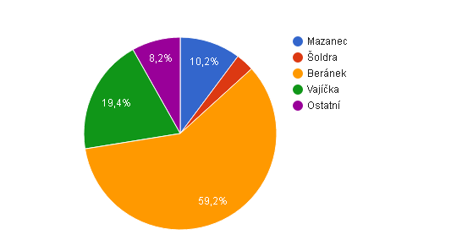
- What dishes are typical of our region?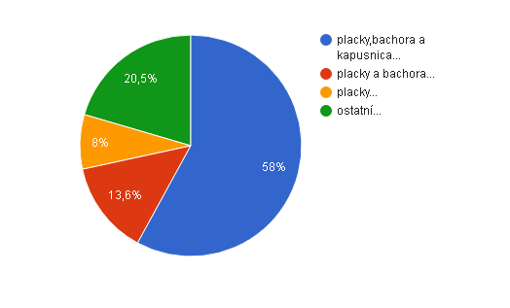
- Give three most commonly used crops and vegetables which were used in our region when preparing traditional dishes in the past.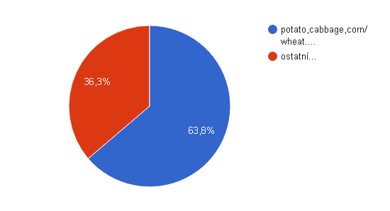
- Who was Belko? 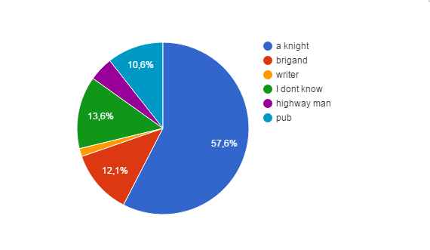
- How many amphitheatres are located in the “Matice slezská” site in Dolní Lomná? 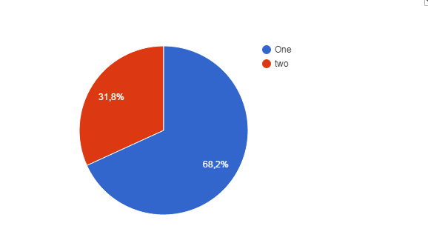
- What is “roubená stavba” made from?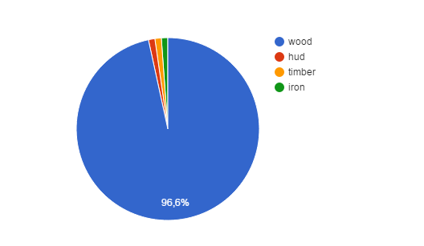
- The life of which saints do our national legends talk about? Give at least two.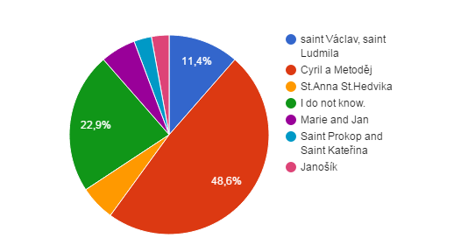
- Give the name of the mutual author of the following legends and folk tales: “Libuše, Praotec Čech and Bruncvík”.