Beef sirloin with cream sauce - recipe

Ingredients:
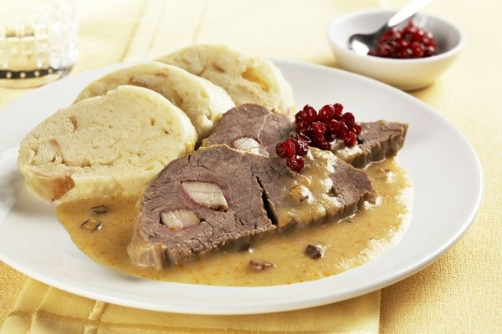
750 g beef sirloin or beef back
50 g bacon, cut in narrow bits
salt, ground pepper
2 bigger carrots
150 g celery root
1 parsley
1 bigger onion
5 peppercorns
3 allspice balls
3 bay leaves
pinch of thyme
150 g melted butter
juice from 1 lemon
2 tablespoons of flour
250 ml cream for whipping if necessary, milk for diluting
sugar
lemon cut in slices
cranberry sauce

How to make it:
- Clean the meat. Put in the bacon. Then sprinkle with salt and pepper.
- Clean the onion and cut it in small cubes, clean the vegetables and grate it.
- Put the vegetables into the pan, place the meat on top, add spices, sprinkle with lemon juice and pour over the melted butter. Cover with a lid and letit rest in the fridge overnight.
- The next day baste the meat with some water and stew in the oven, covered with a lid. When tender, take the meat out.
- Remove the spices from the sauce, especially bay leaves. Bring the sauce slowly to boil. Add mustard, two tablespoons of flour and stir fry. Pour in the cream and boil gently, mixing from time to time.
- Finally press softened vegetables in the sauce through a sieve. Season with salt, add some lemon juice or some sugar.
- Divide the meat into portions, put it back in the sauce and heat up.
- Serve with bread dumpling, slice of lemon and cranberry sauce.

