Fish spread
Ingredients:
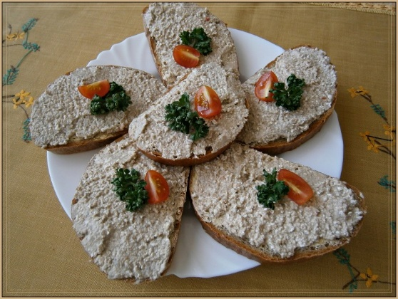
1 spread butter
1 tin of sardines or other fish
2-3 pickles
½ an onion
1 teaspoon of mustard

Procedure:
- Put the spread butter into a bowl.
- Pour off the extra oil from the tin of sardines and add them into the bowl.
- Add finely cut pickles, onion and then mustard.
- Mix everything thoroughly.
- Put the spread on a bread or roll, and decorate.

