STUDENTS WORKSHEET

Based on Classroom activity from www.jpl.nasa.gov/edu/teach/activity/graphing-sea-level-trends/

Graphing Sea-Level Trends
Using a variety of methods, scientists have concluded that global sea level – the average height of the sea surface across the planet – has varied substantially throughout history, especially in response to the ice ages. In recent history, starting around 7,000 years ago, sea level became quite steady, but over the last century, it’s been rising. Global tide measurements from tide gauges suggest the global sea level rose approximately 3.4 millimeters (0.13 inches) per year over the past century. How do we know sea level is rising? Sea level is measured by monitoring stations on the shoreline and at sea. Satellites also collect data on the height of the sea level.

Student task
In this activity, you will use sea-level rise data to create models and compare short-term trends to long-term trends. You will then determine whether sea-level rise is occurring based on the data.

Procedure
With NASA data

1. This 130 years of sea-level measurements have been divided into 20 data sets for examination

http://www.jpl.nasa.gov/edu/pdfs/sealevel_graphing_monthly_GMSL_data_csv.zip

2. Each of you will be examining 1 data set (approximately 6.5 years).
Data is contained in two columns. The first column contains date information. The first four-digit number is the year. The following four decimal places represent a percentage of the year that has passed in days, falling approximately on the middle of each month. Example:
1880.0417 = Jan 1880 (365 days x 0.0417 = 15.22 days = January 15)
1880.1250 = Feb 1880 (365 days x 0.1250 = 45.63 days = February 14)
1880.9583 = Dec 1880 (365 days x 0.9583 = 349.78 days = December 15)
The second column is the Global Mean Sea Level (GMSL) in millimeters, compared with the average level in 1990.

3. Open a spreadsheet and graph the data.

There are two methods for graphing the data, depending on which software program you are using. Google Sheets
- Highlight all of the data in Column A and Column B.
- Click the Insert menu and select Chart.
- In the Chart Editor window, click the Chart types tab.
- If not already selected, click Use row 1 as headers and Use column A as labels.
- Then select Line chart and click the Insert button.
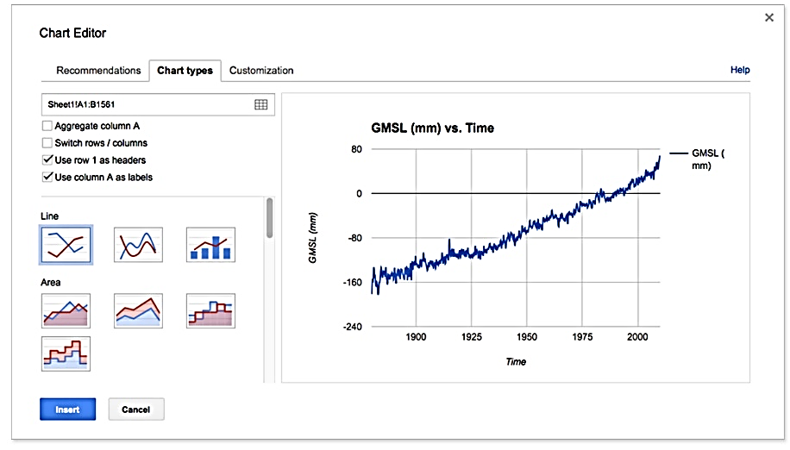
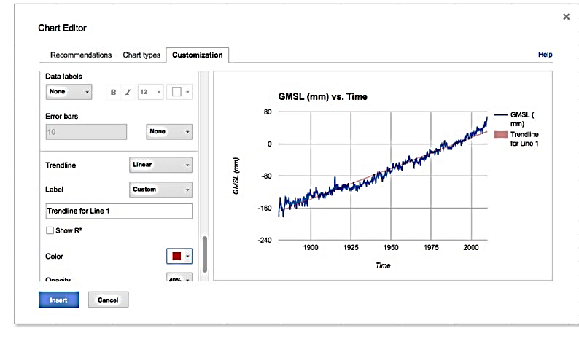
Microsoft Excel
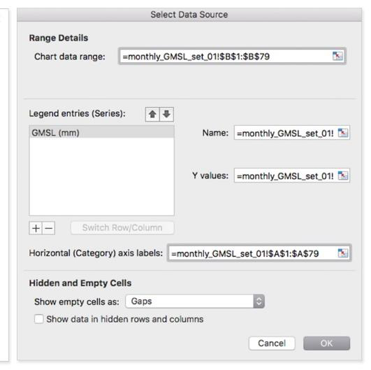
Click to select a blank cell outside of column A or B.
- From the Insert menu, click Chart and select Line (alternatively, select Line chart from within the Insert ribbon).
- In the blank chart area that appears, right click and select Choose Data.
- Click in the Chart data range box and select all of the data in Column B, including Cell B1.
- Click in the Horizontal (Category) axis labels box and select all of the data in Column A, including Cell A1 and click OK.
Note: Selecting data and creating a line chart by default will not display the data correctly. If students want to select data and make a chart, they should select the data and choose scatter plot. Data will be displayed correctly and can then be turned into a line chart

Or with ESA data

1. Search for sea-level measurements
http://cci.esa.int/data

2. Each of you will be examining data set for specific area

3. Open a spreadsheet and graph the data.

Then

4. You will make a determination about what you think is happening to the sea level for the time period.
(Optional: You can estimate or compute the slope of the line of best fit in order to justify their claim.)
Google Sheets:
Right click on the Line chart and select Advanced Edit.
Within the Customization tab, find the Trendline option, select Linear, and click Update.
Microsoft Excel:
Add a linear trendline. There are different ways to add trendlines, depending on which version of Excel is being used. Generally, clicking on the line chart and selecting the Chart Design or Chart Layout tab will provide options to add a trendline directly, or add chart elements, including trendlines.

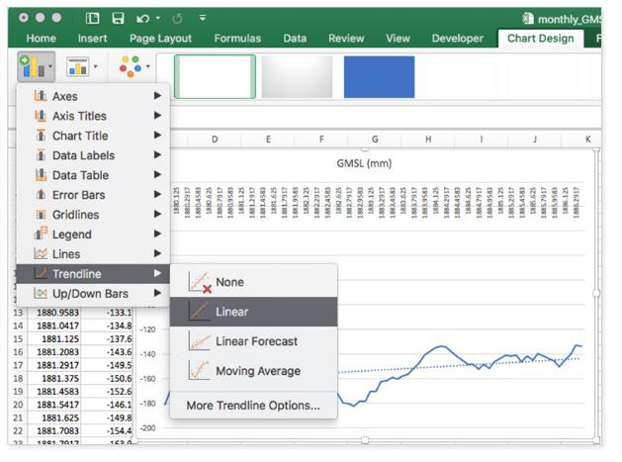

Answer the following questions:

What year and month does your data set begin? ___________________
What year and month does your data set end? ___________________
What is the global mean sea level (GMSL) at the beginning of your data set? ________
At the end? _________
What is the difference? _________
What does the GMSL indicate is happening to sea level across the span of your data?

Add a trendline to your data. Does the trendline agree with your visual assessment of the data?

If there is a discrepancy, why do you think that is?

