Reading for LIFE
2019-1-RO01-KA229-063065

First Semester: Tolerance & Non-Discrimination /Refugees & Migration

CHAPTER 1: FIGHTING DISCRIMINATION & INTOLERANCE
First chapter of the book with Superheroes, AKIRA & ROSE fighting Intolerance & Discrimination
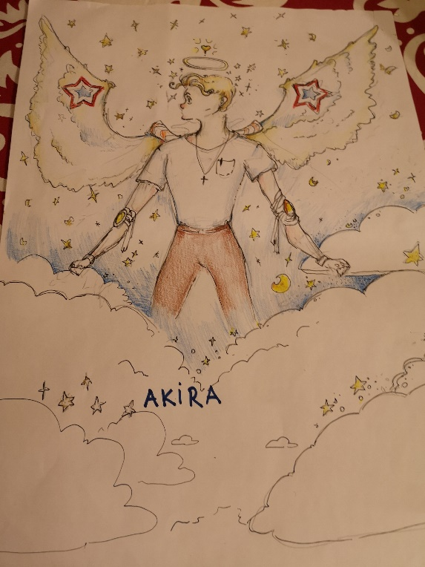

In the state of Alabama, Intolerance and Discrimination are planning to attack the Erasmus, because they try to reunite all the people and they want to split them.
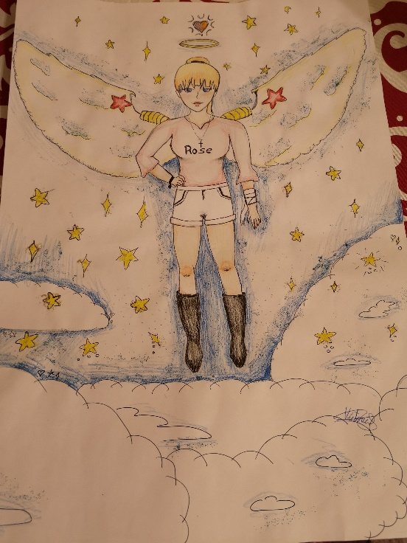
The first country being attacked was Portugal, they kidnapped different races and put them all together in their countries, then they shot glitter bombs, which created bareers between the countries.
Our 19-year-old heroes, Akira and Rose found out and they tried to stop them.
The bad ones hacked televisions and Internet, that’s how the heroes ound them. They wanted to stop them, so they went there to fight Discrimination and Intolerance. Once they arrived, Discrimination and Intolerance ran away keep splitting people. The heroes lost them and the bad ones took Spain.
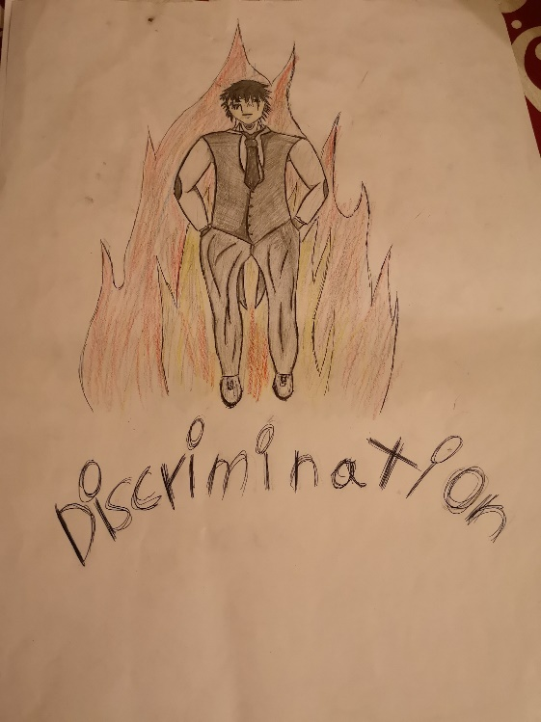

Akira and Rose followed to stop them, but they escaped again. Now, they left to Romania. There, Norway and Slovenia were waiting to help the heroes, so they wouldn’t keep splitting people.
In the end, the heroes caught Intolerance and Discrimination by throwing little metal balls on the ground in front of the evil ones, so that they fell, and the heroes caught them and threw them in jail.

"The European Commission's support for the production of this publication does not constitute an endorsement of the contents, which reflect the views only of the authors, and the Commission cannot be held responsible for any use which may be made of the information contained therein."

