Lesson about emotions:
You are the sunshine because ...
Library club (students 11 – 14 years)

Students will:
Develop the ability to find the positive qualities of classmates.
Develop the ability to recognize and express one's own feelings or emotions.
Get permission for a wide range of feelings.
Build a vocabulary to name your feelings.

Keywords:
Feelings, emotions, emotional, expressing, communicating, managing, identifying, naming

Materials needed:
cut out paper circles (for each student one)
cut paper strips (sun rays)
crayons
glue

Introductory motivation
A conversation about how we feel, how we know how to find positive character traits in ourselves and our classmates, how positive or negative criticism affects us.

The main part
Students first write their name on their circle. Then they pass the circle forward and the classmate puts a ray on it, on which he/she writes a positive affirmation, praises the classmate, tells him/her which emotion prevails in him/her. The task is completed, when everybody comments on every sunshine.
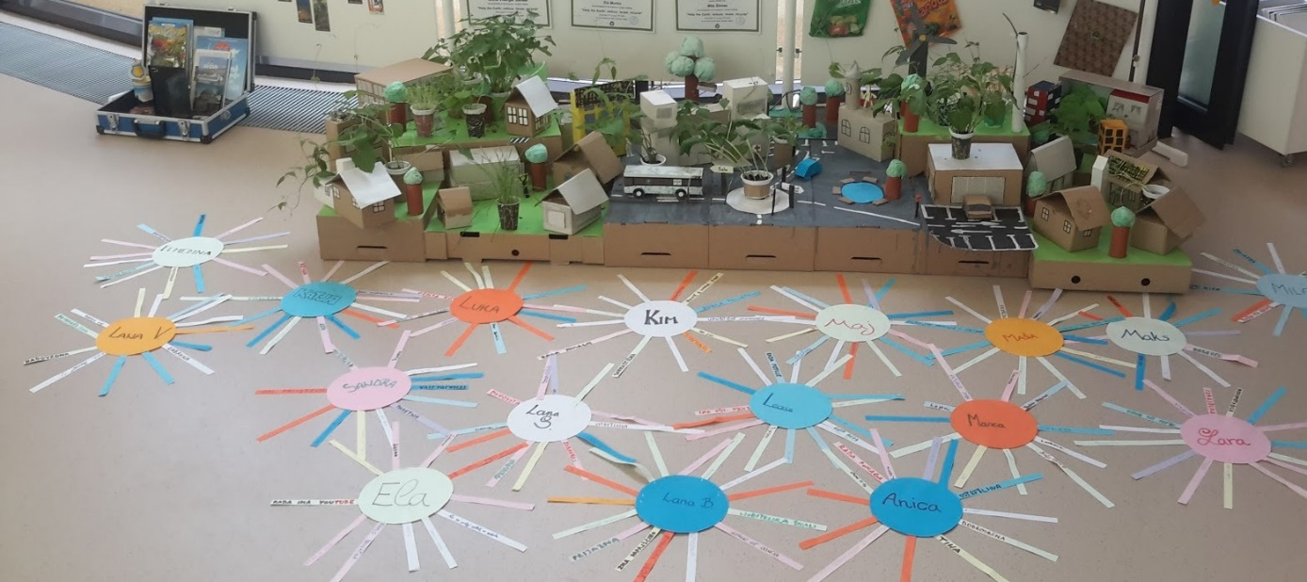
Conclusion:
Each student reads what is written in his sunshine and comments on what is written.
Analysis:
The learning unit is basically very simple, but an adequate properly guided conversation is needed so that students are tolerant, honest and, above all, positive at work.

