Tolerance lesson plan
Liceul Tehnologic Octavian Goga Jibou, Romania
Teacher: Melinda Nagy

Age group: 12-14
Aims of the activity:
1.) Integration of the interrelation skills, in order to develop personally and professionally
2.) Applying the principles of positive interpersonal communication;
3.) Demonstrating skills regarding tolerant behavior.
Values and attitudes:
-Respect and self-confidence
-Recognition of the uniqueness of each person;
-Receptivity to the emotions of other
-Valorization of interpersonal relationships
At the end of the activity, all participants will be able to:
-define the term "tolerance";
-to identify the causes that cause intolerant behavior;
-to exemplify situations of tolerance / intolerance in the gear of interpersonal relationships, in the family, class, society;
-demonstrate appropriate behavior to tolerance / intolerance situations
Materials used:
-whiteboard, video projector, laptop, worksheets in ppt, online questionnaire, internet
Evaluation:
• Observation of participants during the debate
• Feedback offered through discussions with participants
• Interpretation of the online questionnaire applied at the end of the activity
Description of the activities:
Activity 1: Think of words that you can associate with tolerance.
Activity 2: Are the following statements True/False
Being tolerant means:
a) ... to be patient, indulgent with others, good to the others;
b)… to treat with kindness a person, a situation;
c) ... not to be understanding and not to endure the inconveniences caused by others calmly;
d)… to be a person who can forgive, can understand;
e)… to be respectful, to be affectionate towards a person;
f)… to accept people as they are and to understand their problems, that is, to be patient;
g)… to be right and to understand;
h) ... be calm, understanding, kind, patient, respecting yourself only
Activity 3: Identify which of the following situations do you consider to be tolerance or intolerance.
a) Pope John Paul II tried to unite people of different religions. He took a great step towards creating harmony between peoples.
b) During mathematics two students were playing, making noise. The teacher blamed me, calling my parents at school, treating me with indifference and mistrust.
c) I was travelling with my grandmother on a fast train. At one point an old woman came in. She sighed, saying, “They care only about themselves. When will the young people learn to be kind? ”Hearing this, some boys started laughing, smiling at the old woman who lived her life and had nothing to do on the roads, that they paid the ticket and -They are going to give her place. But one girl gave her the place, and the boys said with contempt: "Too much respect leads to nothing good."
d) Parents are always understanding with us. They go to grandparents every Saturday, and most of the time I don't go. And grandparents and parents are not happy about it. However, they have patience with me and do not tell me off, but they explain to me that it is not good what I do.
e) Getting on the minibus, I found that I had only 70pence in my pocket. But the driver allowed me to travel. I thought I was lucky.
f) One day, after lessons, I got in the minibus. It wasn't long before an old woman came in who wanted to sit down. I didn't give her the place because my legs hurt after the football game. I know I didn't do it right. I am ashamed.
g) On the football field of the school, students from the 5th, 6th and 9th and 10th grades were playing. The big ones chased the little ones, took the ball, insulted them, and they could not reproach them. Being helpless, the little ones gave up, leaving very sad.
Activity 4: Present a situation of tolerance and intolerance in your environment. Work in groups of 4 students.
*Activity 5: Xorg is a little different ... Imagine he is your new colleague. What would be your reaction?
*Activity 6: Try to replace the the word unacceptable with a positive one.
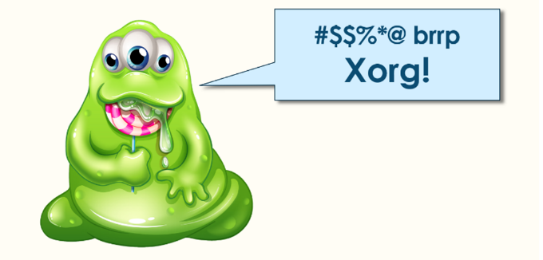
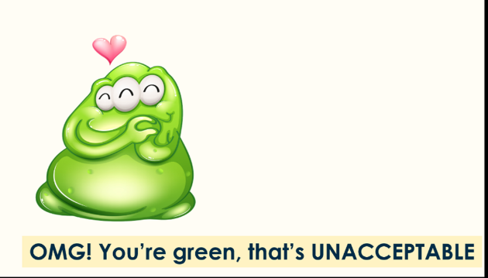
Activity 5 Activity 6

Activity 7: Online questionnaire about tolerance.
https://forms.gle/LBQacCnjfni2STrd6
Activity 8: Definition of tolerance on Twinspace.

*Activities 5 & 6 are taken from Selma Toolkit, https://hackinghate.eu/toolkit/

