  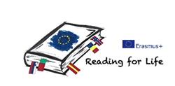 

Hello! I’m not a lost book! I’m a book on an adventure!

Take me home and read me, and then leave me here again for someone else to find me…

…and if you would like to talk books in your native language, or learn more Catalan/Spanish/English while reading, you can also take part in…

**🕮 Institut Consell de Cent Reading Club 🕮**

**Monday afternoons at C/ Carrera, 25**

**Info at the school or at 🖀 934 42 40 48**

   

Hello! I’m not a lost book! I’m a book on an adventure!

Take me home and read me, and then leave me here again for someone else to find me…

and if you would like to talk books in your native language, or learn more Catalan/Spanish/English while reading, you can also take part in…

**🕮 Institut Consell de Cent Reading Club 🕮**

**Monday afternoons at C/ Carrera, 25**

**Info at the school or at 🖀 934 42 40 48**