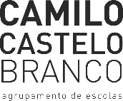
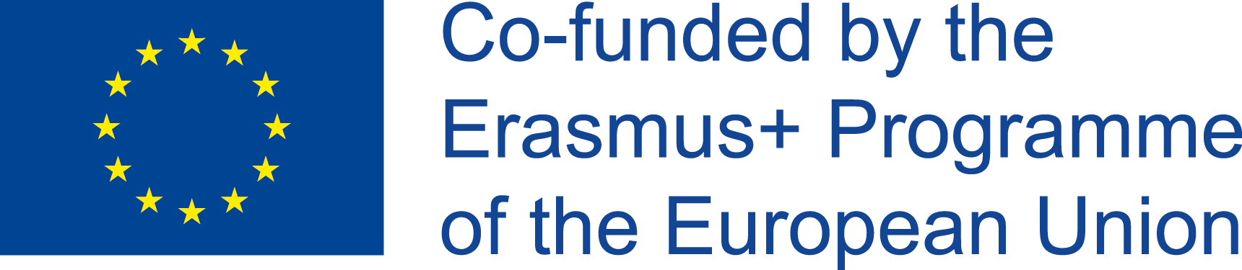

LOCAL YOUTH POLICIES AND PROJECT: AECCB-PORTUGAL
interview with the mayor of Vila Nova de Famalicão and the City Councilor
Questions

1st
According to data from the European Social Survey (ESS), 2019, young Portuguese participate politically less than most of their European counterparts when it comes to voting, but also in three "unconventional" forms of participation: boycotting products for political reasons, signing petitions and participating in demonstrations. What is your portrait of the political and civic participation of young people in Vila Nova de Famalicão?

2nd
What spaces/programs/platforms do the young people of Famalicão have at their disposal in order to have an active citizenship?

3rd
Knowing that the youth vote has decreased, but that in the last 20 years there was a generalized increase of the remaining forms of political participation, how did the City Hall of Vila Nova de Famalicão integrate the new forms of digital democratic participation to stimulate the democratic experience and the active citizenship?

4th
What strategies do you consider to be the most effective in promoting active citizenship among young people?
Mário Passos (Mayor of Vila Nova de Famalicão)

1st- The experience we have of youth participation is very good. We know well the local associative fabric and we know how involved our young people are in the most relevant issues for them, such as sports and the environment, education and civic participation, cultural dynamics and human rights. In a school, associative or sports environment, or on their own personal initiative, the young people of Famalicão have made their presence felt in participating in the construction of our collective future.

2nd- In Vila Nova de Famalicão we have created, over the last decades, a set of policies, projects, infrastructures and spaces so that young people can concretize themselves and find safe dimensions for the fulfilment of their dreams.
The most iconic is Casa da Juventude, a unique building at a national level and which aggregates a relevant part of the offer for the youth of Famalicão, with workshops, rehearsal spaces, auditorium, games space, study space, among many other valences. But almost all the working dimensions of the City Hall have projects and initiatives especially aimed at young people. From education to health, from sports to environment, from security to associativism, among many others.
Examples are the Municipal Youth Council, the support to youth associations and the support to young people through study grants. And we do so with the awareness that it is increasingly necessary to listen to young people and their needs. I myself have had the opportunity to spend time and time again with our young people, listening to their needs and ambitions in the first person, and bringing their positions to the decision-making process.

3th- There are sometimes contradictory results about the participation of young people in electoral processes, and this involvement is also different from election to election.
A very recent study by the Gulbenkian Foundation shows us how young people participate and are interested in participating, but they want to do so with their agendas, through methodologies that motivate them and with structures and issues on their agenda. That is why in Famalicão we are committed to listening to them, co-constructing their Municipal Youth Plan and offering spaces for participation that stimulate them and honor their efforts in our decision-making.
The pandemic has shown that even without face-to-face intervention spaces the activity can continue, and we can even reach more young people. I am convinced that hybrid models of participation are here to stay.

4th- The first strategy is the strategy of example.
Elected representatives have to keep their promises, listen to the people they serve and have proximity strategies that keep their action focused on the general interest of the communities.
On the other hand, it is fundamental that we maintain processes of structured dialogue and co-construction of policies with young people, bringing them into discussions and offering them conditions for participation.
And, also, the promotion and support to associativism, to community participation, to civic intervention, making them actors in the present and not only an asset of the future.

Sofia Machado Fernandes (City Councilor, responsible for: Family; Equality; Interculturality and Integration; Health; Road Safety; Transport and Mobility)

As a short introductory note, I would like to tell you that there are contradictory data regarding the participation of young Europeans in the construction and decision-making processes from their communities to the European institutions. Even so, it is consensual and should be an increasing priority, the creation of safe spaces for participation, the creation of structured dialogue processes with youth and the sharing of spaces for power and decision making i.e. sitting young people at the table in equal circumstances.

1st - response:
In Famalicão the civic and citizen participation of young people is relevant and with profound impacts on the construction of the famalicense community. From their participation in youth organizations and institutions, volunteering to their presence in the Municipal Youth Council, young people are called to participate in deciding the matters that matter most to them because it is their future that we are talking about.

2nd answer:
We have worked to offer them the spaces for participation and also to give them conditions, information, knowledge and skills so that they can have a relevant participation because it is not enough to give spaces, it is necessary that they are trained for participation. There is great diversity in the participation of young people in Famalicão, from education to youth, from health to culture, from the environment to sports, among others. The city council has available to young people, projects and activities, workshops, strategic plans and auscultation spaces where young people have a place and are called to the co-construction of processes and decisions.
3rd answer:
The younger vote has had different levels of abstention depending on the type of elections, but also on the discussion processes. Young people know how to participate when these conditions for participation are respected. Structured dialogue processes and projects based on non-formal education methodologies and based on the opinions and dimensions which are important to young people boost their participation. In the same way, the awareness that these processes really matter for the political decision and are not just matters of little interest, offers credibility to the processes and increases participation.

4th - The pandemic has brought online participation to the agenda, which now offers very good conditions for participation, but does not replace face-to-face events. Hybrid offers of participation will become more and more relevant. The war in Ukraine has reopened the discussion about Peace, Cooperation and the democratic construction of societies. I am sure that the key issues for young people will make them participate even more strongly and with conviction in the discussion and decision-making processes.

To conclude:
It is important that everything that is done for young people is decided with young people. May we all be capable of strengthening intergenerational dialogue for the cohesion of our communities and the successful co-creation of our collective future.

