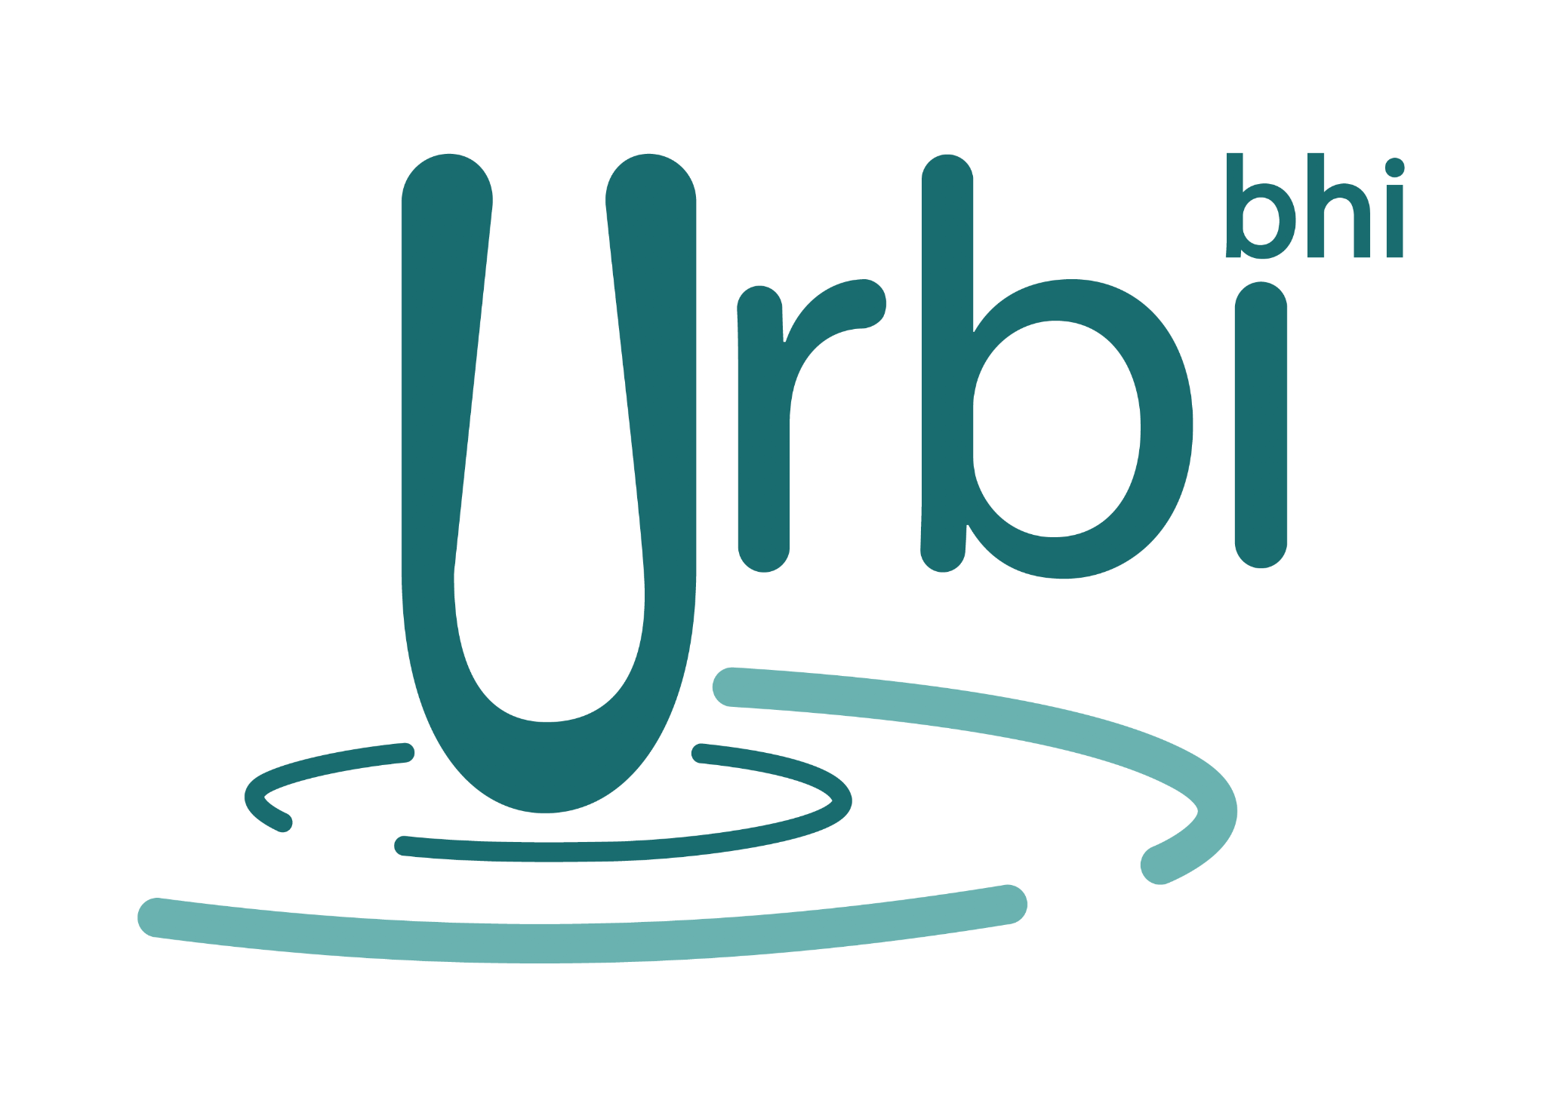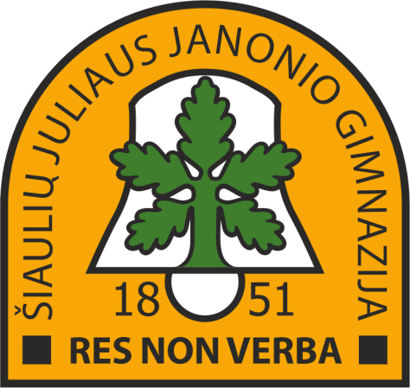

Erasmus+ Programme – Strategic Partnership
Project Nr: 2019-1-PT01-KA229-061433_3
Name of the Erasmus+ project: “More Participatory Democracy, More Active Citizenship”
C2, Strasbourg. Date: 27.09.2021-02.10.2021

MINUTES (1.09.2021, Strasbourg)

Participants:

Elisa Costa
Carla Machado
Kristina Murauskienė
Vilija Šlivinskaitė
Arrate Aldaiturriaga
Karmele López de Abetxuko

- Congratulations to every participant, specially to the organizers (Lithuanians).
- Lithuanians will send the results of evaluation (Google forms).
- Dissemination (photos, Facebook, eTwinning,..)
- Every member must participate in eTwinning to get the Seal (Nacional and European).
- Karmele will create page C3 in Twinspace.
- Carla wil add photos in Google albums and create a final video.
- Articles for the press should be written.
- Padlet must be completed.
- Certificates will be sent by Vilija.
- Principal of the school should send an invitation for mobility.
- Lithuania mobility students list must be sent. Basauri: 2 male, 5 female; Portugal: 4 male, 3 female.
- Products (puzzles, collages, videos, ppt-s…) made by collaborative international teams will be sent by Lithuanians.
- Online meeting: 7th October 18:00 Strasbourg timetable (17:00 in Portugal: 19:00 in Lithuania)
- C4: February 21-26, Basauri.
- C5: May. 9-16, Portugal. 5 days? Application must be checked.

