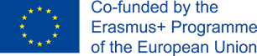
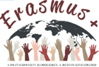
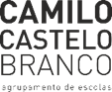
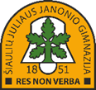
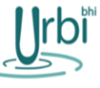

Erasmus+ Program – Strategic Partnership
Erasmus+ project: “More Participatory Democracy, More Active Citizenship”
Type of event: Learning, Teaching and Training Activity, Short-term exchanges of groups of pupils, C5
Activity Title: Train Democratic Participation

HOW TO PROMOTE THE POLITICAL PARTICIPATION OF
YOUNG PEOPLE AND CITIZENS?
PARTNER:
Preamble
Whereas ....

SCHOOL
-
-
-
-
-
LOCAL TERRITORIES
-
-
-
-
-
COUNTRY
-
-
-
-
-
EUROPE
-
-
-
-
-
WORLD
-
-
-
-
-

