“More Participatory Democracy, More Active Citizenship”

C5 – PORTUGAL

9. May. 2022 – 14. May. 2022

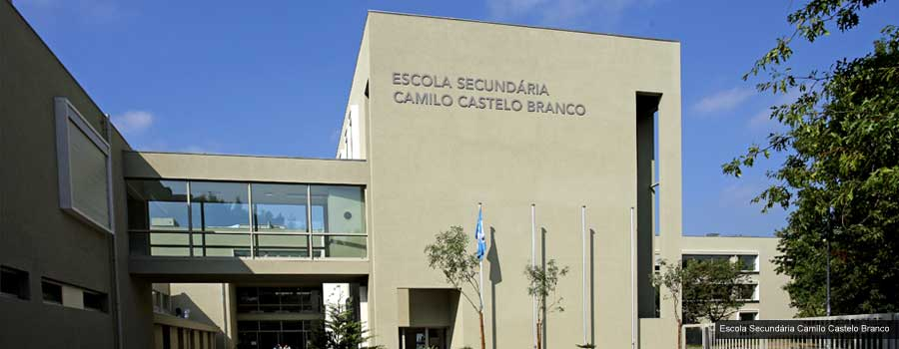

Vila Nova de Famalicão, Portugal

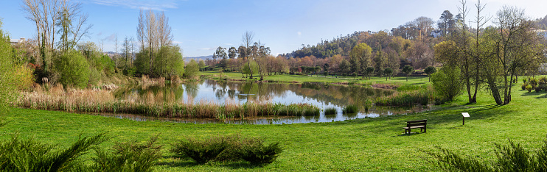

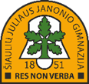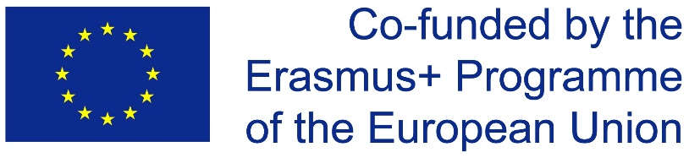

PROGRAM

Monday, 9.May.2022: Welcome to Portugal!

|  |  |  |
| --- | --- | --- |
| 11:15  13:00  15:20  16:30  17:00  18:20 | arrival Lithuania (airport)  lunch with LT team at local market  arrival Spain (airport)  **welcome meeting at AECCB**  room “Sala das Expressões”: casual get-together  city tour  meeting host families |  |

Tuesday, 10.May.2022 – Lisbon

|  |  |  |
| --- | --- | --- |
| 06:00 | departure to Lisbon |  |
| 10:00 | city tour  Praça de Espanha, Parque Eduardo VII, Av. Liberdade, (Largo do Rato) Assembleia da República  visit to Padrão dos Descobrimentos, Torre de Belém and Mosteiro dos Jerónimos |  |
| 11:30 | visit to the Museum of the Presidency of the Republic of Portugal |  |
| 12:30 | lunch (picnic) - Jerónimos |  |
| 13:30 | visit to Places of carnation Revolution |  |
| 14:30 | visit to the Museum of Quartel do Carmo |  |
| 16:30 | visit to the castle of S. Jorge |  |
|  | visit to Baixa Pombalina |  |
| 19:30 | dinner in Parque das Nações |  |
| 19:30 | departure |  |
| 23:30 | arrival |  |
|  |  |  |

Wednesday, 11.May.2022 - AECCB

|  |  |  |
| --- | --- | --- |
|  |  |  |
| 8:30 | AECCB: meeting (Auditorium)  opening ceremony, official gifts  ice-break activities: Tie Activity (Auditorium hall)  school facilities: Trek & Track |  |
| 10:15 | international coffee time |  |
| 10.45 | World Café - social innovation workshops (Room “Sala das Expressões”) |
| 11:45 | partners presentations about the importance of the integration of student participation in projects and extracurricular activities into its assessment and curriculum (Faria & Filipa)  partners presentations about local youth policies and project impacts (Simão & Alvaro) |  |
| 13:00 | school canteen: lunch |  |
| 14:00 | workshop on peer instruction (GIVE) – (12 M) |  |
| 14:30 | debate: YOUTH PARTICIPATION IN POLITIC – |  |
| 16:30 | Surprise |  |

Thursday, 12.May.2022 – Guimarães and Braga tour

|  |  |  |
| --- | --- | --- |
| 08:30  09:00 | departure  visiting Guimarães Castle, Palace of the Dukes of Bragança, Santa Maria Street, Alberto Sampaio Museum, Historic Centre of Guimarães |  |
| 12:00 | lunch - Historic Centre of Guimarães |  |
| 14:00 | Sanctuary of Bom Jesus do Monte in Braga |  |
| 15:30 | Braga Cathedral and city tour |  |
| 17:30 | coffee-break at Brasileira/free time |  |
| 19:00 | arrival at AECCB |  |
| 19:45 | school: dinner together |  |

Friday, 13.May.2022 - AECCB

|  |  |  |
| --- | --- | --- |
| 08:30 | students: debate and registration of concrete proposals to “foster the political participation of young people and citizens in general, at school, in the local environment, in the country, in Europe, in the world, to send to policy makers in each country at the various levels presented” and merging of the 3 documents from the 3 countries – CREATION OF A DOCUMENT OF MEASURES/PROPOSALS  teachers: coordination meeting |  |
| 10:00 | break |  |
| 10:15 | Project Recommendation |  |
| 11:15 | final ceremony and certificates |  |
| 12:00 | school canteen: lunch |  |
| 12.45 | departure to Porto |  |
|  | city tour |  |
|  | cruise on the Douro River |  |
|  | dinner in Porto  departure to Vila Nova de Famalicão |  |
| 20:30 | departure Spain |  |

Saturday, 14.May.2022 - AECCB

|  |  |  |
| --- | --- | --- |
| 16:30 | departure Lithuania |  |