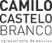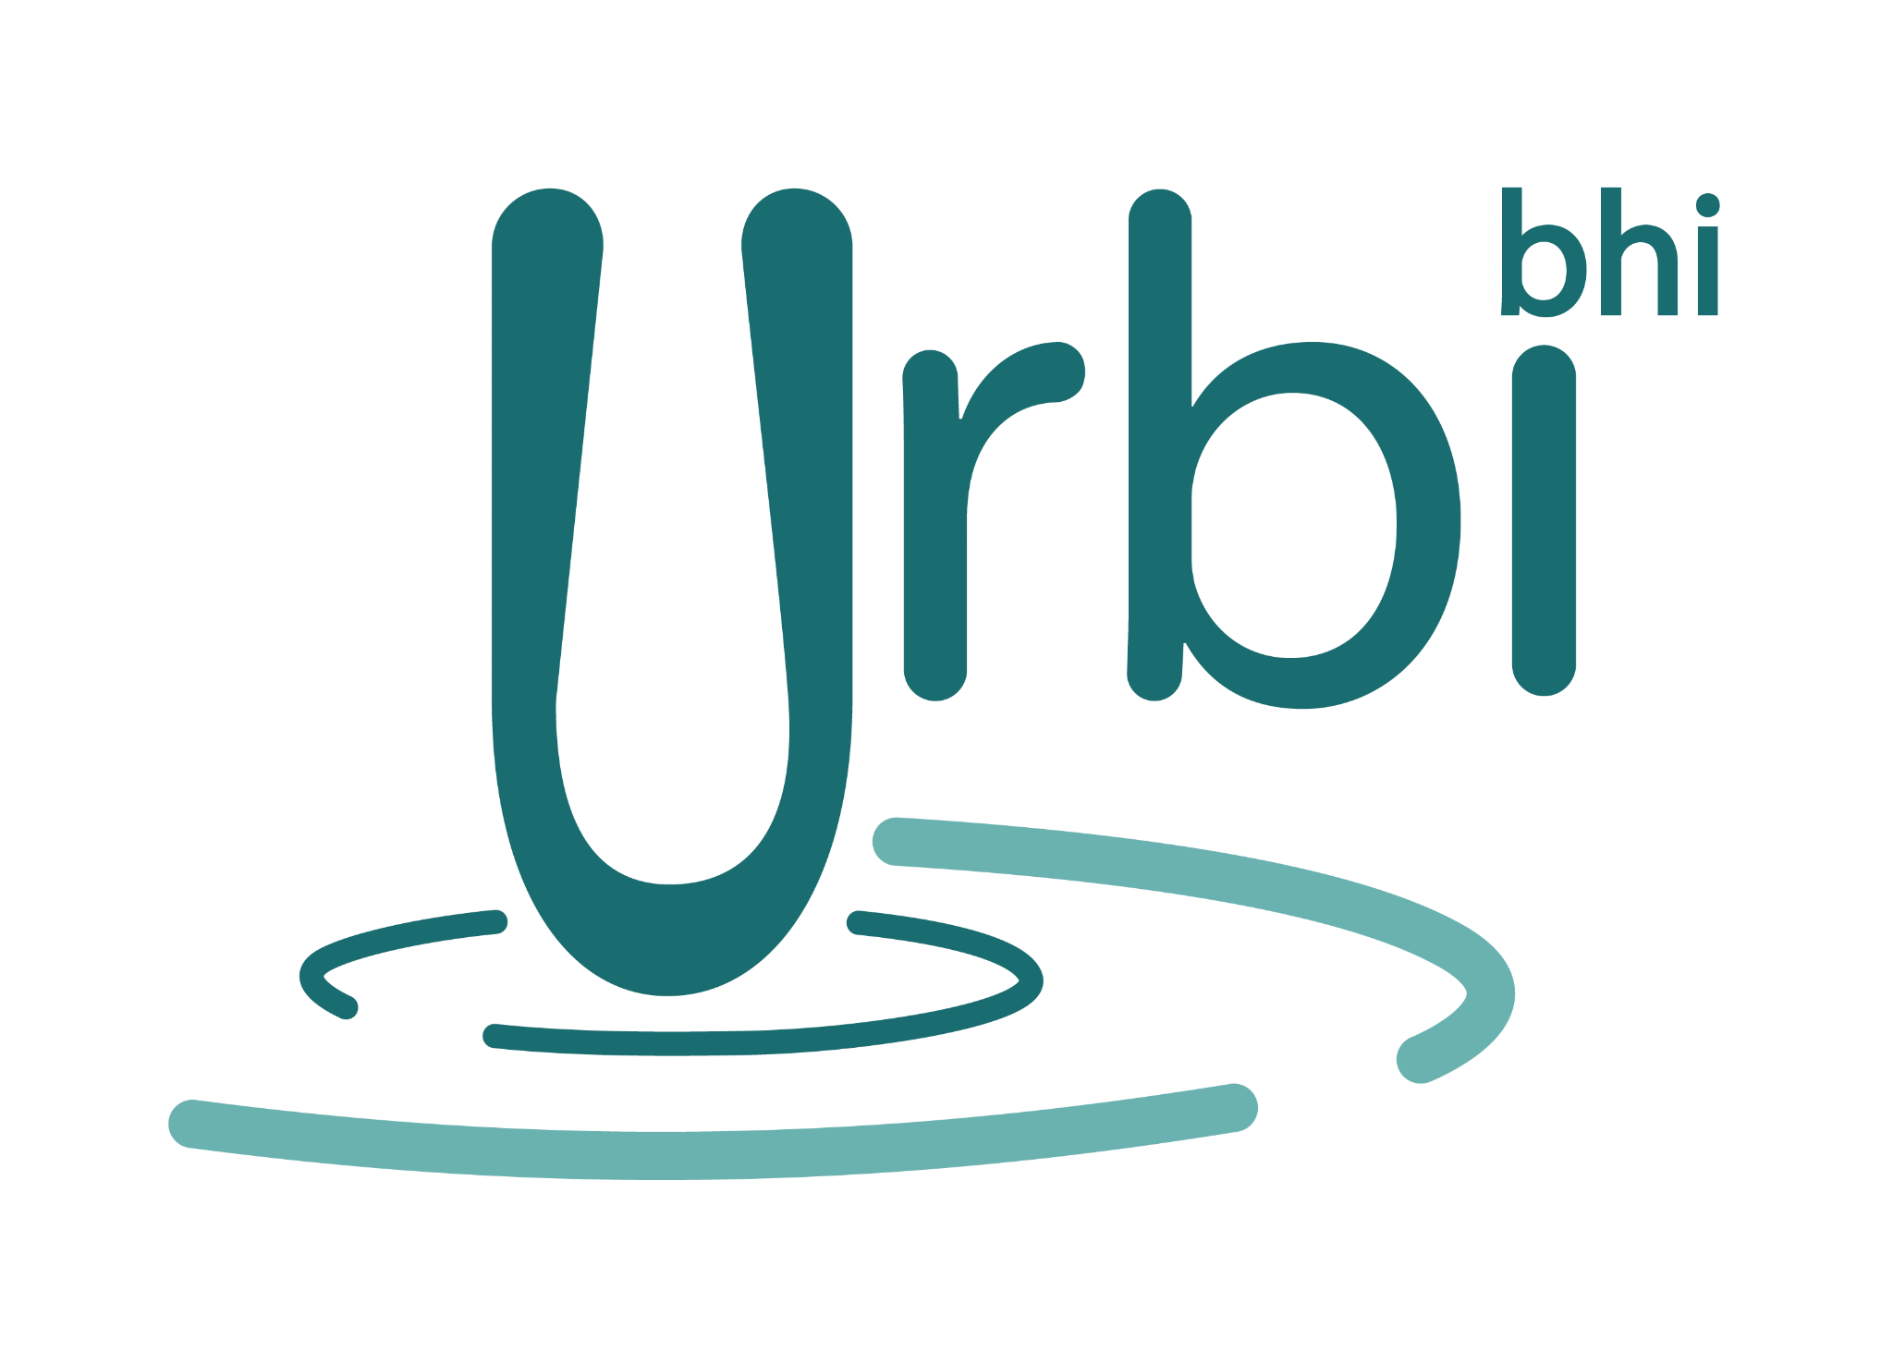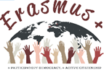

ERASMUS+ PROJECT: + Participatory Democracy, + Active Citizenship
2019-1-PT01-KA229-061433_3
ONLINE MEETING
MINUTES of the meeting March 23, 2021

Participants:

• Elisa Costa
• Kristina Murauskienė
• Vilija Šlivinskaitė
• Andoni Larrea
• Karmele López de Abetxuko

1. Google forms questionnaire about 9th March Virtual Event made by Karmele will be send to every participant.

2. Articles written in Basque and Lithuanian will be written in English for project dissemination (Karmele and Vilija)

3. Thank you letters have been written for the ambassador and consul who took part in 9th March Virtual Event.

4 . Postponement of LTTA C2 to last week of September (27th September- 2nd October). Next mobilities´dates will be decided later.

5- 9th March: Virtual Event dedicated to Lithuanian Independence Day. Successful, 240 participants, but some students' behaviour must be controlled. Elisa recorded, she will send it to the rest. Kristina made a reflection.

6.- Elisa explained how to add information in project Twinspace.

7. 26th April Virtual Event: at 16:00 with Teams
Urbi High School programm draft.
dress code: red carnations + red, white, green colors.

8.- Exhibition “Democracy in my life” was displayed in IES Urbi, Basauri, Spain. From 19th April in Camilo Castelo Branco, Portugal.

9.- Mobility Tool: C2 has been removed by Portugal and Spain. Lithuania will do it. A new one will be created.

10.- Next teachers meeting: 13th April at 14:00.

