PIXTON USERNAMES AND PASSWORDS FOR EDITION
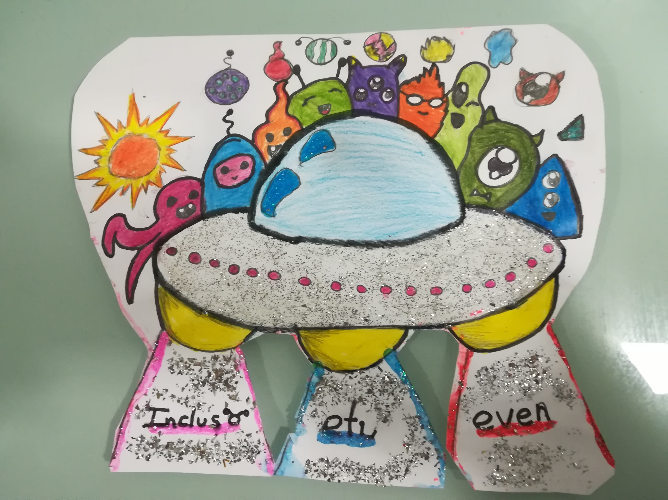

TEAM/GRUPO | USERNAME | PASSWORD
Ross 128 b | markelandalazne@gmail.com | alaznemarkel
Tau Ceti e | etietwinning@gmail.com | inclusoeti,even
Gliese 581 g | oscarandane@gmail.com | 18201921
Kepler-62 e | charizardsucks42@gmail.com | Snorlax143
HD 40307 g | HDeTwinning2018@gmail.com | EXOHD2018

