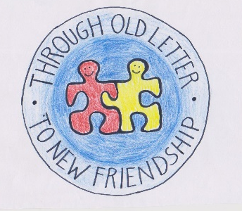
The programme of the short-term students exchange in Grodzisk Maz, Poland
23-27 May 2016
Sunday 22 May
The arrival of the participants

Monday 23 May
9.00 Welcoming at school
9.15 – 10.15 The assembly with students` performances
10.15 – 11.00 Visiting school (geography, English, maths, Tradition Room)
11-11.15 Ode to Joy recording
11-11.30 coffee break
11.30 – 14.00 Past and Present of Letters - art workshop
14.00-14.30 break
14.30 lunch at school
15-17 Grodzisk for Beginners – a city game in groups

Tuesday 24 May
8.15 arriving at school
8.30 – 9.15 visiting the Mayor in the Town Council
9.30 – 10.45 The classical play The Maiden Vows with a task for students about the old letters, sport and dance performances (in the Grodzisk cinema)
11.30 – 16.30 a visit to the headquarters of worldwide famous Polish National Dance Group Mazowsze, learning Polish national dances, lunch (trip by train, about 20 minutes ride)

Wednesday 25 May
5 – 22 Old Letters in Kraków (a trip to Cracow by coach)

Thursday 26 May Corpus Christi – bank holiday and religious festival
10 – 15.30 a trip to Żelazowa Wola - the birthplace of Frederic Chopin, lunch (by coach, about 1 hour ride)
16-17 project meeting at school
17-18 Workshop on students with special needs

Friday 27 May – bank holiday
9 – 15.30 Hightlights of Warsaw – a trip to Warsaw, lunch (by coach, 45 min. ride)
16-18 – a goodbye meeting in school: teachers, students, host families

Saturday 28 May
The departure of the participants

