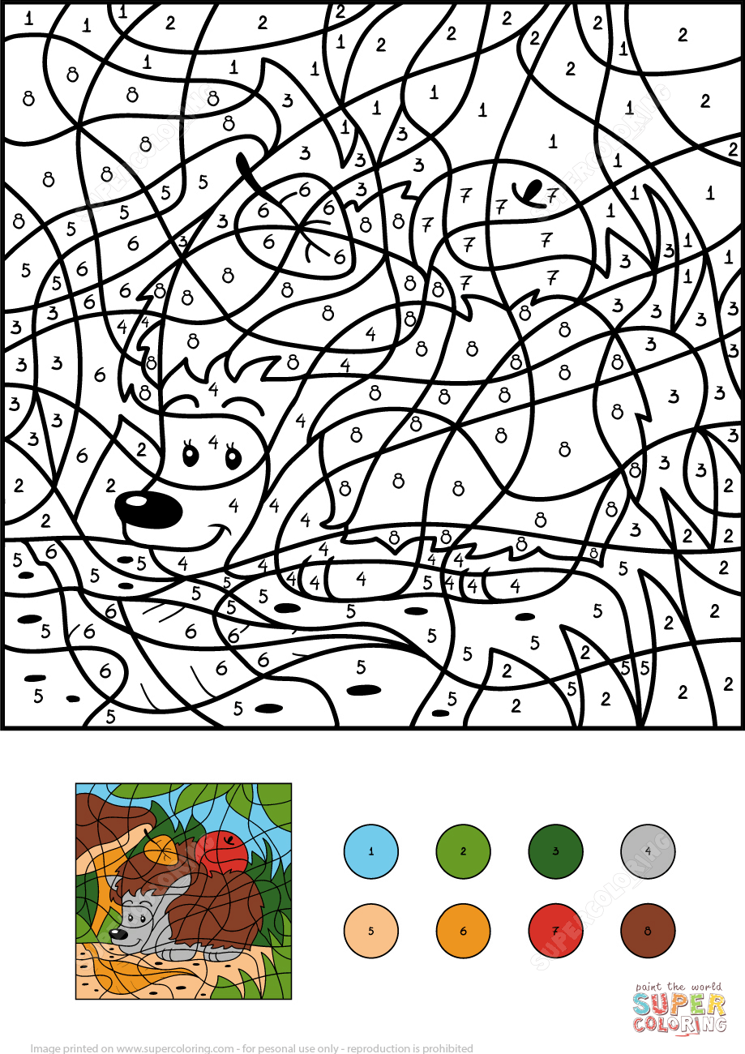

1. BLUE

2. LIGHT GREEN 7. RED

3. DARK GREEN 8. BROWN

4. GREY

5. CREAM

6. ORANGE

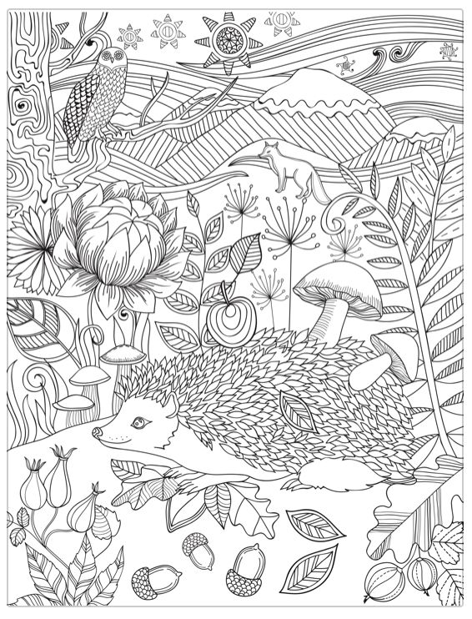



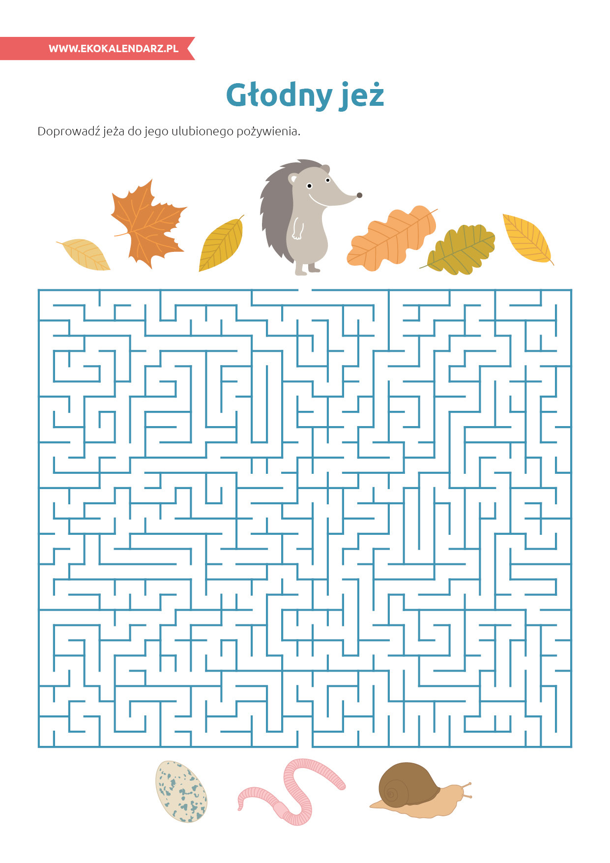

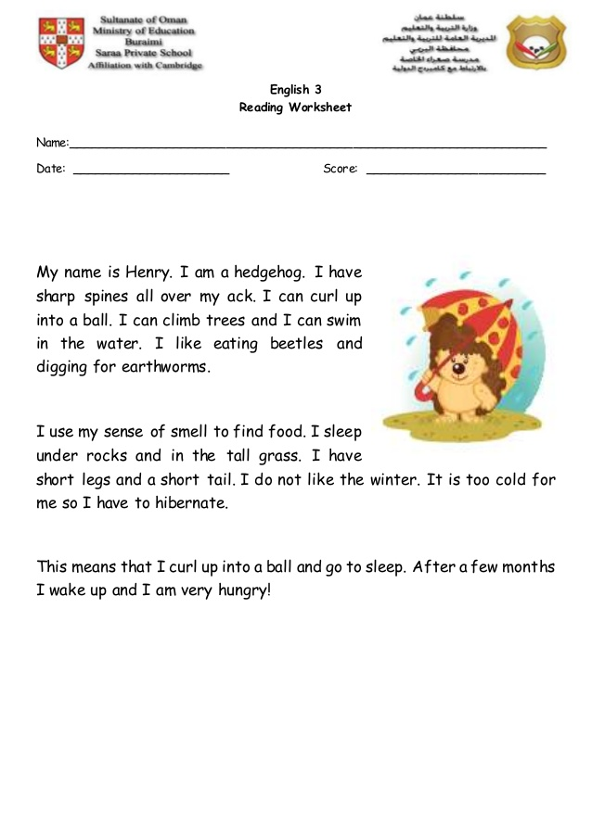

1. What’s the hedgehog’s name? ……………………………………
2. What can a headgehog do? …………………………………………
3. What do hedgehogs eat? ……………………………………………
4. Where do hedgehogs sleep? …………………………………………

