“BIG DREAMS”

Written by Team Scheherazade

Project “to be continued…” 2016-2017

Chapter 1
This was to be another boring, normal school year. Holidays were obviously too short. I wasn't very happy when my mum stopped the car and told me to get off quickly- she was in a hurry, as usual. I wasn't in a hurry, I walked to school at a snail's pace. When I entered the corridor, that crazy Martin ran at me shouting that we had a new friend in our class. Yes we had indeed. It was Laila – she joined our class and brought some fresh air with herself. I was the first person that approached her while standing at the corridor and both of us felt that instant connection between us. I finally found the person that kept me alive. We couldn't stop talking, we were talking during breaks, during lessons, on our way back home. The weeks had passed and I learned more and more about my new friend. Laila had so many interesting things to say. She was a very cheerful, talkative person, but sometimes she seemed to be somewhere very very far away …

One day Laila invited me to visit her house. I couldn't wait meeting her family - if she was so great, they also had to be fantastic people. When I reached Laila's house, she showed me around. The house was a beautiful mansion, full of different souvenirs from far-away places. And I was right, my friend's family members were really cool. Her grandfather made us laugh to tears and her father was very friendly, although very busy in his cabinet. After the sightseeing tour around the house, we went to Laila's room. It was so spacious and beautiful, full of foreign books and maps. The maps were everywhere, the biggest one was hung on the wall and it had dozens of red and blue crosses on. Laila saw my astonishment, she asked me to sit down and started talking and talking …
I found out that her beloved mother, who was a famous voyager, had been traveling round the whole world and suddenly had disappeared, nobody knew what happened. They were searching for years but nobody could find any answer.
Laila wanted to be as her mother, she wanted to travel and find out what had really happened. All the red crosses on the map were for places her mother had discovered and the blue ones were for places Laila managed to visit.

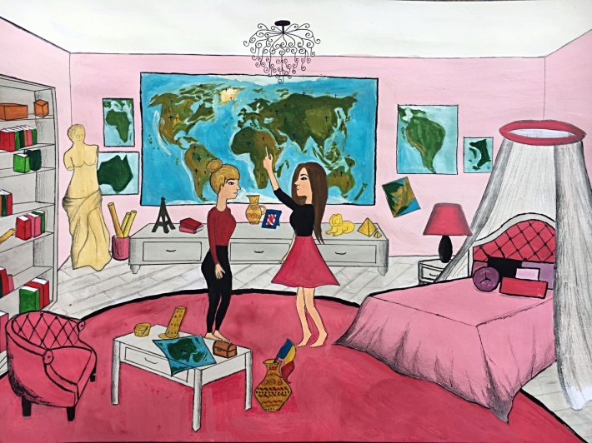

I was amazed at Laila's story, it was so unbelievable. Such a young person had been in so many places.!!! I begged my friend to tell me about all her voyages. We phoned my mum to tell her that. I would spend the night at Laila's house, we ate big delicious supper, washed ourselves and I was ready to listen and listen to my friends exciting stories. Something told me that it would be a very long night.
I sat on the comfortable bed and listened with my mouth opened. Laila started her story.
One of her most memorable journeys was visiting the biggest cities in Poland. She decided to travel by boat on the Vistula – the longest Polish river. She passed forests and fields, they were full of beautiful flavor and wild animals. She reached one of the oldest Polish cities - Krakow. She was captivated by the charm of the old town, Kazimierz and the Wawel castle – the place where Polish kings used to live. Laila walked around the whole city, she listened to St. Mary's Trumpet Call and watched dozens of colorful merchants traveling to the Market Square.
After leaving Krakow, she went to Warsaw – the capital city of Poland. She visited the Palace of Culture and the National Stadium. She went for a walk round the Old Town, she admired the Royal Castle and the Sigismund's Column – all these places were just like in her mother's stories. She loved them. Following her mother's memories, my friend visited also Toruń - a birthplace of Copernicus. After that, she finally reached Gdańsk, where “the sea ends”. She walked along beautiful beaches, watched the green sea, sat on silky sand. She kept asking the seagulls if they hadn't heard about her mum. During one of those walks, she noticed something weird in the water . She came closer and she found out that it was a shiny bottle, she grabbed it and opened it. Inside was a letter written in Romanian. She couldn't read it - but she felt it was a piece of clue. She had to keep traveling and find out …
Chapter 2

Laila kept telling me about how she found that letter. I was amazed by her story. I couldn't believe how brave Laila was. After she told me the rest of the story about her mother, we decided to go to sleep. Laila fell asleep almost instantly...Perhaps all that talking made her tired. I stayed awake, thinking about how my friend travelled all around the world, and how I wish I could be able to do the same. The last thing I thought about, before the sleep trapped me under its spell, was that letter in Romanian that Laila told me about.
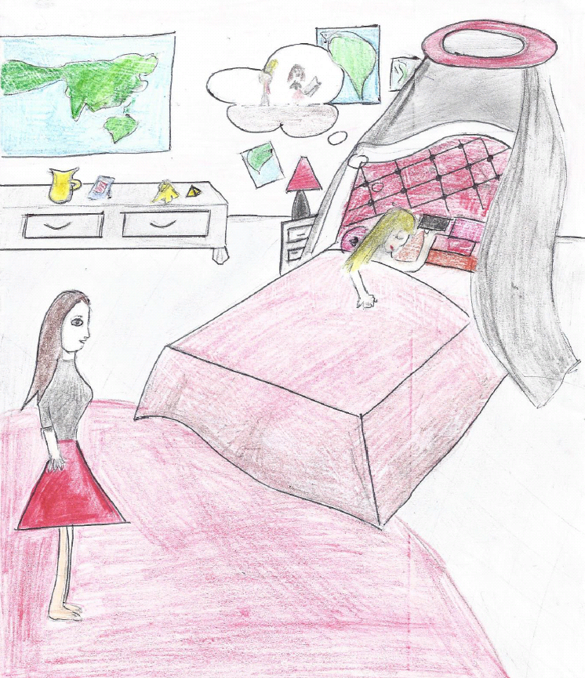

In the morning I woke up after a weird dream I've had. I looked around and I saw that Laila was gone. I sat alone in the bed remembering every detail about the dream.
In my dream, I was walking around the streets of Bucharest, the capital of Romania. Laila was right next to me studying a piece of paper. The paper seemed very old, and Laila looked worried. Then, she stopped and gave me a weird look.
-I found her! she screamed as she started running to me.
And then, I woke up. I didn't know what that dream meant... I closed my eyes, trying to see the old piece of paper again.
-What are you doing? Asked Laila as she walked in the room and found me standing on the bed with my eyes closed.
-Laila, I said trying not to scare her with my dream. Can you show me that letter you've been talking about last night?
-Why? she asked confused.
-I will explain it to you later. Just please, show it to me.
Laila went straight to her closet and pulled out a box. It seemed really heavy. She opened it and started looking through all the stuff that was there. There were a lot of things in that box!
-These were my mom's things, Laila explained. They are from all over the world.
She seemed sad when she told me that. Poor Laila…
-Here's the letter, she said handing me a piece of paper. It looked exactly like the one from my dream! I took it with shaking hands and opened it. As Laila said, it was in Romanian, so I couldn't understand a single word. Except one...Bucharest.
-What's wrong? Asked Laila. Do you understand anything?
-Laila, I said looking her straight in the eye. I need to tell you something.
And so, I told her about my dream. She listened to me carefully while I was talking. At the end, neither of us said anything. She was just staring at that letter.
-Say something, I said after a while. What do you think?
She raised her head and she looked at me. She had tears in her eyes, but she had something else along with those tears. I saw faith in her eyes.
-Do you think we could find her in Romania? she asked with a trembling voice.
-Well, it's worth the shot. I mean, at least we can try.
-So what are you saying? Do you want to go in Romania?
-Me? I said with my eyes wide open.
-Well, of course, she answered. Do you really think my father would let me travel alone? Are you coming or not?
She had such a big smile on her face and I couldn't refuse her. She needed a friend and I couldn't let her down.
-I am coming! I said full of enthusiasm.
-Thank you! she whispered while hugging me.
For the next few weeks, all we did was make plans. Every day after school we would meet at her place and talk about how we could get to Romania. We were both so excited. When the holidays were around the corner, we told our families about our journey. We first told her father. I noticed that Laila was very nervous before we went to talk to him.
Fortunately, her father agreed with everything.
-I trust you, girls, and I hope you will find her. I'm going to personally buy the train tickets and everything that you need. I wish I could come with you, but I think this will teach you some things. We both hugged him and then we went to my place. My family also agreed, so Laila and I went to pack all the things we needed for our little holiday.
When we left, Laila's father came with us to the train station.
-Good luck, he said before we got on the train. I hope this journey will be a success and I expect you home soon!
The train started to move and the last thing we saw before we left the train station was Laila's father waving.

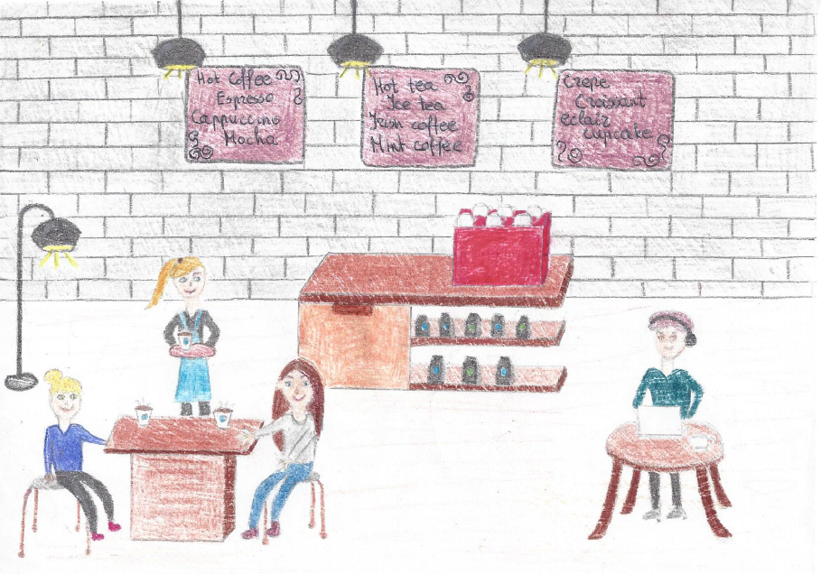

The train journey was really long, but at least we had each other. Laila told me a lot of things about her mother, so those 15 hours passed quickly. When we finally arrived, the weather was very cold. Bucharest was such a beautiful city! It was full of decorations and happy people. We saw a coffee shop and we entered in it.
-A hot chocolate is right what we need right now! Laila said as she pushed the door.
We found some seats and then ordered. A nice woman served us. As we were sipping from our cups, Laila pulled out the letter from her purse. She stared at the letter, reading it again and again.
-How are we going find her if we don't understand anything?
-Can I help you with anything? the waitress asked, smiling.
Laila hesitated, so I told the woman that we need some help to translate the letter. We found out that her name was Anna. She was nice enough to sit down and tell us what the letter was about.
Apparently, Laila's mom had a good friend here in Bucharest, working in a library. Anna told us where we could find the library and we left as soon as we finished our drinks. Of course, we thanked Anna for her help, and we promised her that we will return to this cafe before we'll leave.
We walked down the streets of Bucharest. Laila and I were very happy to be here right around Christmas. After a while, we finally found the library. It was a big, purple building, and it was called "The Mystery".
-It seems a bit creepy, Laila said.
-Come on, it's just a library, I said while entering it. The door opened and a little bell rang. It was so nice and warm inside, but it was empty. We looked through the shelves filled with books, most of them really old. As we were walking around, Laila stopped and stared at a book. The title was visible, but I was able to read it somehow.
-"World War III" I said, trying to understand why was Laila so impressed about this book.
-It was my mother's favorite book, said Laila. When I was a child, she would read me from it before sleep. I know, it seems strange to read such things to a kid, but I loved everything about history.
She pulled the book from the shelf and opened it. I've never seen anyone so surprised as she was. The look on her face was the weirdest thing ever! What did she see inside that book?

Chapter 3

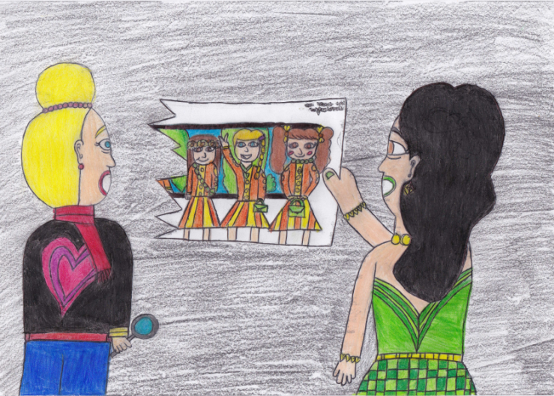

An old picture of three young women - that's what left Laila so shocked. The girls were all wearing the same uniform and there was a map on the wall behind them. The map looked exactly like the one in Laila's room, but had way fewer crosses on it. Laila flipped the picture over and I saw four handwritten names and an address. Wait... four names? We flipped the picture over again and examined it closely. There were certainly only three of them. But... there was a hand pointing to a spot in Europe, near the Baltic Sea. A part of the picture must be cut off!
Not only had a part of the picture been cut off, but the fourth name that happened to be Laila’s mother’s had the surname cut off as well. I looked at Laila, she was confused - neither of us knew what this meant. Obviously, it had been done on purpose, as it had been removed in a clean way.
But why would someone do that? It was an unsolved mystery. We were both very tired, so we got back to the hotel and stayed up all night figuring out clues and clearing up the mess in our minds. With her sleepy eyes Laila noticed an address written on the photo - they looked it up and it was a house not too far away from the library. We decided to go there the moment we got up the next morning. Something was telling us that this would be our big next move.

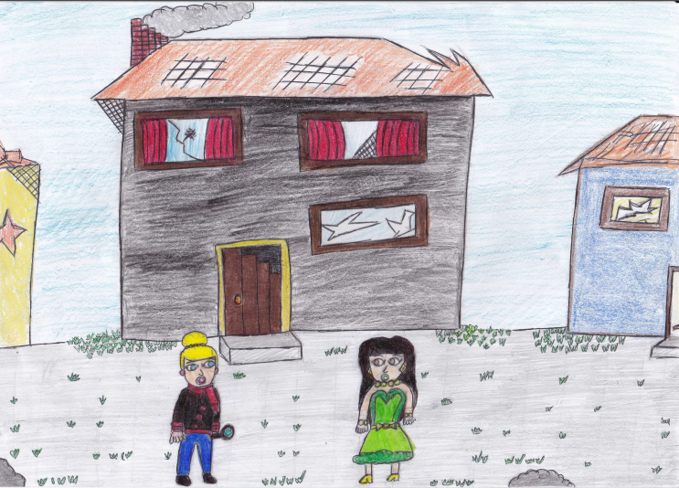

The morning came, and with our worried minds we went to look for the house. It was a really old building, with a few windows smashed. Clearly no one lived here anymore - the patio had weeds all over and the house was being slowly destroyed to match the surroundings. We slowly walked towards a wooden antique door and rang the bell. We were not surprised when no-one answered. We were about to walk away when we heard the door slowly open making a creepy, yet inviting creaking sound. We looked at each other and decided to take the risk and walked into the unknown.
While searching the house, we came across a room that looked exactly like the one in the picture. It was full of antique furniture, ripped off wallpaper, useless stuff flung around in every corner, ancient souvenirs from all around the world. Laila suddenly came across a familiar scent - her mother’s perfume. It popped into her head that this was only be possible if her mother had been here not too long ago or she was just going crazy. We looked around the room and spotted an old, mouldy cardboard box. Laila remembered that her mom used to own a lot of these. We took the top off and the whole box fell completely apart. Inside it was full of old photographs, books with the library stamps and inscriptions and a rather new diary that just did not fit in with the other items.
There was a pencil hidden inside the pages. Laila opened the ones held apart by the pencil - and saw a story written in an unknown language. Neither of us could understand it, but we noticed that Laila’s mom’s name was mentioned there a lot of times. Laila and I were lost - all those clues just didn’t fit into one story. Laila was about to put the pencil down, but saw "Lietuva written on it". We finally decided to go to the librarian and figure out what all of this meant.

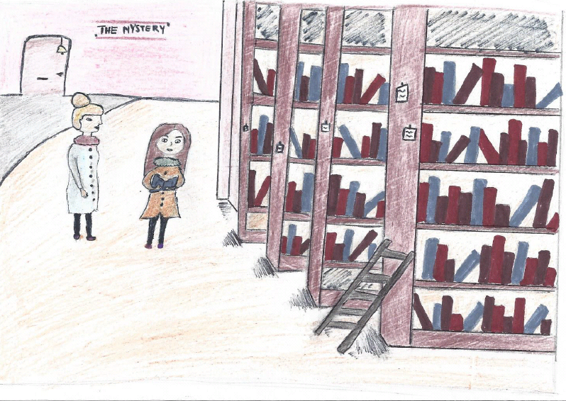

The library was empty - we waited a few minutes and a woman we hadn’t seen before walked out of nowhere. Unfortunately, our friend was nowhere to be seen, and we did not trust the new worker. Laila decided that we should get back another day when some help would be around. We came back two days later and found out that Laila’s mom’s friend was back at work. I asked her about the peculiar language and the photo, but she would change the topic every time we were about to get closer to the truth. Eventually, she pitied us and told us to follow her. We were not sure if we should, but our hearts told us to. She led us into a little secret room, and we saw...a couple of dusty chairs and an old projector. She gave us a movie tape and left us alone. We turned on the movie projector and...
Chapter 4

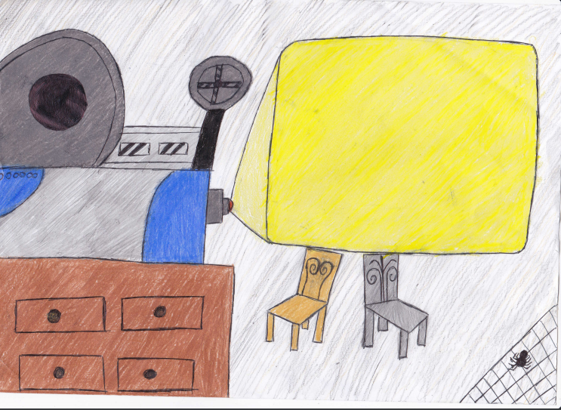

The movie started playing on the filthy wall full of dirt and cobwebs. We barely had enough time to see Laila's mother in the back of an old rusty van when the tape stopped abruptly and the projector exploded into a mess of fire and gears.
- Could it be a coincidence??? - asked Laila.
- I don’t know, maybe it is a coincidence, let's go to the main room - I acknowledged.
When we got upstairs and opened the secret gap on the wall, we stood up in shock. All of a sudden our eyes turned black and we woke up in the hotel bed. Thankfully, it was all a dream.

Our adventure sailed on, despite that horrible dream. In the morning we went to Anna's coffee shop to have a sweet, brown latte and she offered us a delicious pastry chocolate roll for free. Then we went to the library, and because of the dream last night we were really scared. Laila entered the library and while she was speaking to the lady at the reception desk, I went straight to the 3rd shelf, because I saw an old golden book entitled “The Adventures of Ferdinand Magellan”. What got my attention was that my sister was always reading the book, over and over again. Being a curious teenager I opened the book, when Laila arrived.
- What a beautiful book! – commented Laila.
- It’s really curious… – I told her.
- Why? Is the story enjoyable to read? – asked Laila.
- No! It’s because my sister is always reading it. I wonder why!?- I questioned.
Right after I said that I found a CD stuffed in one of the pages and we immediately went to the librarian asking if there were any computers available.
- I will certainly look into it for you, please wait a brief moment… - elucidated the librarian in a kind voice - … Oh, I found one for you!
We inserted the CD in the CD drive and clicked play. There were some beautiful images of Oporto, in Portugal. It showed the Cleric’s Tower, the St. Louis Bridge and the St. Francis church. It was a really old beautiful town, full of charming monuments and tiny black and white cobble roads. Laila’s mother was in a typical Portuguese pub, eating a delicious “Francesinha” with a mouth-watering red viscous sauce. She was also drinking a full glass of tasty Oporto Wine with a dry, yellow straw hat on her head. But there was a problem; the narration was all in a foreign language. What was that language?
- I think its French! – guessed Laila.
- No! It’s Italian! – corrected the librarian.
They went to …

Chapter 5

The strange thing about that video was that at one point Laila’s mother was in a temple, dedicated to Venus ,the goddess of beauty ,in Portugal. I watched intensily, but, her image began to become invisible, almost like a ghost, only to reappear in another indefinite temple.
Focusing the attention on the woman's voice I listened to her saying:
"Recently I discovered to be pregnant, a wonderful creature is growing inside me, the father is the man I fell in love, the only man I've ever fallen in love ... It will be so nice to raise this child with him, if she is a female baby I will call Laila, if is a male baby I call him Luke ... I still remember the first meeting with the man who stole my heart: I was in Italy and I had a collision with him , who was riding his red Vespa, and it was love at first sight "the voice of the woman was so warm and kind. Laila had told me, crying this story about the first meeting of her parents , her father, who had also taught to ride the shiny Vespa .

However, after a while, a certain melancholy began to appear by the video.
"But what I flatter myself? I I will remain very close to my baby ... and if I can not resist to go to Rome I cannot oppose, but as long as I can, I will give to this creature all my love ... and the movie ends
Laila was so sad and I had no idea how to help her, I just knew that the next stop would be Rome.
After arriving at Fiumicino airport, we went to the hotel to drop our bags and have a sightseeing of the city.

We wander Rome for three days without finding a clue, we visited every archeological site, but nothing. On the evening of the third day, when I closed my eyes I thought that I had no more hope .
"Stop! Laila is looking for you! Where are you going?" I shouted to the woman who appeared and disappeared, going from one temple to another. It was the same woman in the video, wearing a white dress and seemed not to hear me.
"Please stop!" I cried with my whole being, begging to give me her attention
Just before it was next to a column of a circular temple, the next moment it was next to a greater temple and then changed yet again and again ... The whole street got into a dark place near a column there she stopped looked at me: she was crying!!!
"Wake up!"
Laila?
"It's late! Wake up! She lazily opened her eyes: it was just a dream.
I knew that dark place: IShe lazily opened his eyes: it was just a dream.
I knew that dark place: I recognized immediately. “The Achilliane Baths” in Catania , I had visited them during an school trip .
I told my dream to Laila, who quickly booked some tickets for visiting “The Achilliane Baths” in Catania.I

Once we arrived we went straight to the spa.
Laila was fascinated by the place, but in an even darker corner, sitting, there was a woman who covered her face so we approached her , because she seemed suffer er.
"Excuse me, madam, can we help you?
The woman looked at us and was astonished to see so young people in a similar site, what are you looking for in this ancient place? she said, her voice made me realize that she was old enough ..
"We're looking for a woman, she disappeared three years ago" replied Laila.

"An ancient legend tells of a woman ... She was a beautiful priestess ,lived during the Roman Empire,who prayed the God Neptune, as this God WAS in love with her ,HE gave her A great power: he could be moved in time and see things that no one could see, but she was faithful to her real lover and resisting the attentions of God this provoked his fury: she was taken off the gift and was made immortal, but was forbidden to bind to human, if he did would be punished. the columns surrounding her at that moment impregnated with magic then absorbing it, she discovered that through these could move to any part of space, where there were other columns dedicated to his gods. the name of this priestess was Clelia. " He told the woman in a solemn voice. Clelia was also the name of Laila's mother.
Me and my friend looked at each other in confusion. A moment later, when we turned to the corner, the woman disappeared.
In silence, not wanting to believe what we suspected (it was completely unnatural) we went off to better control the place.
For a moment, I leaned against a column and it was like falling into an abyss.

When darkness faded, the image of Laila's mother appeared again, she was wrapped in that white robe, who seemed to belong to another time, she ran away in despair and fear, something seemed to scare her . Her face was a mask of pain and had a hoarse voice and strong enough to boom there.
"You Do not bind to human beings! Nor will never find release in death! You who have dared to reject god Neptune! Clelia will wander forever in space and when your mind is clouded by madness, there will be no one to help you!" that voice put the shivers, while the woman had the horror in his eyes. Another cry, tears of sorrow, Laila embraced by her mother’s arms, the statue of a mermaid ... This was what so before I found myself leaning back to that column suffering from a terrible dizzine.

Chapter 6

My head was spinning and I called for Laila. I was surrounded by fog as I looked down at my hands, they were shaking. Laila and the mermaid statue had disappeared so I screamed out “Laila, where are you?!” There was no response. I could hear my own breathing as I tried to take in the thin air.
I hear Laila distant screams and I tried to follow her voice through the thick fog. “Laila please, where are you!? Try to follow my voice!”
I see a small light flying up towards the sky and I hear Laila’s voice ”I’m here! I’m here!” And I start to run. The gravel crushes under my feet as I sprint towards Laila’s voice.

As I approach her I no longer see the mermaid statue. But the golden light in the sky gets brighter and brighter and Laila is just staring at it. She lifts her hand, still focusing on the light and mumbles words I can’t form. She closes her eyes and a strong wind starts to set. I see a face forming in the golden sky and I recognize it. It’s Laila’s mother. But she doesn’t look like herself something is different, her eyes doesn’t shine the same and the golden light slowly disappears as a watery shield surrounds her.
“What are you doing?” I ask Laila who still is holding her hand up and focusing on her mother.
“I need to save her!” She answers. “What do you mean save her? You’re drowning her!” I yell.
“No I’m not! She needs water!” Laila says.
“What?” I’m so confused. “She’s a mermaid okay? She needs the water to breath and I’m helping her!”
“Are you a magician?” I ask.
“No, I’m a witch!” She yells.
I back away and look up at the water ball Laila made around her mother. She moves her hand and the ball move as well. She moves it towards the ocean and lets go.
I look at Laila and see her tear soaked face as she realizes she lost her mother. Again.

The End
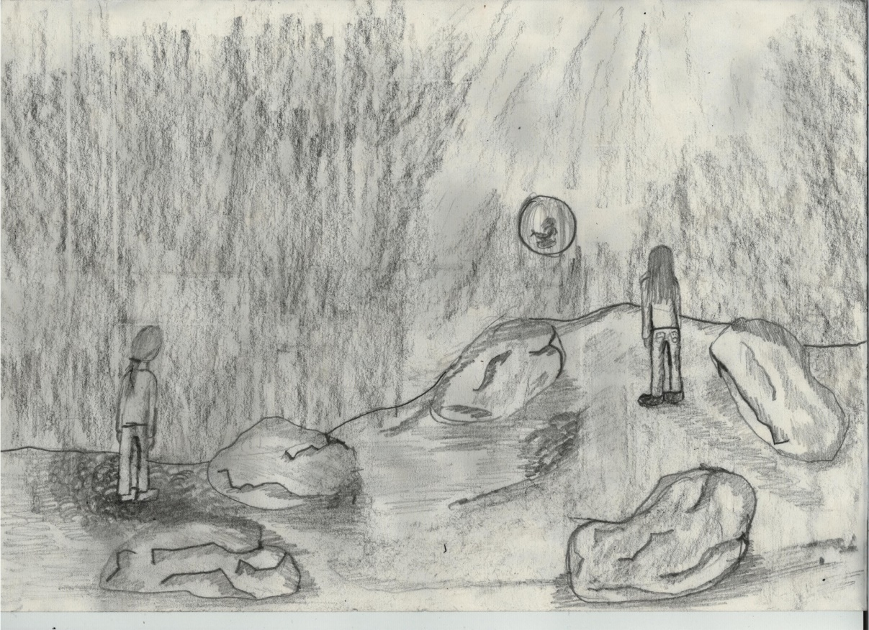

Authors:

Stefania, Julia, Anna, Adeline, Adriana, Loana, Elena,

Marija, Andreja, Edvinas G., Edvinas K., Mantas, Guste, Dovydas,

Sergio, Daniela, Beatriz, Lucia, Sandra, Alessio, Christoffer, Julie

Editor:

Zosia

