If you want to know something about our school, click on this text.

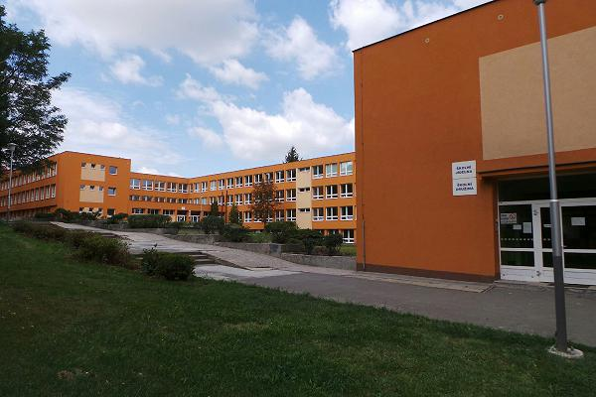
(http://www.youblisher.com/p/1101599-Our-school/)

