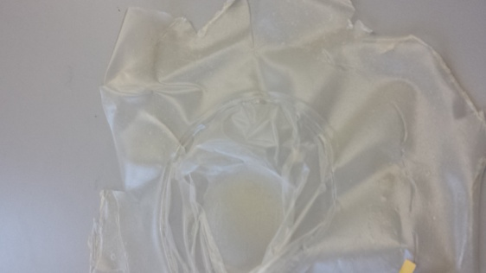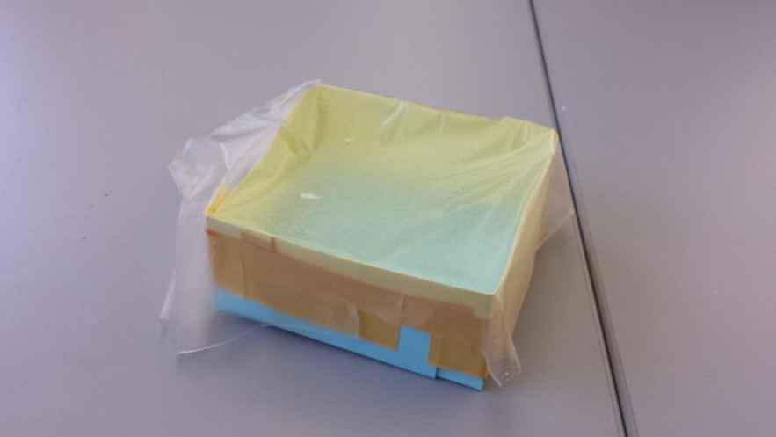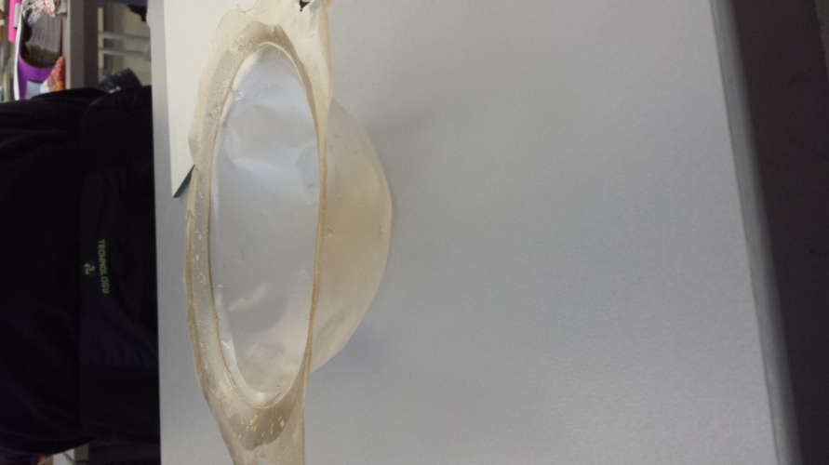**Bioplastics**

Ingredients:

3ml Glycerin

50ml Water

1TSp Agar

½ sheet of Gelatine

Use for:

Packaging which you can cord up.

Ingredients:

50ml Water

3 TSp Agar

3ml Glycerin

Use:

Window for packaging

Ingredients:

100ml Water

10ml Glycerin

1 TSp Agar

You can use it for:

Rice package for example