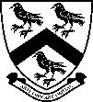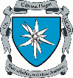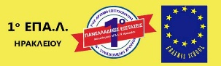
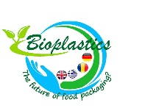 Bioplastics: The Future of Food Packaging?
2. Project Meeting in Romania in April 2018

Once again in April the four participating countries came together- this time in Piatra Neamt, Romania at Calistrat Hogas National College - to continue their work on bioplastic products.
The Greek team were first, arriving in Bucharest and sampling the architecture of the capital city before heading north. Later, the German and British groups would arrive too, given a warm welcome by their host families during the warm evening and catching some well-earned rest.
On Monday morning a busy schedule saw an elaborate opening ceremony of rousing speeches and musical performances from students and staff before time in the laboratory was spent finalising product ideas. Continuing in mixed international groups, the students developed the products created during the first mobility in Mosbach, Germany. Now turning their attention to the prospective markets, branding strategies, production costs and packaging aesthetics were finalised ready for presentation to industry professionals later in the week.
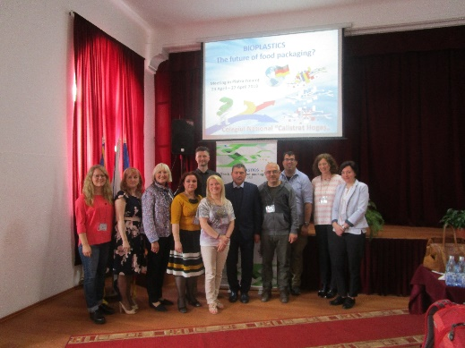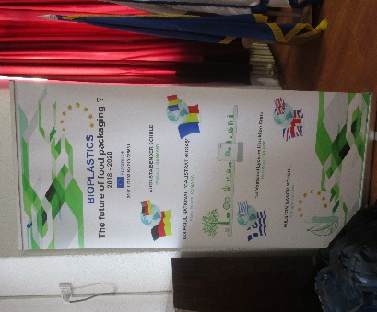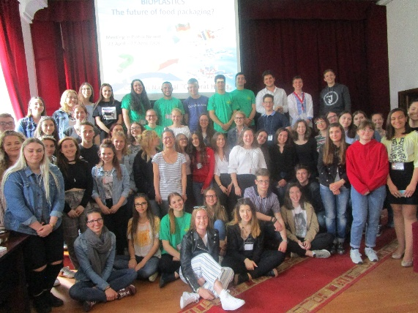
Tuesday morning was an opportunity to share some of the things learnt since the last project meeting. Market research results were discussed and presentations explaining the impact of plastic waste in all four countries served as a reminder of the importance of the students’ work. Workshops then took place where students had the opportunity to design infographics about the topic which contributed to the business plans of each international company. Everything was beginning to look quite professional!
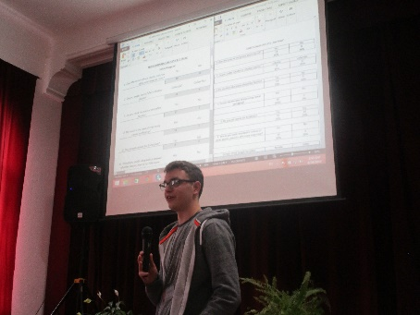
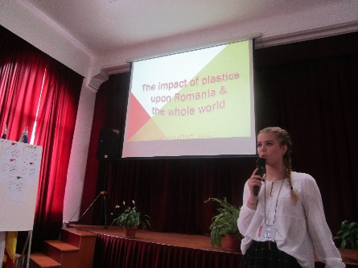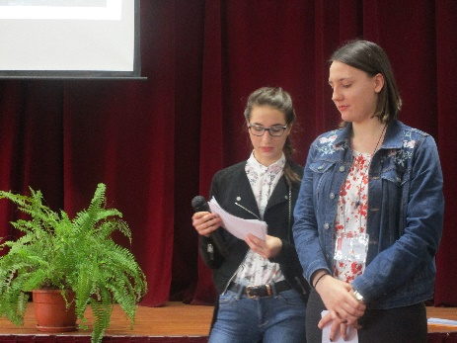

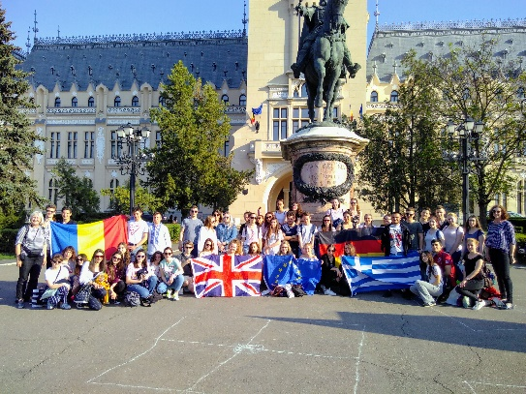
By mid-week it was time to visit institutions exploring the field of bioplastics and food packaging- to get a better picture of what the industry is really like. Travelling across the rich agricultural landscapes of Moldova and Bucovina, the group visited the Food Industry Faculties at Suceava University and the `Al. I. Cuza University Iasi before tours of the baroque splendour of the Iasi university library, impressive Palace of Culture and the stunning Voronet monastery.
Bringing the week to a close, presentations were given to a packed house and students were offered guidance by industry specialists before receiving the congratulations of the town mayor. With the project meeting now over it is time to turn our thoughts towards Greece and proceeding with the next chapter: using the internet to promote bioplastic products.
Embodying the European Parliament’s ethos of co-operative learning, sustainability and unique learning experiences, the students can be proud of their international diplomacy and the role they are playing raising awareness of sustainable thinking and clean living.
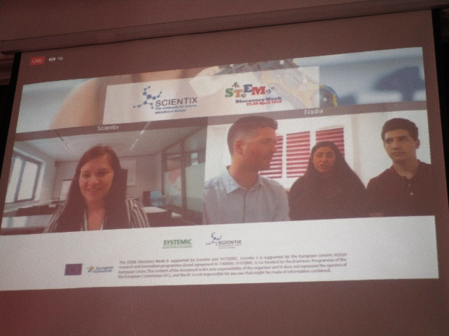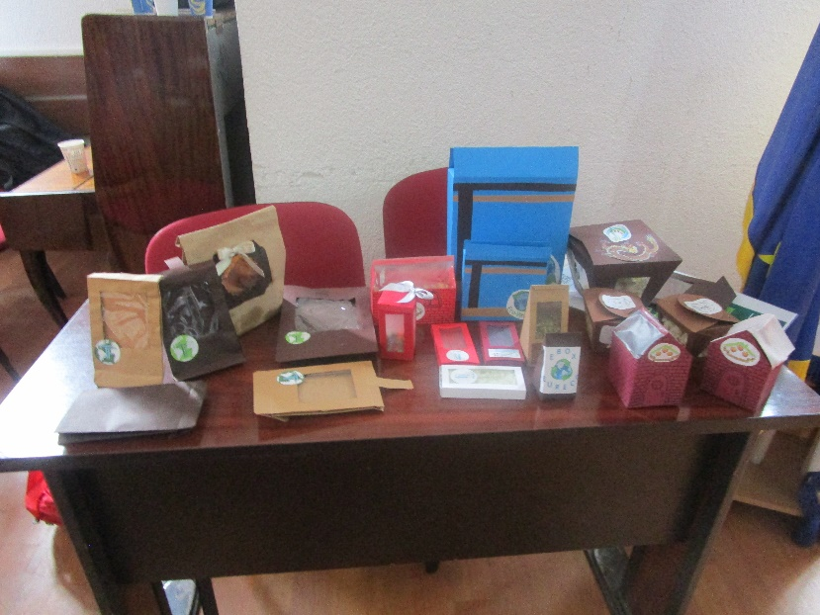
During the live stream of the The final bioplastic food packagings.
“STEM Discovery Week 2018” in
Brussels .

