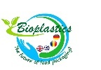 Bioplastics: The future of food packaging?
Erasmus+ Mosbach

In late January, 6 Fulston students made their way to Germany for the first mobility in the new Erasmus+ Project, Bio-Plastics: The Future of Food Packaging? Fulston has, alongside participating schools in Germany, Greece and Romania received in excess of £20000 each from the European Parliament to explore, produce and market bio-plastics- biodegradable alternatives to plastics used in the food-packaging industry.

Bleary-eyed and quiet in the winter twilight, the group were soon travelling across the snowy landscape of Baden-Württemberg on the way to Augusta Bender Schule for a week of international cooperation. Bringing an almost cosmopolitan touch to the cobbled streets of Mosbach, the fifty-strong team would transcend cultural differences and language barriers to bring to life the European Union’s vision for sustainability.

Surrounded by bubbling pots, sizzling hobs and white powders the Erasmus students soon turned the laboratories of the school into a hive of scientific activity. Ideas percolated and were discarded as quickly as the ingredients. Should the product be for confectionary or lunches? Is waterproofing important? Will surface area cause shelf-life limitations?
Deciding on a chosen product, one which would imitate the composition of conventional plastic and biodegrade within a short time proved a significant challenge and the students were regularly brought 'back to square one'. But success is built from the stock-pile of failure; undeterred, recipes were refined, quantities meticulously measured and temperatures vigilantly maintained as- little by little- something like a production-line started to form in the classrooms.

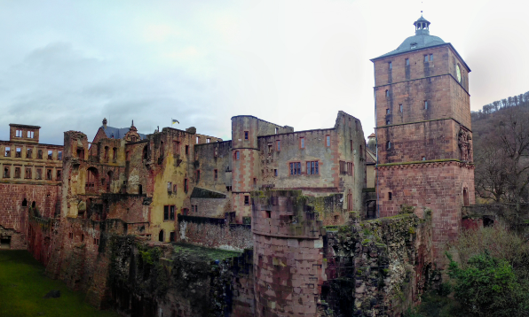
Yet any surprises encountered in the laboratory paled in comparison to the research shared with staff and students by the IFEU Institute in Heidelberg. Coming to the end of a three year enquiry into the bioplastic industry, the Institute is providing insights, debunking myths and revealing many hidden truths too sensitive to share here but which will surely transform the plastic industry in the years to come. As the students dispersed amongst the grand architecture of the university city for impromptu lunches and coffees, the importance of the project was beginning to fall quickly into focus.

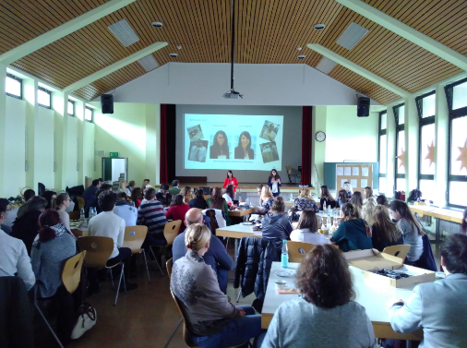
But the glorious German cakes, evening bowling competitions and appointments with local dignitaries and press could not hide the inevitable conclusion to the week. Always with Erasmus there is a final hurdle and it would not be long before the students were show-casing the final results in-front of an expectant panel of industry professionals…

As the clock struck 10am on Friday morning the 7 international groups gathered in the main hall to face their biggest challenge. Nervous tension was tangible: experienced figures had been summoned to lend their expertise as the students gathered together their products, business plan and branding for an intensive two-hour session of presentations. Professor Hubert Speth of DHBW Mosbach offered guidance to the budding presenters on their delivery whist staff from Friesland/Campina gave insights into the food-packaging industry and presented students with practical advice about the products and their potential within current-day markets.
As the warm applause following the final presentation died down, a mixture of relief and celebration descended upon the groups. Invigorated by the flawless hospitality of our hosts and the good-will and collaborative spirit of our partner schools, the conviviality would continue well into the evening.

Another milestone in Fulston Manor’s numerous Erasmus successes, the school is once more broadening horizons of our students and helping the torch of cooperation to shine bright across Europe.

