Organic plastic packages

Instruction 1

Sodium alginate
- 1 heeped tsp. Sodium alginate
- 3 drops 1% glycerol solution
- 200 ml Water

Instruction 2

Coloured
- recipe 1 above
- red gelatin leaves
- 200ml water
- ½ tsp. Sodium alginate
- 3drops 1% glycerol solution
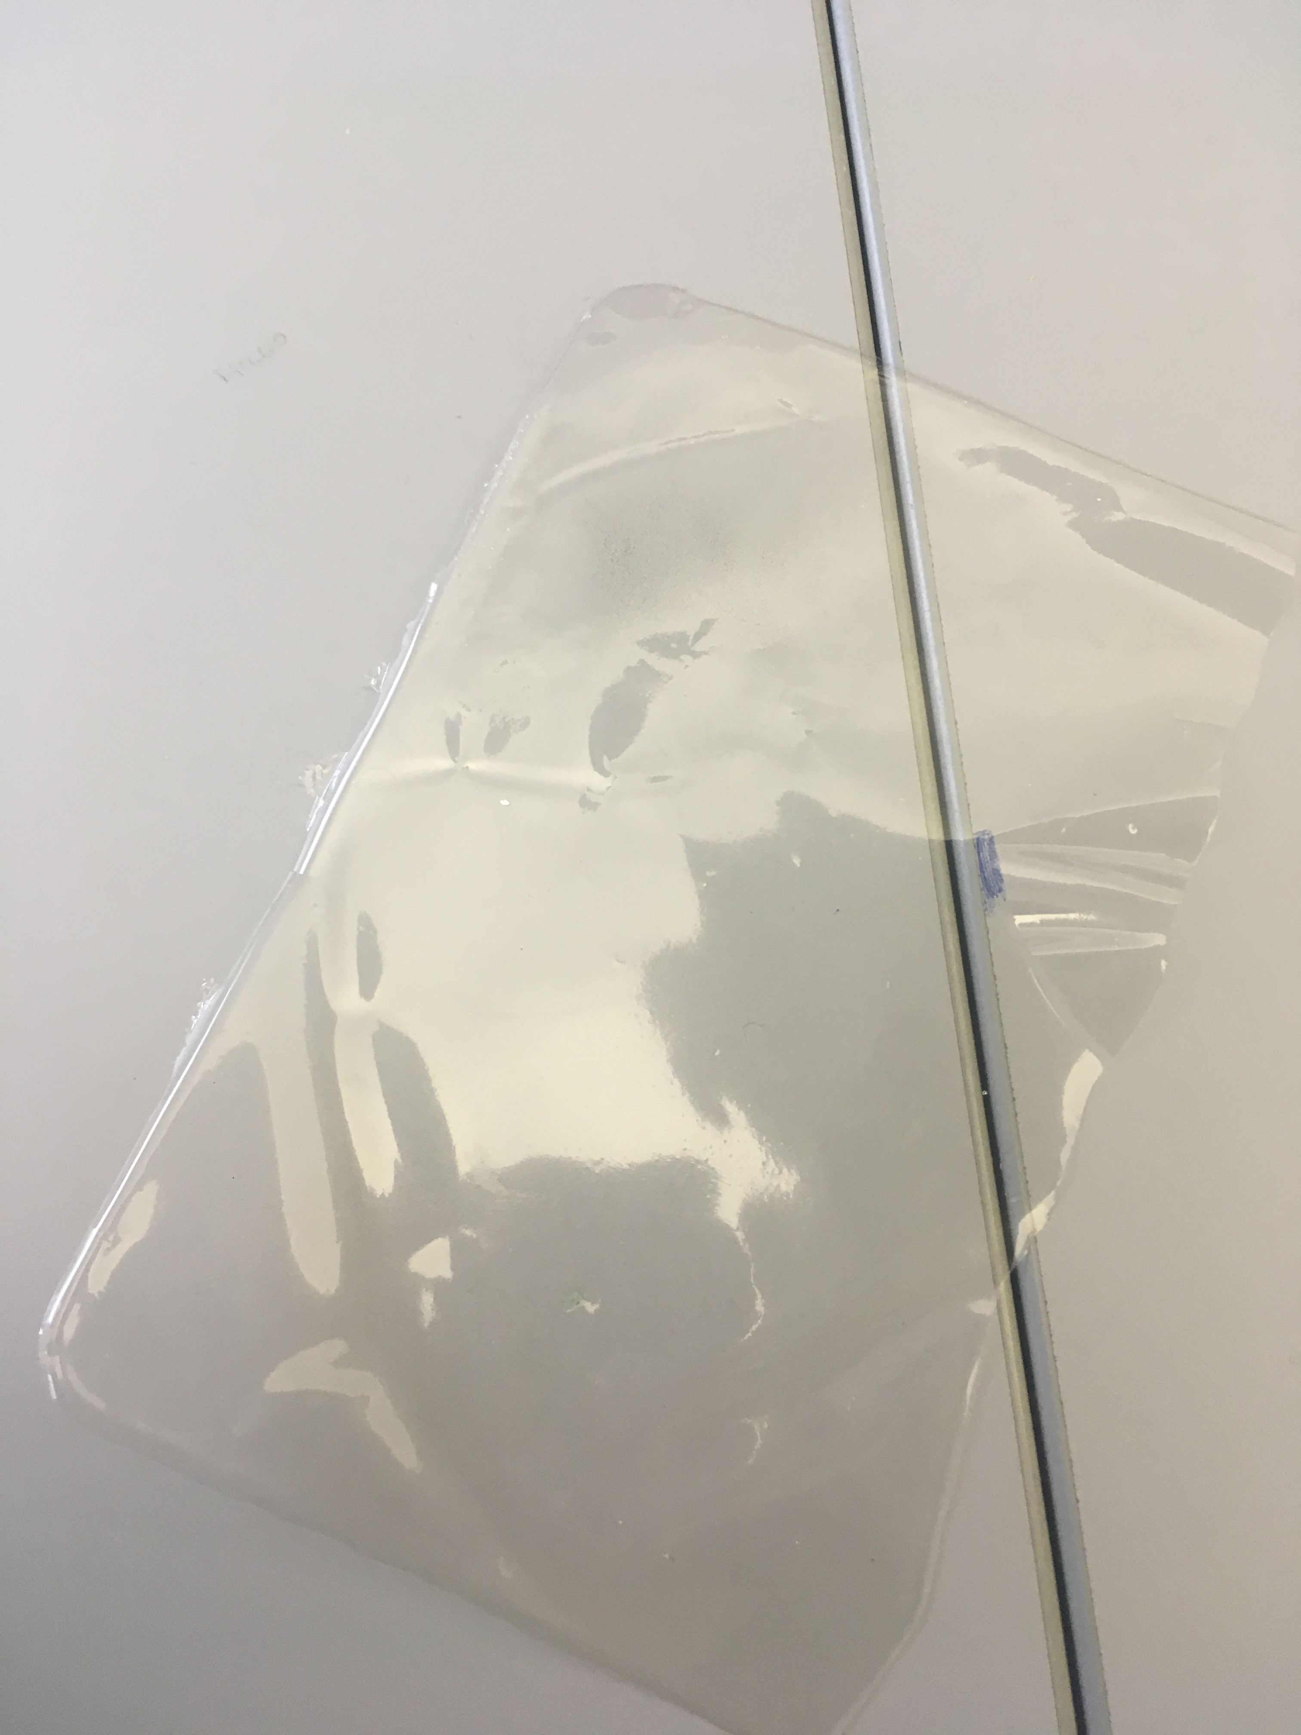

Instructions

- Heat all ingredients in a pot and stir constantly
- Continue until it becomes a pure mass without any lumps
- Then pour the mixture onto a flat surface,spread thinly and evenly and let cool overnight.
- Once it has dried and cooled,carefully pull off the finished organic plastic from the surface
- Done

Instruction 1
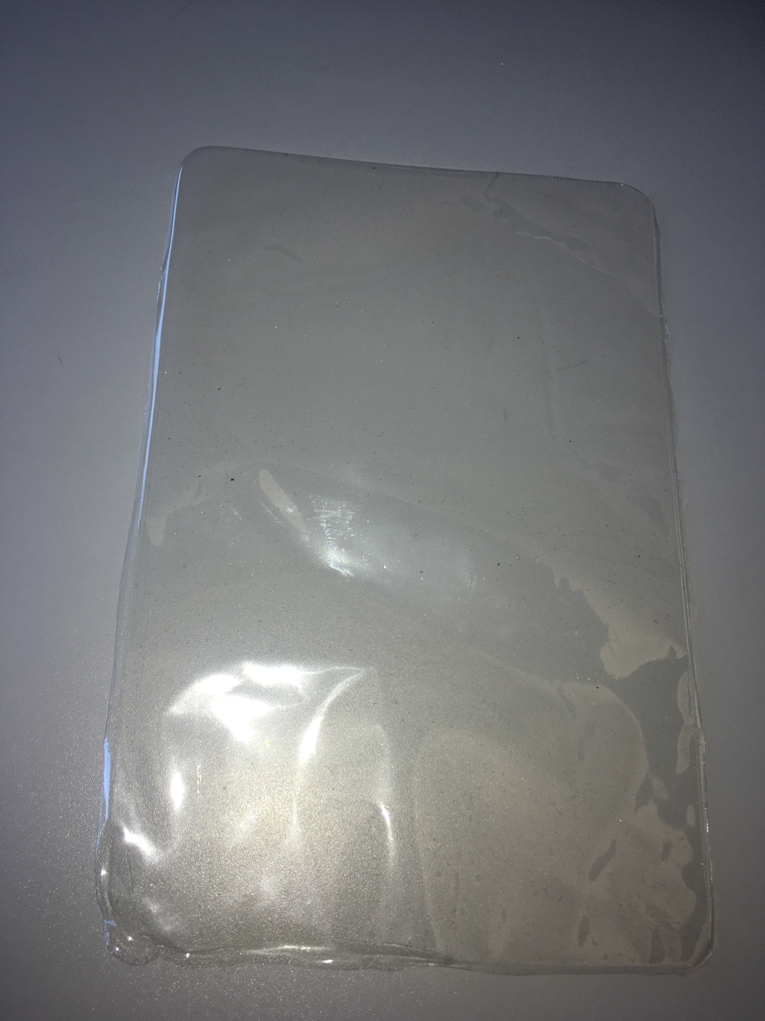
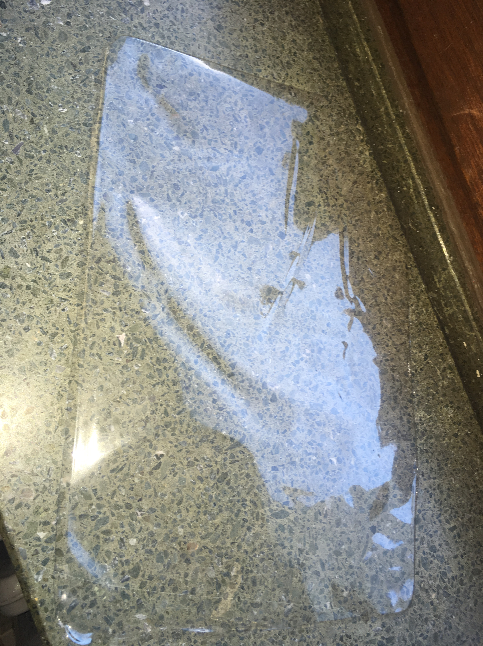
Instruction 2
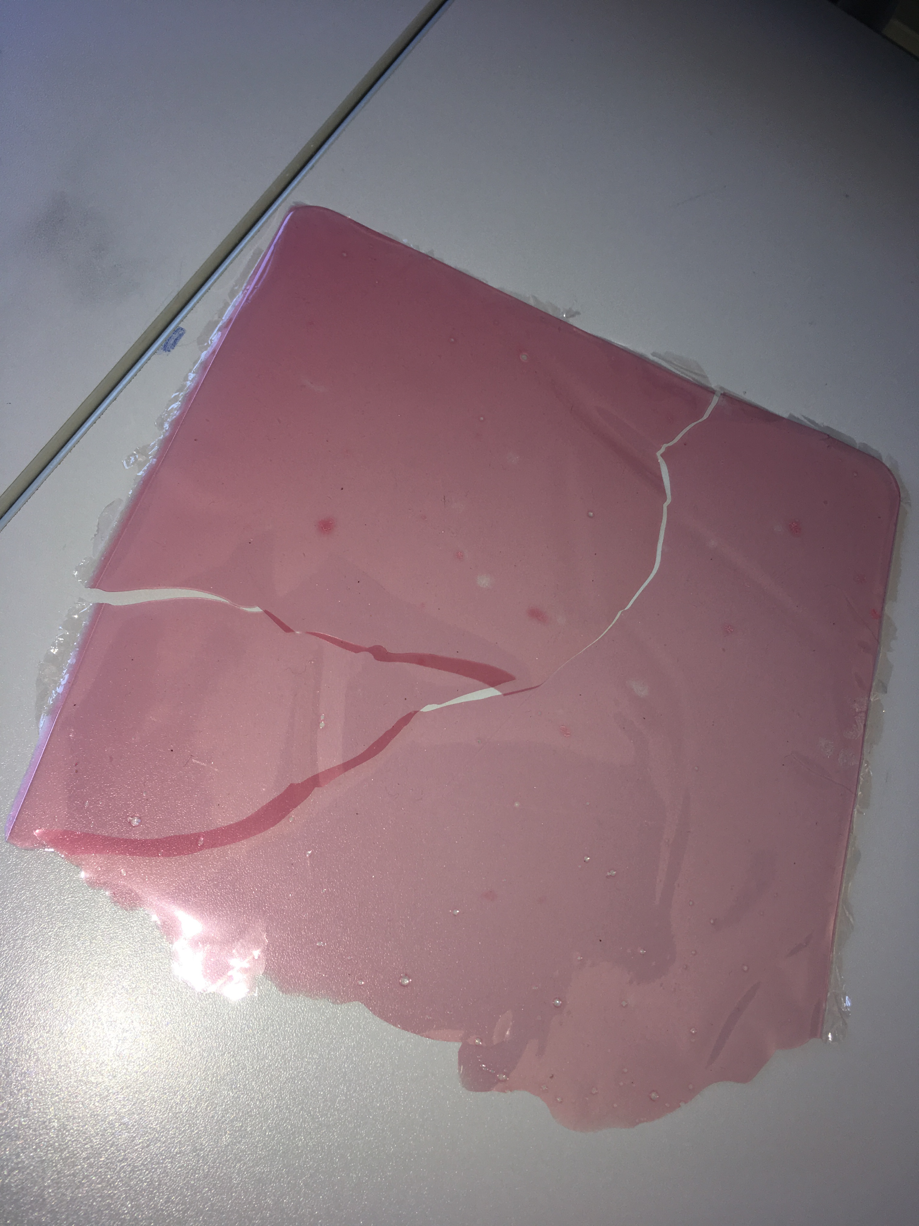

Example



