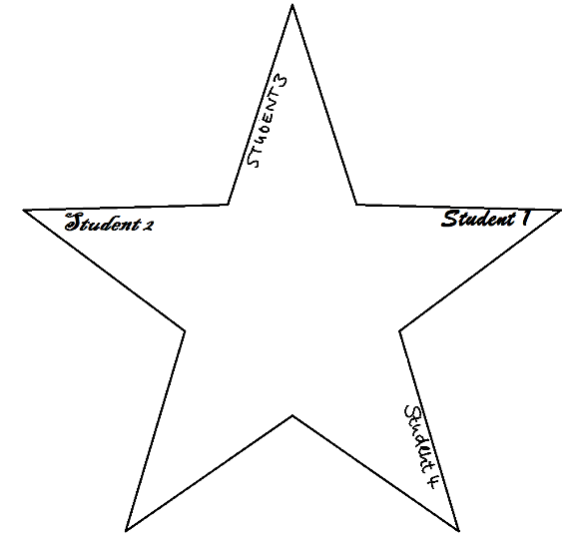
- You will be given a star and some pens to write with.

Begin by writing each of your names in a different
tip of the star.

- Talk to each other and find:

- Three similarities, i.e. three things that all students in your small group have in common.
- Two differences each, i.e. two things for each student in your group that make this person special. These things should only be true for this one person and not for the others in the group.

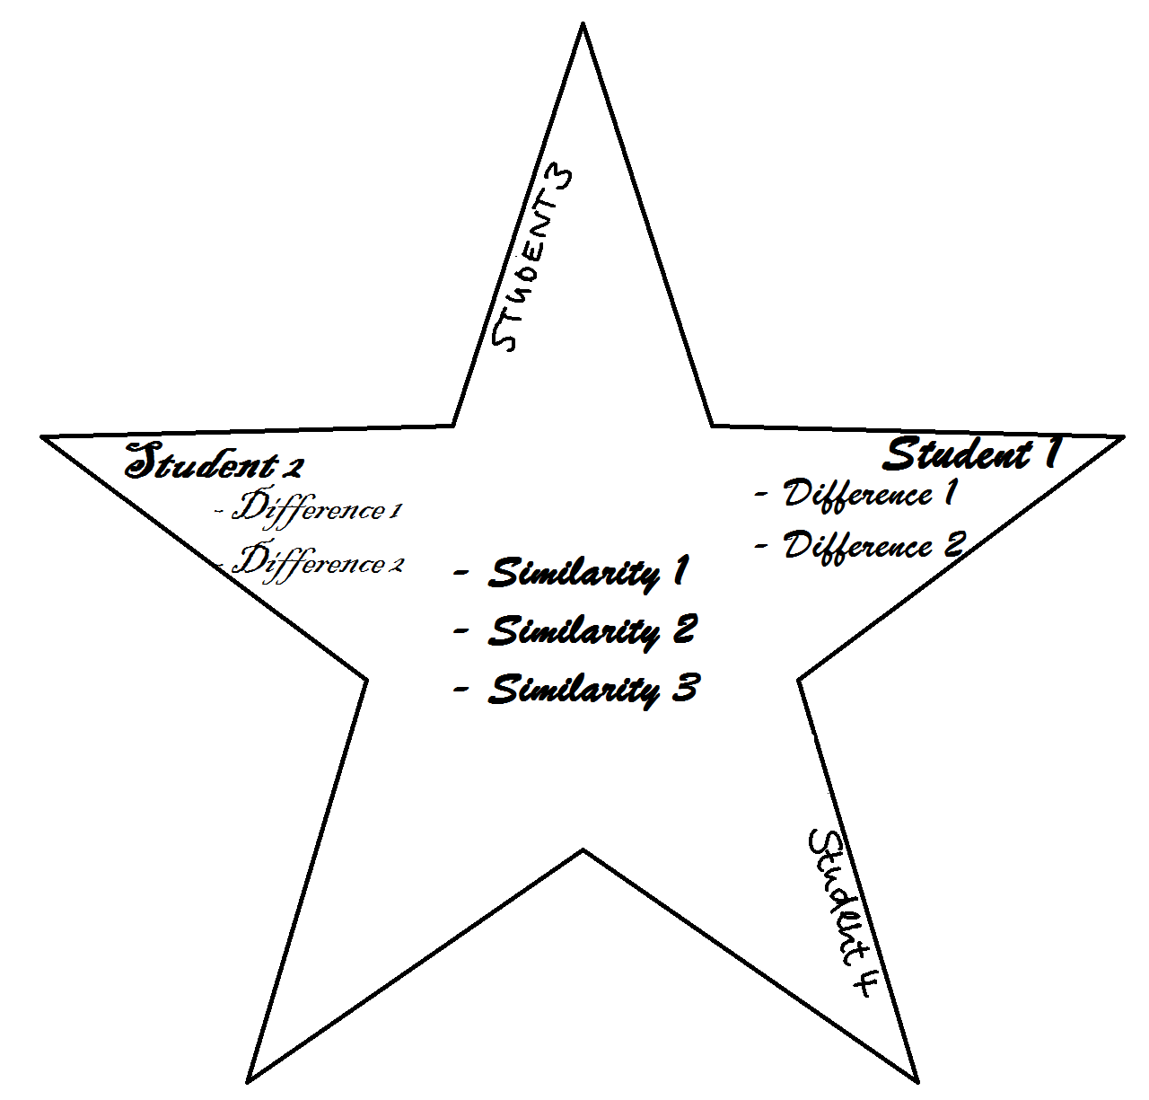
- Let’s fill the stars with meaning and let them shine.

Write your findings on your star in the following way:

- Similarities in the center

- Differences in the jags of the star together with the name of the person they belong to.

