A word on eco packaging…
Eco packaging a new sustainable way to package goods in a safe and environmentally friendly way, the world is now becoming more environmentally friendly by the day the next step is to develop eco packaging that can be recycled this help to sustain a good healthy environments for the generations to come.
There are businesses supporting the innovation of eco packaging for example biopac technology believe that this is the sustainable packaging solution. Eco packaging can be many different things for example many coffee outlets, festivals and outdoor events now have eco-friendly drink cups these are a FSC board lined starch material these cups are 100% compostable meaning they will not harm the environment.

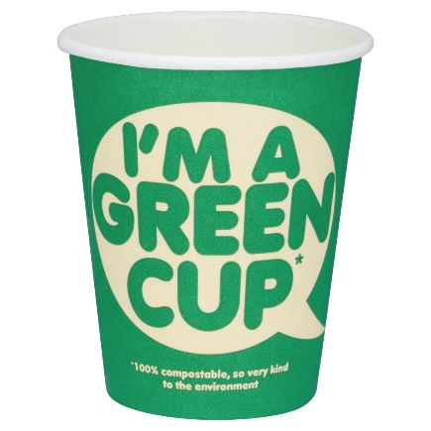
Eco packaging saves large amounts of emission from reaching the atmosphere for example over a year we can save 4,908,885kg of carbon this can result in the greenhouse gas levels slowly lowering over time and helping to improve the global warming crisis.

Problems & Solutions
Household products are a large portion of the contribution to landfill waste, for example, crisp bags and toothpaste tube are two of the hardest products to recycle due to the separation of materials within the product themselves. Crisp packets, made from seven layers of foil and plastic made this way to reduce shipping volume. A hard ineffective way to help recycle the market for recycling crisp bags is not cost effective and there is no market for it. A solution to this is that although it is not quick fix if company’s and businesses decide to go forward fewer layers or metal and plastic will be fused together this will reduce time and cost of the separation and recycling of the crisps packets.

