Erasmus week in Crete
On Sunday all students from the different countries arrived in Heraklion. After our arrival we had some free time to ourselves or with our host families.
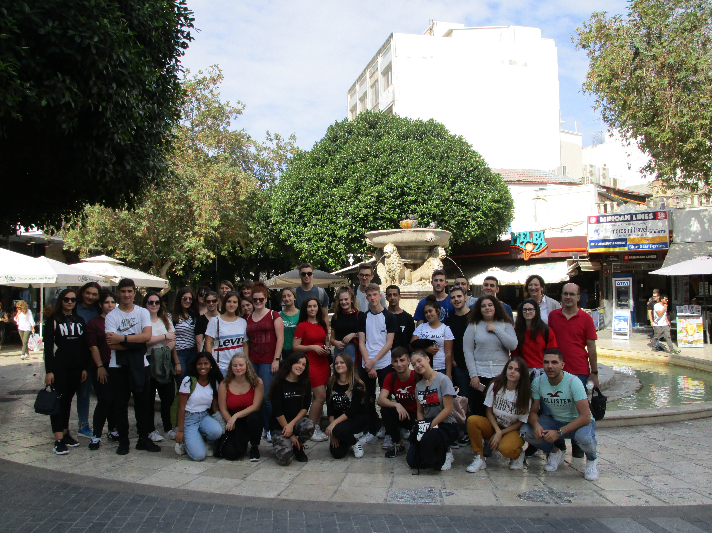
On Monday morning we met for the first time in the Cretan school. The headmaster and some teachers held speeches and told us about our project and the plans of the upcoming week. After that, the Greek students showed us some of their traditional dances and invited us to dance along with them. In the afternoon we went on a guided tour through the old city of Heraklion. We also visited the Victorian sea fortress and had some free time. In the evening we participated in international workshops and got to know each other better.
On Tuesday morning we drove by bus to Knossos to have a guided tour through the palace. After our visit to Knossos we went to the Cretan Aquarium where we also had a guided tour. We learned a lot about the marine organisms and could also see a lot of different marine species. From there we walked to the Hellenic centre for marine research (HCMR) and listened to a presentation about “Marine litter on the beach and the sea” and restoring the marine ecosystem (merces). In the afternoon we had free time to spend in Chersonissos. In the evening we went back to school where we had a workshop about Interlinking.
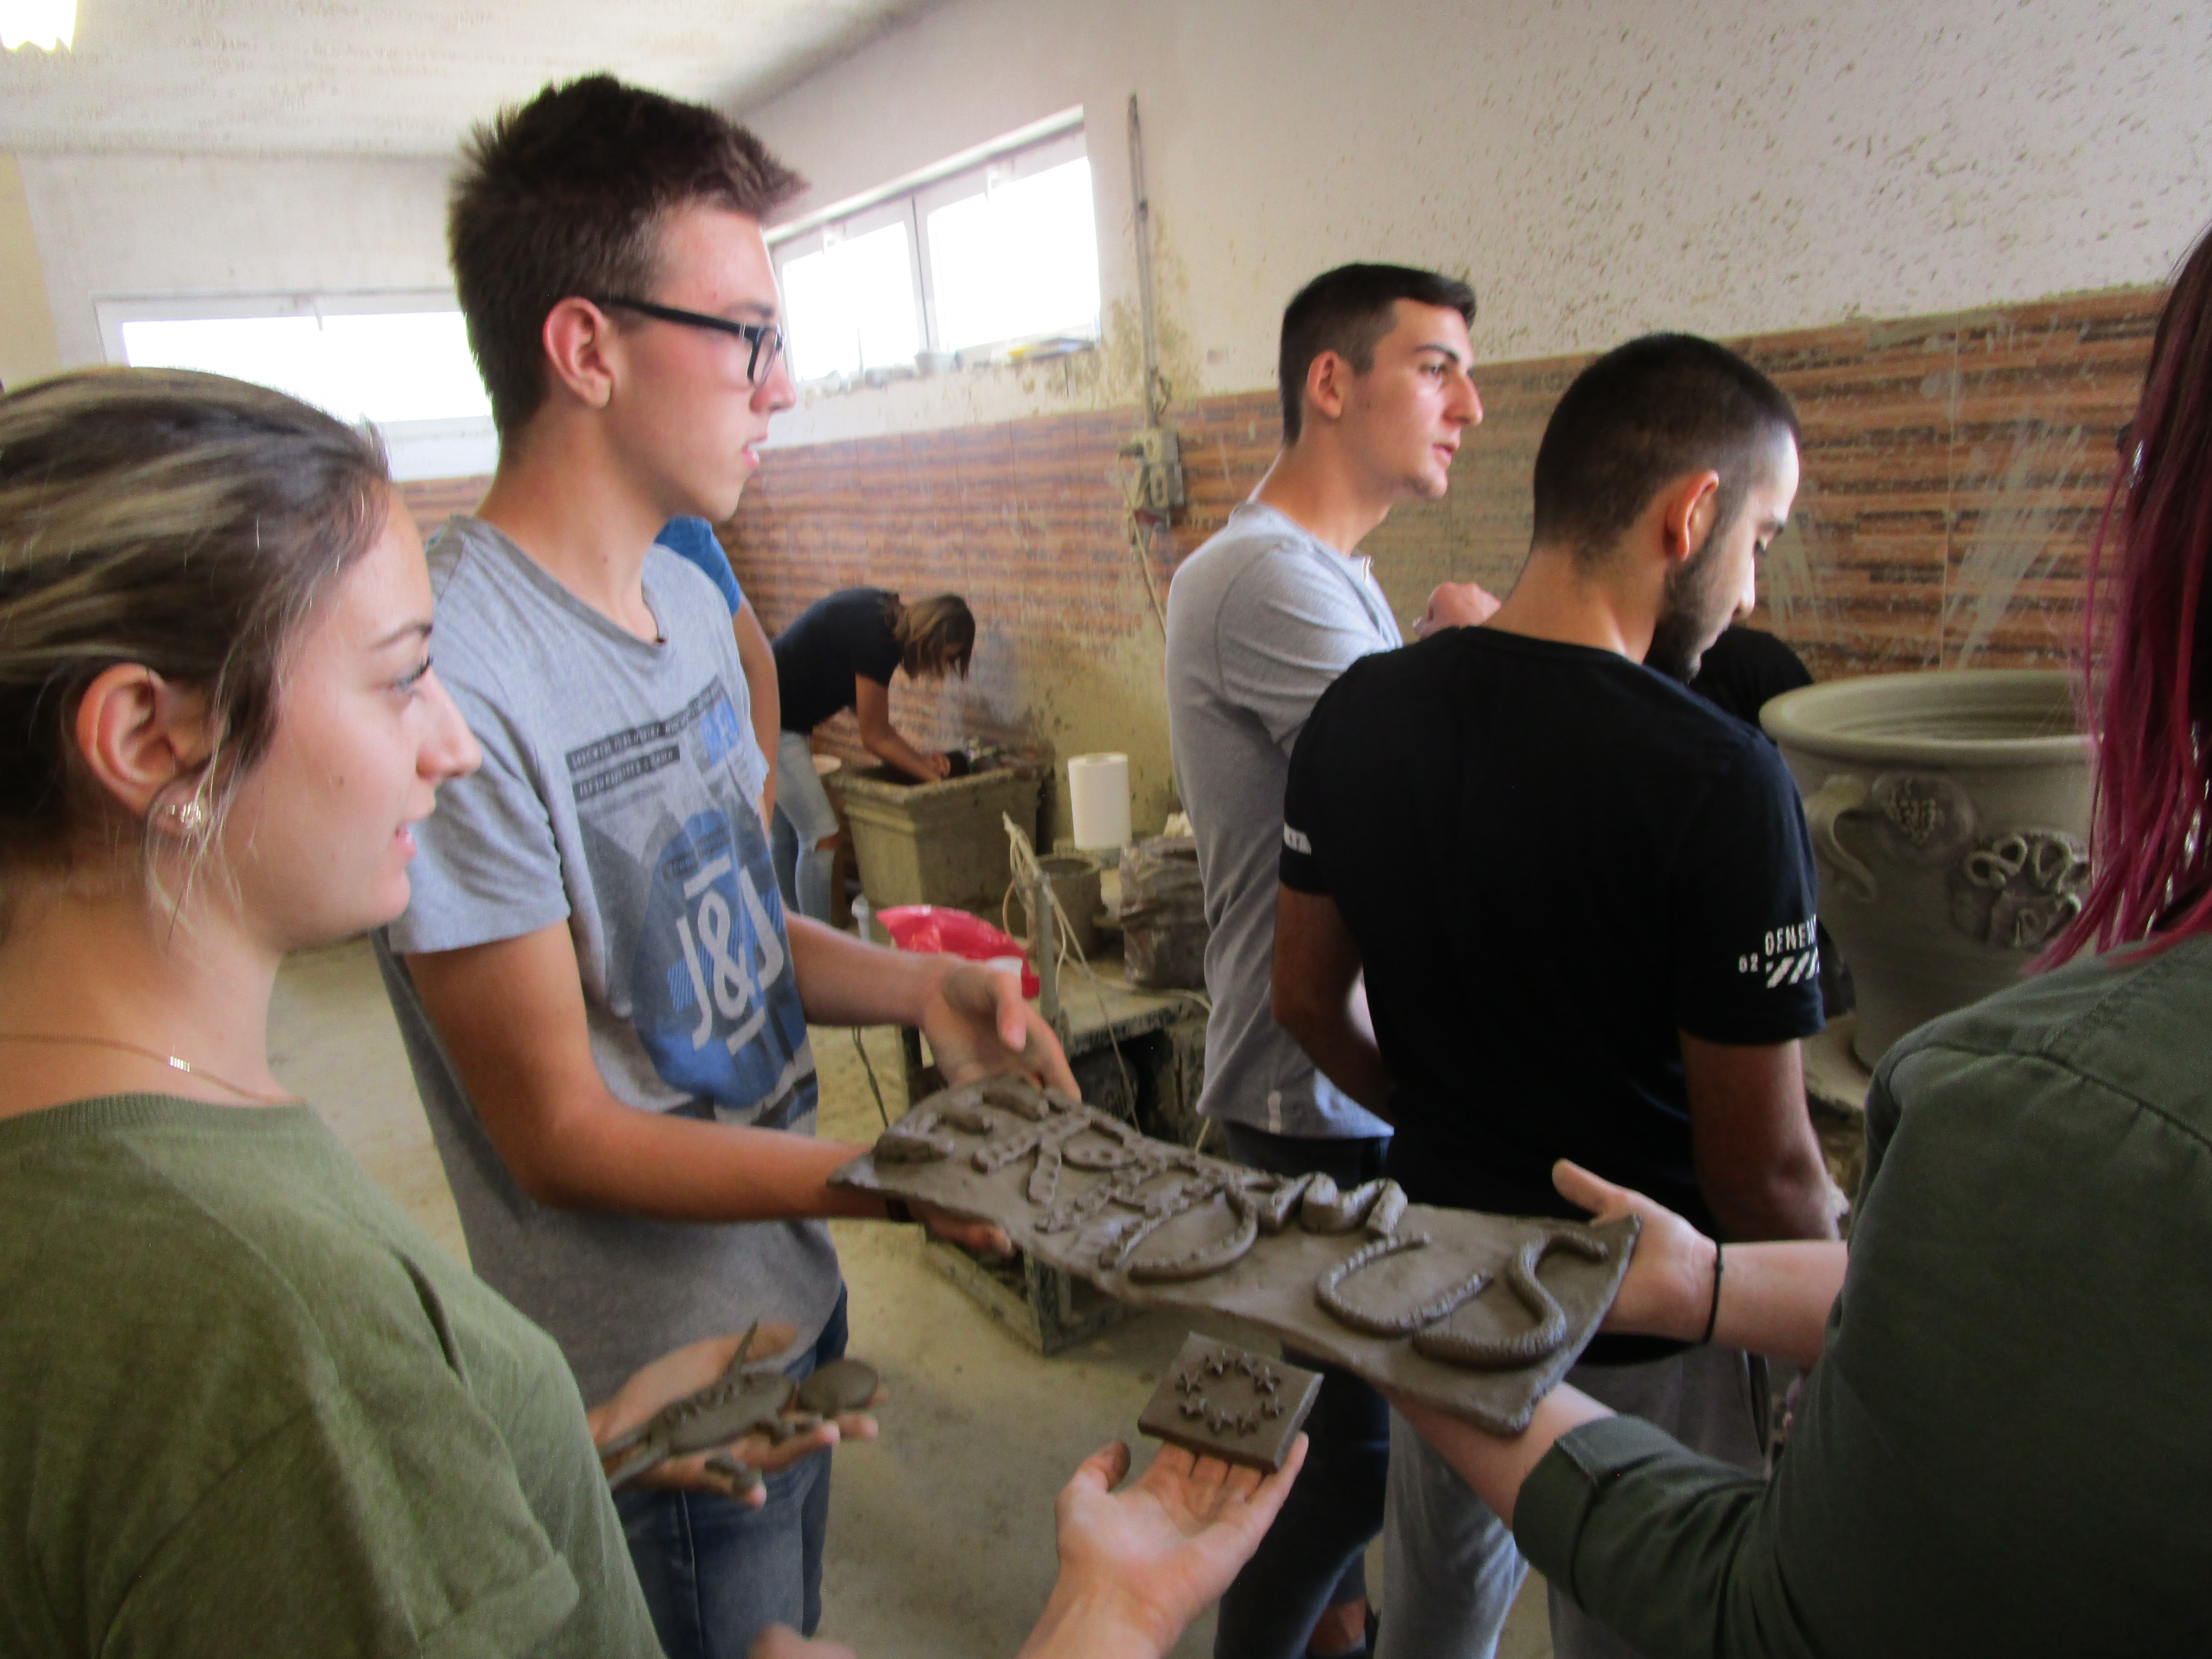
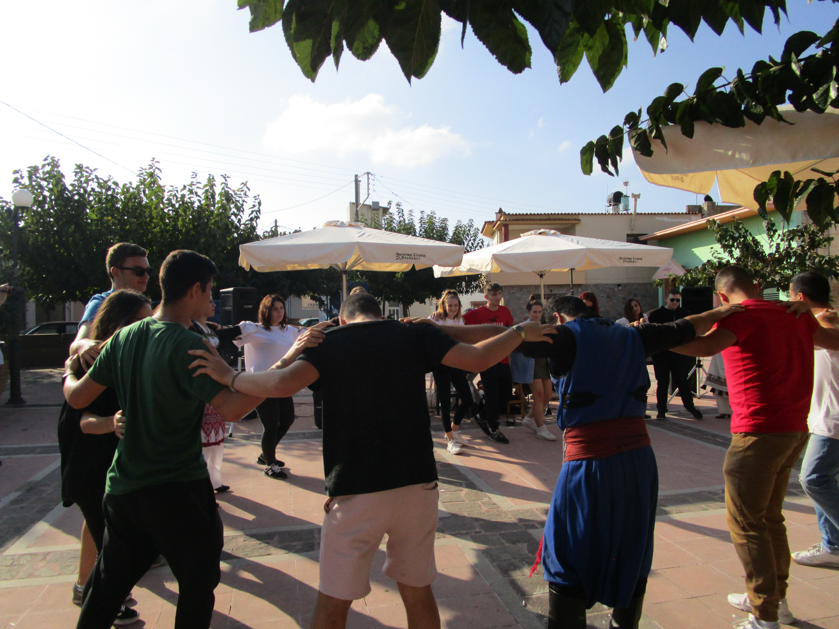
On Wednesday morning we took a bus to a landfill, one of the biggest in Crete. There was also a local television crew and interviewed the Greek students. We also got to see the laboratory at the landfill. Again we had a long bus ride to the Town of Chania and had some free time to see the city, eat there and to go shopping. We met again and had a bus ride to the Town of Rethymnon. We were back in the hotel at 9 pm.
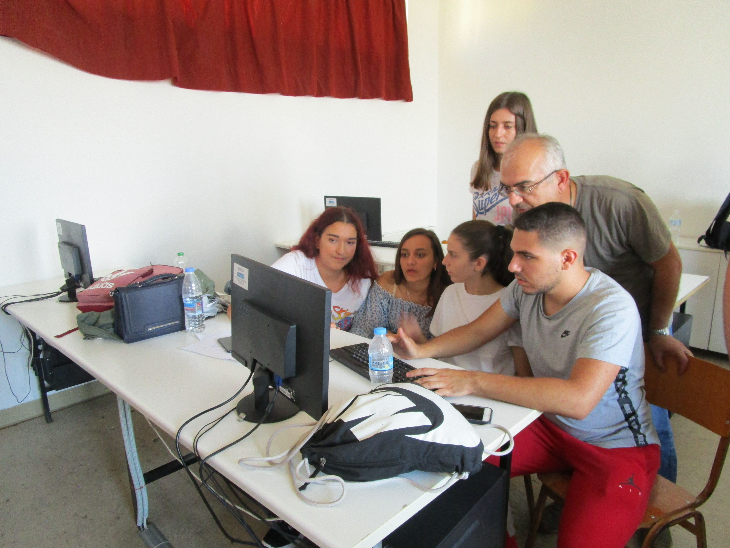
On Thursday we drove to the company “Plastica Kritis” where we listened to a presentation about their products and also had a guided tour through their factory. We went to Thrapsano after the tour where we had a pottery workshop and made our own pots we also got a little souvenir from there. Then we also had a guided tour through a distillery where we also could buy wine for our families. We had a fiesta in Thrapsano where we ate and also danced with the Greek students traditional Cretan dances. In the evening we drove back to school where we had workshops and finished our blogs.
On Friday we presented our work. After the presentation we had some free time and in the evening we had a nice farewell party at the school with all students and some nice food.
On Saturday we had some free time until we left for our flights back.
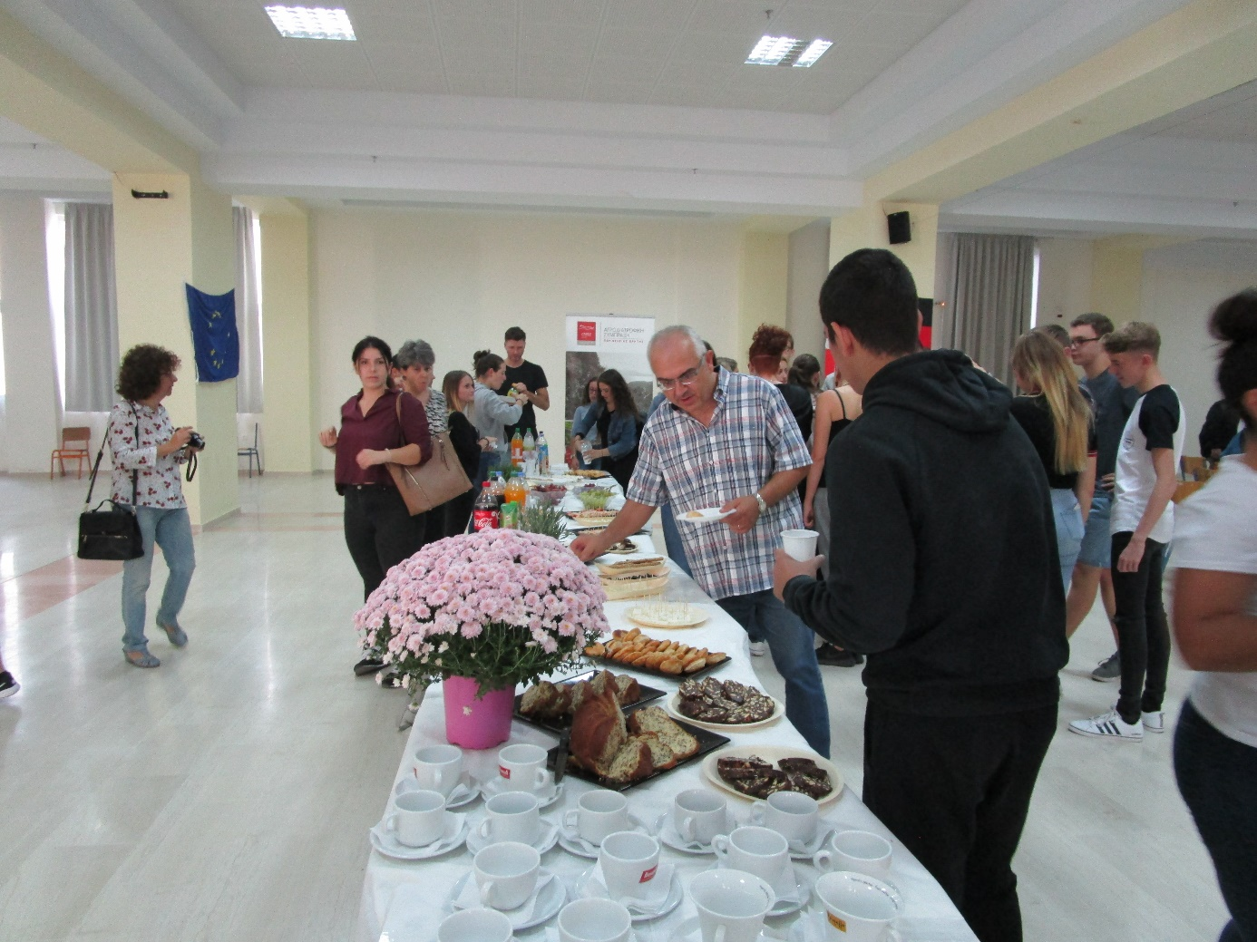The time in Crete was great, Heraklion and the island were so beautiful and we got to meet so many nice and interesting people from different countries. We are all glad to have participated in this programme.

