**Creating spirals with GeoGebra**

1. How was this spiral created? Describe the construction und create it with GeoGebra.

2. How has someone created this spiral? Is she dynamicand remains in the same form when you drag on points? You may use this geogebra-File.<https://www.geogebra.org/worksheet/edit/id/dzvesr2c> . If the construction is dynamic you create tools!



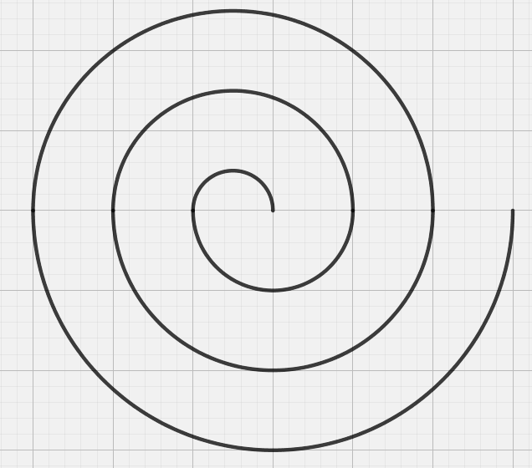

1. Is this spral dynamic and remains it form if you drag on points (when you have them made visible again)?

Monika Schwarze, PGU Unna 2019