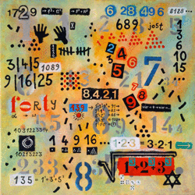
1.
This is right. This is a rule, we call it commutation law. This is right for all numbers which are multiplied.
1+2+3= 1*2*3 =6 , but 3+4+5=12 but 3*4*5=60.
2. In the second line there are the square numbers of 3,4 and 5. 33^2 is 1089.
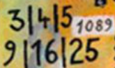
3.
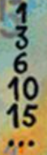 0 +1= 1 1+2=3 3 +3 = 6 6+4=10 10 + 5 =15 15 +6 =21 … and so on.
4. The points show what we have claculated in the line above. The pattern form a triangle. One point more at each bottom line.
German team: Emma, Erik, Florian, Mathis, Sascha, Simeon, Tino, Torben from Pestalozzi Gymnasium
5. 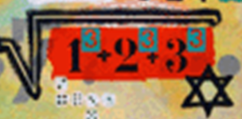 $1^{3}+2^{3}+3^{3}=36 ⇒\sqrt{1^{3}+2^{3}+3^{3}}$=6 and the star have 6 vertices
6. 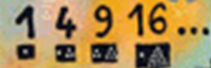1point →1; (1+3) points →4; (3+6 )points→9; (1+15) points →16
7. 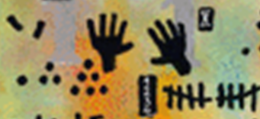 1point+3points+6points=10points→(5+5) fingers= =(5+5) sticks
8. 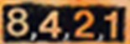 the sequence with the string of natural numbers obtained by dividing at 2
Romanian team 3: Sofia, Teddy, Daria, Theo –Jean Monnet High School

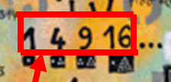
9.

Squares of natural numbers
$$1^{2}=1, 2^{2}=4, 3^{2}=9, 4^{2}=16$$

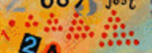
10.
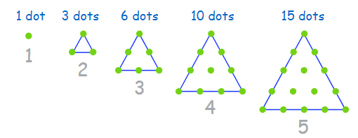

• The first triangle has only one point.
• The second triangle has the second row with 2 additional points, which makes 1 + 2 = 3
• The third triangle has one row with 3 additional points, which makes 1 + 2 + 3 = 6
• The fourth has 1 + 2 + 3 + 4 = 10 etc.!
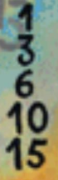
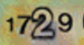
11.

1729 is the natural number following 1728 and preceding 1730. It is known as the Hardy-Ramanujan number, after an anecdote of the British mathematician G. H. Hardy when he visited Indian mathematician Srinivasa Ramanujan in hospital. He related their conversation:
I remember once going to see him when he was ill at Putney. I had ridden in taxi cab number 1729 and remarked that the number seemed to me rather a dull one, and that I hoped it was not an unfavourable omen. "No," he replied, "it is a very interesting number; it is the smallest number expressible as the sum of two cubes in two different ways."
$$1729=1^{3}+{12}^{3}=9^{3}+{10}^{3}$$
The quotation is sometimes expressed using the term "positive cubes", since allowing negative perfect cubes (the cube of a negative integer) gives the smallest solution as 91 (which is a divisor of 1729):
$$91=6^{3}+\left(-5^{3}\right)=4^{3}+3^{3}$$
Numbers that are the smallest number that can be expressed as the sum of two cubes in n distinct ways[5] have been dubbed "taxicab numbers". The number was also found in one of Ramanujan's notebooks dated years before the incident, and was noted by Frénicle de Bessy in 1657. A commemorative plaque now appears at the site of the Hardy-Ramanujan incident, 2 Colinette Road, Putney.
CRO team: Ena, Matej, Ivano – 8. grade

