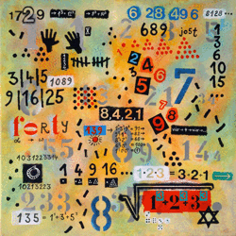
1.
This is right. This is a rule, we call it commutation law. This is right for all numbers which are multiplied.
1+2+3= 1*2*3 =6 , but 3+4+5=12 but 3*4*5=60.
2. In the second line there are the square numbers of 3,4 and 5. 33^2 is 1089.
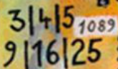
3.
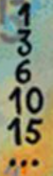 0 +1= 1 1+2=3 3 +3 = 6 6+4=10 10 + 5 =15 15 +6 =21 … and so on.
4. The points show what we have claculated in the line above. The pattern form a triangle. One point more at each bottom line.
German team: Emma, Erik, Florian, Mathis, Sascha, Simeon, Tino, Torben from Pestalozzi Gymnasium
5. 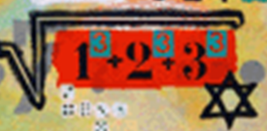 $1^{3}+2^{3}+3^{3}=36 ⇒\sqrt{1^{3}+2^{3}+3^{3}}$=6 and the star have 6 vertices
6. 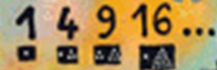1point →1; (1+3) points →4; (3+6 )points→9; (1+15) points →16
7. 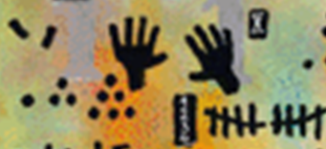 1point+3points+6points=10points→(5+5) fingers= =(5+5) sticks
8. 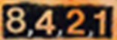 the sequence with the string of natural numbers obtained by dividing at 2
Romanian team 3: Sofia, Teddy, Daria, Theo –Jean Monnet High School

