[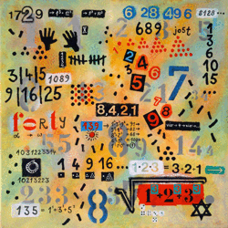](https://www.google.de/url?sa=i&rct=j&q=&esrc=s&source=images&cd=&cad=rja&uact=8&ved=2ahUKEwig26XqjIThAhWDJ1AKHRH8Bn4QjRx6BAgBEAU&url=http%3A%2F%2Fgeonext.uni-bayreuth.de%2Ffileadmin%2Fmathematik_und_kunst%2Fdesign%2Fmotive%2F&psig=AOvVaw1q5OSEZIVKK4ieCZcldf5B&ust=1552736268684670)