1.
This is right. This is a rule, we call it commutation law. This is right for all numbers which are multiplied.
1+2+3= 1*2*3 =6 , but 3+4+5=12 but 3*4*5=60.
2. In the second line there are the square numbers of 3,4 and 5. 33^2 is 1089.
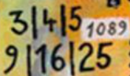
3.
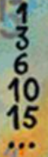 0 +1= 1 1+2=3 3 +3 = 6 6+4=10 10 + 5 =15 15 +6 =21 … and so on.
The points show what we have claculated in the line above. The pattern form a triangle. One point more at each bottom line.
German team: Emma, Erik, Flroian, Mathis, Sascha, Simeon, Tino, Torben from Pestalozzi Gymnasium

