Art with circles and polygons
Project 2: students‘ results (10/11 years old) of PGU Unna (GER)

constructed and coloured with GeoGebra

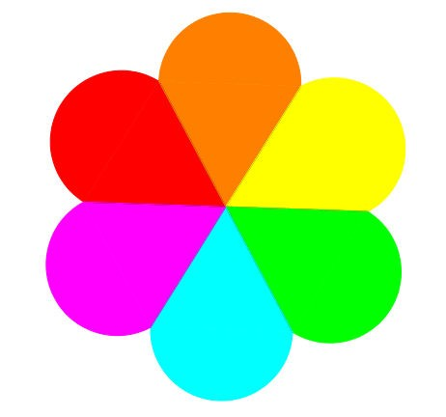

Constructed and coloured with GeoGebra

Constructed and coloured with GeoGebra

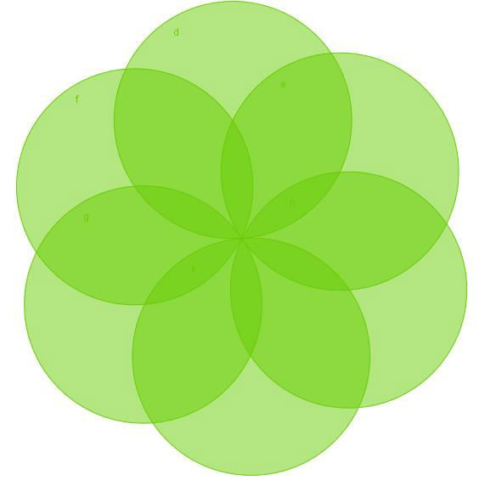

Constructed with GeoGebra

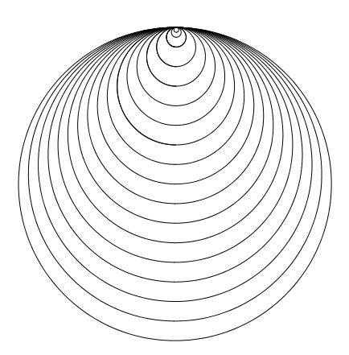

Constructed with GeoGebra, then coloured with Paint (grade 5)

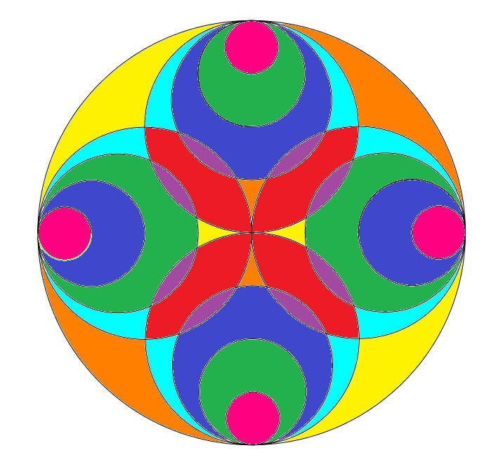

Constructed and coloured with GeoGebra

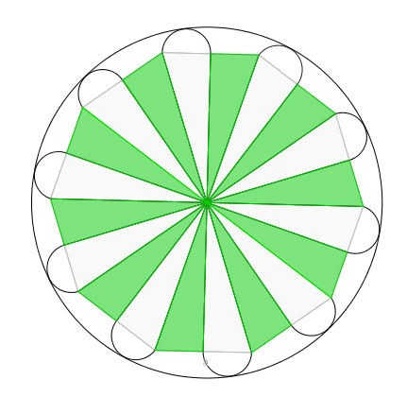

Constructed with GeoGebra, coloured in Paint by Merlin, grade 9

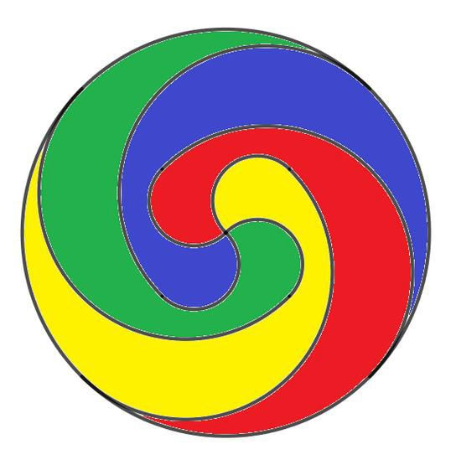

Constructed with GeoGebra, then coloured with Paint by Merlin(grade 9)

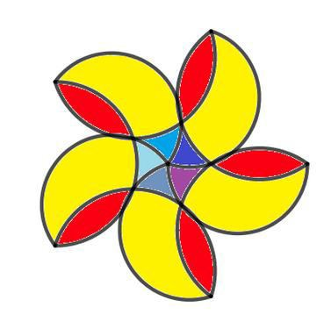

Constructed with GeoGebra, then coloured with Paint by Merlin(grade 9)

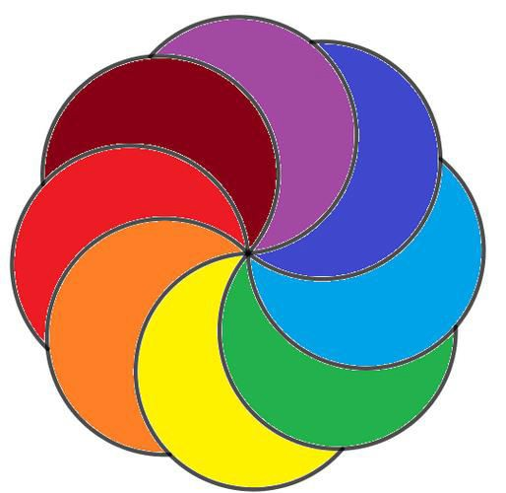

Constructed with GeoGebra, then coloured with Paint by Merlin(grade 9)

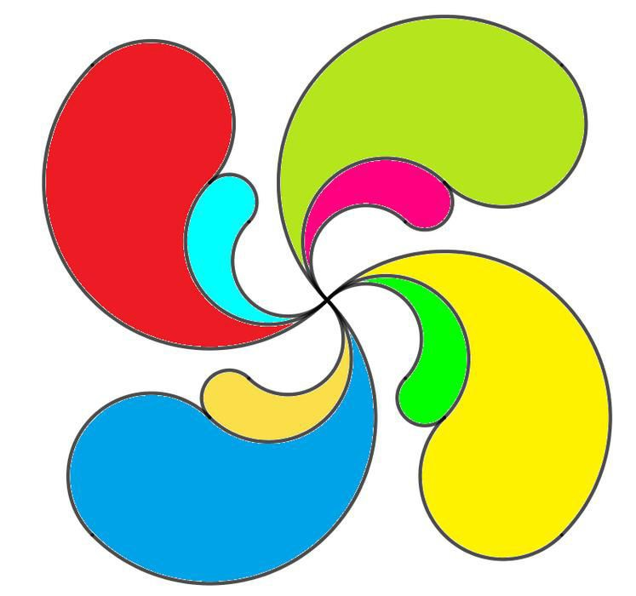

Constructed with GeoGebra, then coloured with Paint (student grade 6)

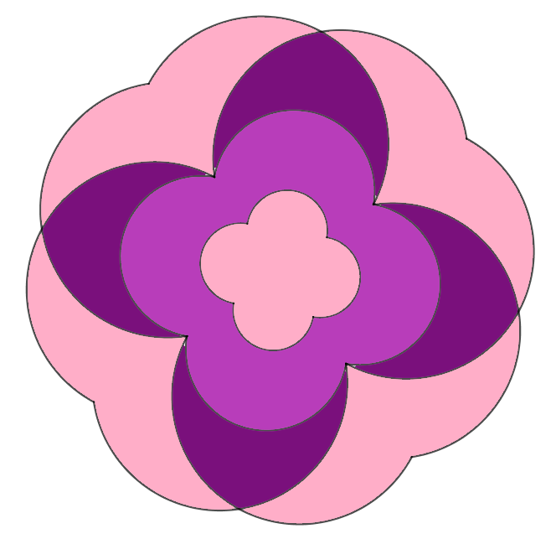

Constructed with GeoGebra, then coloured with Paint by Merlin(grade 9)

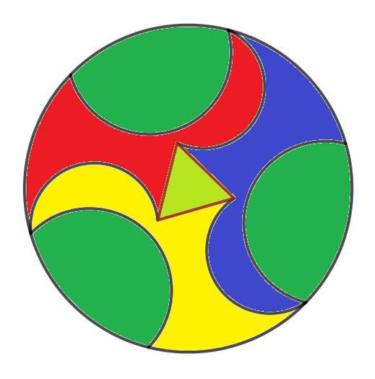

Constructed with GeoGebra, then coloured with Paint (grade 9) 9)9)Merlin(grade 9)

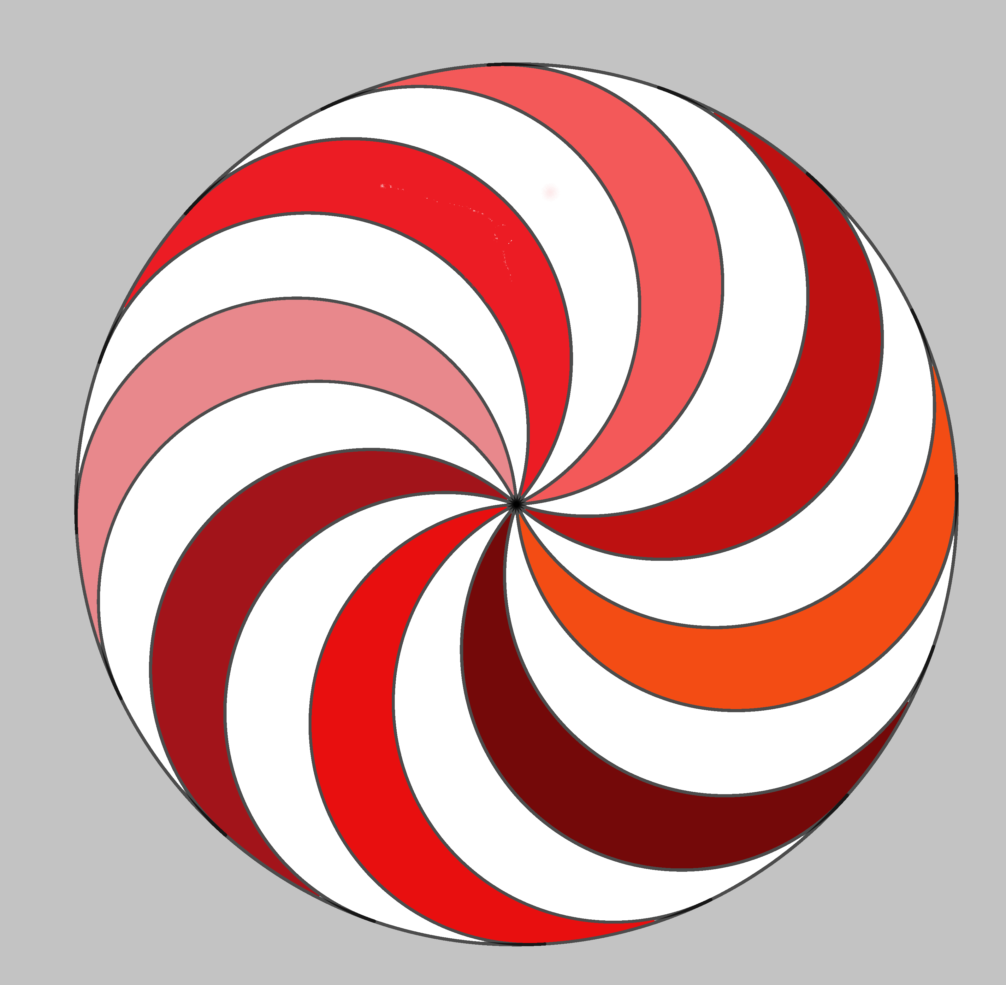
Constructed with GeoGebra, then coloured with Paint by Mika (grade 6) 9)9)Merlin(grade 9)

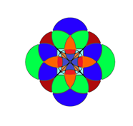
Constructed with GeoGebra, then coloured with Paint by Merlin(grade 9)

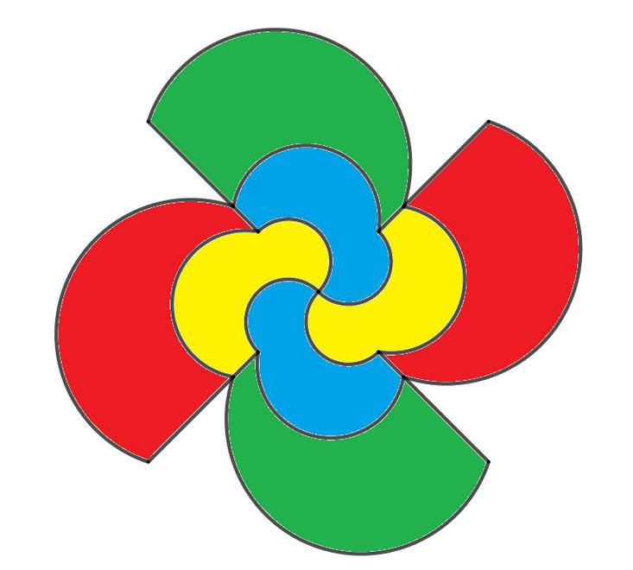
Constructed with GeoGebra, then coloured with Paint (grade 9) 9)9)Merlin(grade 9)

