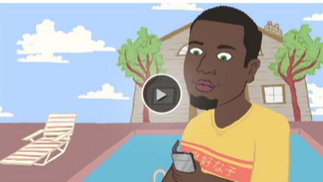
Oversharing: Think Before You Post
• After watching the video, do you think you might be guilty of any type of oversharing?
• Did any of the information in the video surprise you?
• Why is it sometimes tempting to post bragging status updates? How do you feel when you see other people bragging online?
• The video suggests that you should curate your photos and not post any pictures you wouldn’t want your grandma to see. What kinds of pictures do you think fall into this category?
• Would you ever tell a friend if he or she was oversharing online? Would you want your friends to tell you if you were oversharing?
• What do you consider “TMI”? Is there a difference between TMI offline when you’re talking to your friends and TMI online?
• Do you use privacy settings on all your social media accounts? How do privacy settings help you manage your digital footprint?
• Have you ever been in a situation where someone shared something about you that you didn’t want posted online? How did you handle the situation?

