Mish-Mash
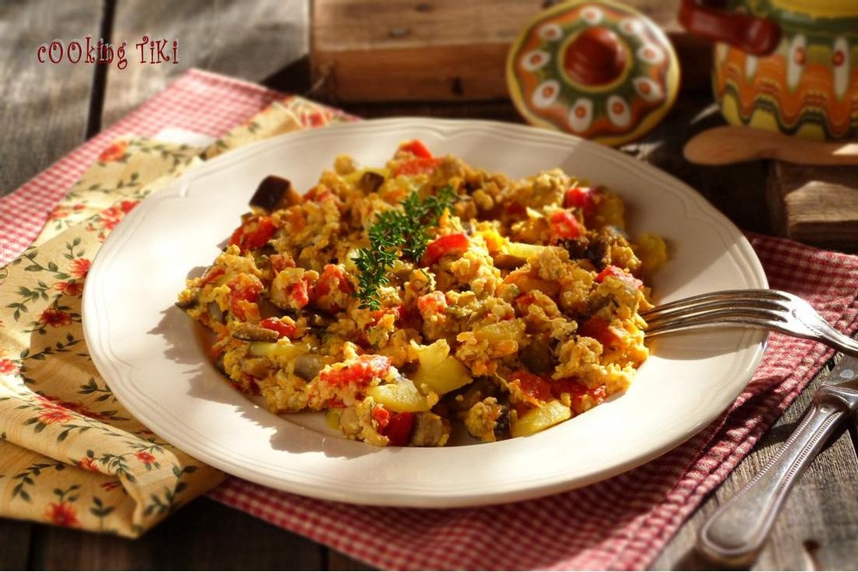
(Eggs, Peppers, Cheese)Literally translated mish-mash means hodge-podge. This is a very tasty meal which I grew up on as my parents were never home to prepare lunch and it takes 10 easy minutes to make.
Ingredients:
3 tomatoes, chopped
3 red peppers, chopped
1 onion chopped,
2 tbsp oil,
1/2 lbs cheese, crumbled (feta),
3 eggs, chopped parsley,
salt and pepper to taste

Preparation:
Heat the oil in a frying pan, add the onions and the peppers and cook until onions are golden. Add the tomatoes and cook for additional 3 minutes. Add the cheese and eggs and cook for another 2-3 minutes. Sprinkle with parsley and serve. Delicious with toast.

